|  |  |
| --- | --- |
| eNVIRONMENTAL SCAN PROJECT  Prevention Coalition | Abstract  Coalition youth and adults conducted an environmental scan on the availability and marketing of substances in Fayette County, Ohio.  Christina Blair  Coalition Chair |

Contents

Background 1

Environmental Scan 5

Environmental Scan Results 6

Comments for Surveyors 13

Fayette County Prevention Coalition Recommendations for Retailers 14

# Background

In early 2014, a local emergency room nurse, Mandy Waters, began to notice an uptake in the number of overdoses coming into Fayette County Memorial Hospital. Concerned by what she was seeing, Mandy contacted city council members Dale Lynch and Leah Foster. Together, they organized a community-wide event on April 6, 2014. Well attended by the community, the decision to form the Faith in Recovery Coalition was made and their first meeting was held on May 21, 2014. At first the coalition was small, with about 6 individuals meeting over coffee to discuss strategies on how to attack the drug issue in the community. Over time, membership in the coalition grew.

In June 2016, the coalition identified the need to work on youth substance abuse prevention and at the urging of Senator Portman’s office researched the Drug Free Communities Support Program. Members of the coalition formed a Healthier Buckeye Council and applied for a pilot grant through the Ohio Department of Job and Family Services.

This grant allowed CACFC to obtain staff support for conducting a community-wide needs assessment and to conduct a gaps analysis of the coalition to bring it into alignment with Drug Free Communities standards. The full-time Healthier Buckeye Planner was hired in August 2016. The coalition decided to hold separate meetings for all prevention planning in September 2016. The prevention coalition (PC) held a community-wide focus group and began meeting separately in October 2016.

The first few months were reserved for conducting a community-wide needs assessment of youth substance abuse and expanding the membership of the coalition to include the mandated 12 sectors. The 12 sectors include: youth, parents, law enforcement, schools, health care, government agencies with expertise in substance use, other agencies dedicated to reducing substance use, civic/volunteer groups, faith-based organizations, youth-serving organization, media, and businesses.

The first step in the community needs assessment was to conduct a new core measures survey of 6, 8, and 10th graders at both of the local school districts to collect individual needs assessment data. Next, a community readiness assessment was developed, distributed, and analyzed. Fayette County was determined to be in the pre-planning stage of community readiness. Since then, the community has been mobilized and is in the initiation stage.

The Planner held community-wide, law enforcement, school district, and youth focus groups to obtain interpersonal, organizational, community, and policy level needs assessment data. Use and consequence data was requested from the local school districts, the Health Department, Sheriff and Police Departments, Juvenile, Municipal, and Common Pleas Courts, Children’s Services, Scioto Paint Valley, Fayette Recovery, and the local hospital. Due to how law enforcement data is collected in the community and how minors are charged with crimes, the Planner identified the need to obtain more data from Juvenile Court from probationers. Those surveys were collected in January 2017.

The coalition was thoughtful and methodical in its selection of priority substances. The core measures surveys identified alcohol as the leading substance for the coalition. The choice for the second was much more difficult, because the data supported both tobacco and marijuana. The group agreed that it wanted to narrow its focus to two substances to gain the most community buy-in and develop more detailed action plans.

The group recognized that with time, technical assistance, and additional resources, planning for additional substances would be more realistic. Ultimately, the group chose marijuana based upon school district and law enforcement buy-in and the results of a youth focus group. The focus group clearly demonstrated that youth perceptions of marijuana use required immediate intervention.

During the needs assessment, the following information was uncovered by community planners, relevant to the work of the coalition:

* 54% of youth reported being provided information on drug and alcohol use less than 3 times/school year from parents, teachers, counselors, pastors, etc.
* 78% of youth surveyed reported that they believed that more than 40% of their peers used alcohol at least 3 times a month; 80% of youth surveyed believed more than 40% of their peers used marijuana at least 3 times in the past month.
* Youth reported obtaining alcohol from the following sources most frequently: friends over 21, friends, parties, their parents, and local stores.
* Youth reported obtaining marijuana from their friends, dealers, and parties most frequently.
* 32% of juvenile offenders reported being under the influence at the time of their arrest. The majority reported being under the influence of marijuana. 55% reported failing a drug screen while on probation, with marijuana being the most reported substance they were using when they failed.
* While juvenile offenders’ friends did not perceive alcohol or marijuana use ask risky or wrong, the coalition was surprised to learn that the majority of their parents found the use of alcohol and marijuana “very wrong.” (Alcohol, 60%; Marijuana, 55%)
* Both juvenile probationers and middle school focus groups identified cultural acceptance as a major contributing factor encouraging youth substance use. Juvenile probationers viewed peer use as the number one reason for use. The middle school focus group viewed being a “Rite of Passage” was the first major contributing factor, almost tying with cultural acceptance. Multigenerational use was a close third for the focus group. Juvenile probationers identified the availability of substances as the third greatest contributing factor.

Enforcement activities surrounding youth substance abuse has taken a backburner in the community due in large part to a general lack of community resources available for law enforcement. While the community has 175 individuals on juvenile probation, the aforementioned survey was required to identify how many were under the influence of substances (32%) and how many failed a drug screen (55%), because most youth are charged under “unruly.” There were 11 alcohol related arrests of local youth that was reported through the needs assessment process. Additionally, the local police and sheriff’s department’s databases do not allow them to pull reports differentiating between minor and adult arrests.

During the last full school year, 2015-2016, there were 203 out of school suspensions and 503 in-school suspensions. 15% of all out of school suspensions were related to substance use. Fayette County had about a 5% drop-out rate for the 2015-2016 school year and 85.4% of its population has a high school education or higher. However, another predictor of risky behavior is teen pregnancy rates.

According to the Fayette County LIFE Pregnancy Center, they recently received a grant from the Ohio Department of Health due to the county having the highest teen pregnancy rate in Ohio. According to the most recent statistics available through the 2016 county health rankings, Fayette County continues to have a high teen pregnancy rate, with 52 births per 1,000 of the female population.

In terms of collecting treatment data, it was very difficult for community partners to differentiate between adults receiving service and minors receiving services due to how their database systems are set up to pull reports. However, local partners were able to comb through data by hand for the purposes of this application. According to Fayette County Memorial Hospital, 6% of all overdoses during the 2016 calendar year were minor overdoses. The local ADAMH Board reported that there were 673 youth receiving treatment services that were identified as being at-risk for substance abuse. 3% of those were identified as having an active substance use disorder.

Since its inception, the coalition has conducted two Core Measures Surveys. The data and outcomes from the latest survey, conducted 2/24/17 is as follows:

|  |  |  |  |  |  |  |  |  |  |  |  |
| --- | --- | --- | --- | --- | --- | --- | --- | --- | --- | --- | --- |
| **Past 30 Day Use (Yes)** | | | | | | | | | | | |
| **Substance** | **MT 6th** | | **WCH 6th** | **MT 8th** | | **WCH 8th** | | **MT 10th** | **WCH 10th** | | **Combined** |
| Alcohol | 2% | | 5% | 12% | | 18% | | 26% | 19% | | 12% |
| Tobacco | 0% | | 3% | 4% | | 7% | | 9% | 13% | | 5% |
| Marijuana | 1% | | 3% | 3% | | 10% | | 13% | 9% | | 5% |
| Prescription Drugs | 0% | | 3% | 2% | | 7% | | 4% | 3% | | 3% |
| **Perception of Risk/Harm of Use Combined Data (6th, 8th, & 10th Grades)** | | | | | | | | | | | |
| **Risk Rating** | | **Alcohol** | | | **Tobacco** | | **Marijuana** | | | **Prescription Drugs** | |
| No Risk | | 4% | | | 3% | | 15% | | | 2% | |
| Slight Risk | | 23% | | | 12% | | 16% | | | 11% | |
| Moderate Risk | | 41% | | | 28% | | 25% | | | 27% | |
| Great Risk | | 32% | | | 57% | | 44% | | | 60% | |
| **Perception of Parental Disapproval Combined Data (6, 8th, & 10th Grades)** | | | | | | | | | | | |
| **Perception**  **Rating** | | **Alcohol** | | | **Tobacco** | | **Marijuana** | | | **Prescription Drugs** | |
| Not at all wrong | | 3% | | | 2% | | 4% | | | 1% | |
| Little bit wrong | | 7% | | | 5% | | 5% | | | 4% | |
| Wrong | | 15% | | | 11% | | 6% | | | 11% | |
| Very Wrong | | 75% | | | 82% | | 85% | | | 84% | |
| **Perception of Peer Disapproval Combined Data (6, 8th, & 10th Grades)** | | | | | | | | | | | |
| **Perception**  **Rating** | | **Alcohol** | | | **Tobacco** | | **Marijuana** | | | **Prescription Drugs** | |
| Not at all wrong | | 10% | | | 7% | | 12% | | | 5% | |
| Little bit wrong | | 18% | | | 18% | | 12% | | | 9% | |
| Wrong | | 25% | | | 23% | | 15% | | | 21% | |
| Very Wrong | | 47% | | | 58% | | 61% | | | 65% | |

The PC conducted focus groups and had several conversations with local youth on the topic of youth substance abuse. During these interviews and focus groups with youth, the PC was told that marijuana use is pervasive among youth, in spite of the data that it had collected. Some youth were obviously against marijuana use, but stressed to the coalition that they were offered it on a daily basis and that many of their friends are using.

Other students were obvious advocates for legalization. One youth stated, “Marijuana doesn’t kill. It is medicine.” Another, with his fist in the air proclaimed, “Stop heroin! Go weed!” Another group of admitted drug users were encountered, many of them pointed towards stress, anxiety, or “sucking at life” as reasons for their use of marijuana or alcohol.

The coalition applied for and was approved to expand its capacity by forming youth coalitions at each school district. The Prevention Action Alliance and Center for Capacity Building awarded the Fayette County Prevention Coalition the #PUSH4Prevention Stipend. The coalition used those funds to develop Lead Out Loud Coalition at Miami Trace and Break Free at Washington City Schools. Thirty-six youth were recruited. At the culmination of that recruitment period, the youth coalitions in partnership with the Prevention Coalition held the Pizza for Prevention Event. Sixty-nine members of the community attended the event where Scioto Paint Valley and Fayette Recovery trained community members on evidence-based ways to discuss substance use with youth.

The coalition’s 12-month action plan included the use of a reward and remind campaign due to reports from local youth that they were able to obtain alcohol, tobacco, and paraphernalia from local retailers. The Prevention Coalition was awarded additional funds to conduct the Summer Scavenger Hunt Environmental Scan to document the marketing and availability of substances in the community.

# Environmental Scan

Coalition youth, along with adults, conducted "environmental scans" at 29 local retailers located within Fayette County, Ohio. Retailers surveyed included: grocery stores, convenience stores, gas stations, drive throughs, and pharmacies.

The scans took place on the following dates:

June 21, 2017 – 18 volunteers  
July 12, 2017 – 19 volunteers  
August 9, 2017 – 22 volunteers

Surveyors were provided a training on how to conduct the survey. Adults and youth received different surveys. A list of the questions are as follows on both surveys:

|  |  |  |  |  |  |  |  |
| --- | --- | --- | --- | --- | --- | --- | --- |
| **Step 2: Ad placement & discounts ads** | | | | | | | |
| Are there ads on doors? | | | | | | No | Yes |
| Are there ads on building walls? | | | | | | No | Yes |
| Are there ads on property fences? | | | | | | No | Yes |
| Are there ads on functional items? (trash cans, benches, windshield cleaning station, etc. | | | | | | No | Yes |
| Are there any “special” price ads? | | | | | | No | Yes |
| Are there any ads with multi-purchase discounts? | | | | | | No | Yes |
| Are there neon signs for alcohol? | | | | | | No | Yes |
| Are neon alcohol signs visible from outside? | | | | | | No | Yes |
| Are there any other ads not described above? | | | | | | No | Yes |
| If yes, please describe: __________________________________________________ | | | | | | | |
|  | | | | | | | |
| **Step 3: Types of Advertisements** | | | | | | | |
| Are there ads for cigarettes? | No | Yes | How many? ______________ | | | | |
| Are there ads for little cigars? | No | Yes | How many? ______________ | | | | |
| Are there ads for smokeless tobacco? | No | Yes | How many? ______________ | | | | |
| Are there ads for vaping? | No | Yes | How many? ______________ | | | | |
| Are there ads for alcohol? | No | Yes | How many? ______________ | | | | |
| Are there ads for any type of paraphernalia? (Papers, pipes, etc.) | No | Yes | How many? ______________ | | | | |
|  | | | | | | | |
| **Step 4: Other** | | | | | | | |
| Are there single-unit sales? (1 beer or shot) | | No | | Yes |  | | |
| Is there a “no sale to minors” sign? | | No | | Yes |  | | |
| Is there a “we ID” sign posted? | | No | | Yes |  | | |
| Can you purchase alcohol for immediate use? | | No | | Yes |  | | |

Adult surveys had additional data points on the availability of substances. This included:

|  |  |  |  |
| --- | --- | --- | --- |
| Are paraphernalia items visible? | No | Yes |  |
| (Paraphernalia = papers, pipes, one-hitters, dugouts, grinders, clips, hookahs) | | | |
|  | | | |
| **Substances Available**: Beer Wine Liquor Cider Cigarettes Papers  Pipes Shots of Liquor E-Cigarettes Energy Pills Vaping Supplies  Other: _____________________________________________________________ | | | |

At the final session in August, Fayette Recovery provided a debrief presentation on careful consideration regarding the intents of ads. Community Action asked individuals that participated to share their observations.

A few comments are described below:

* Many retailers are doing things right! We are a small community, but it is still impressive that so many take this seriously.
* One retailer was very uncomfortable and asked the surveyors to leave their premises.
* A few retailers had several paraphernalia items prominently displayed. Having these items on display normalizes their use.

# Environmental Scan Results

**Ad Placement Section**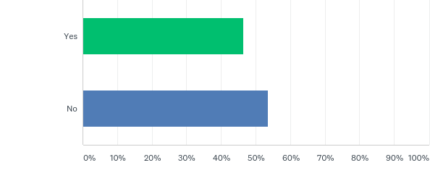

**Are there ads on the doors?**  


**Are there ads on building walls?**

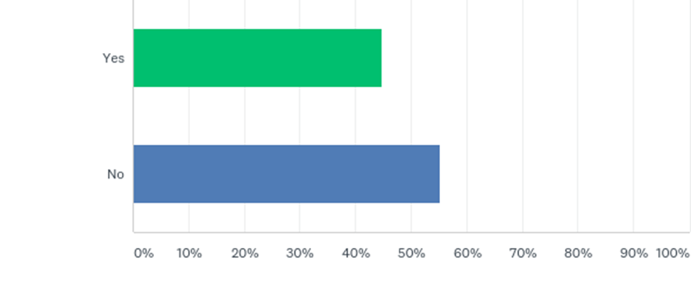

**Are there ads on building fences?**

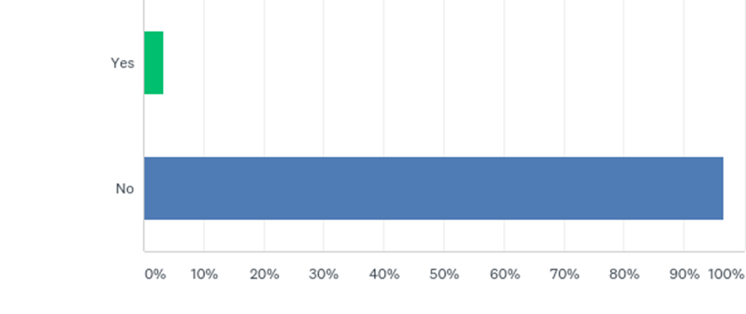

**Are there ads on functional items?**

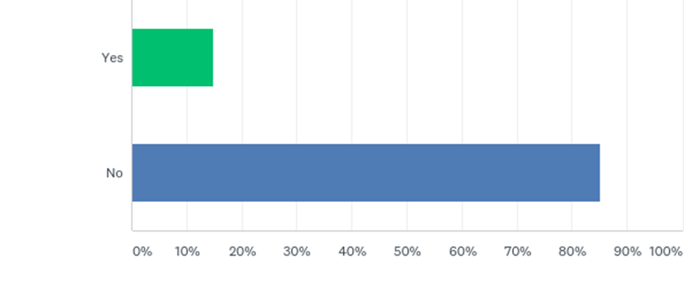

**Types of Ads Section**

**Special price Ad’s**

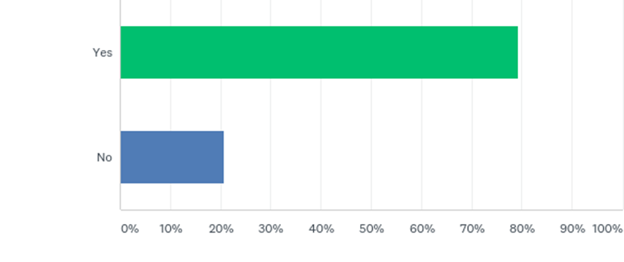

**Multi-Purchase Discounts**

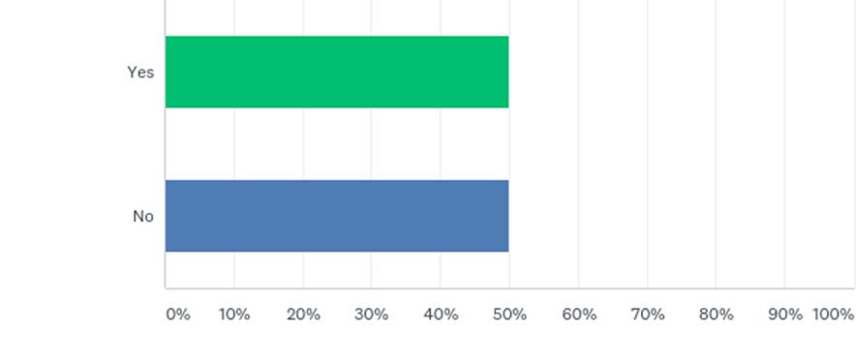

**Neon Signs**

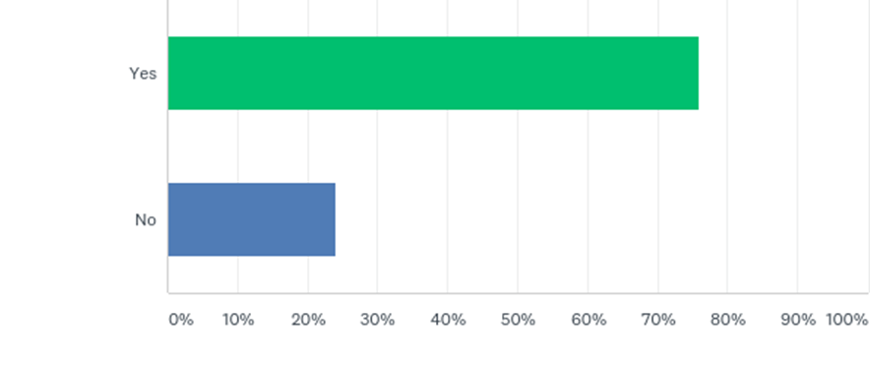

**Neon Signs – Visible from the Outside**

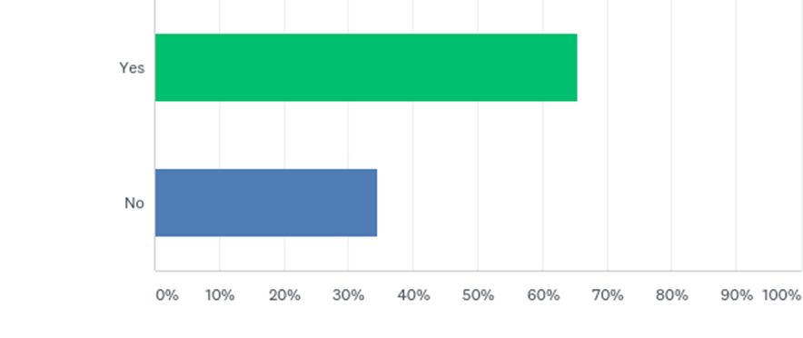

**Availability Questions**

**Single Units Sales**

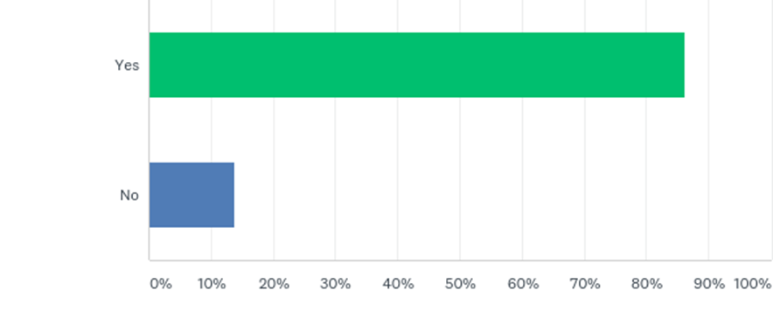

**Minor’s Signage**

**"no sale to minors" sign?**

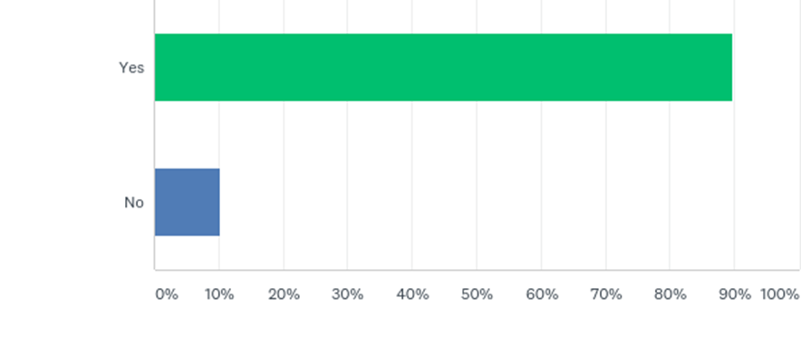

**Other Signage Relating to Identification**



**Purchase for Immediate Use**

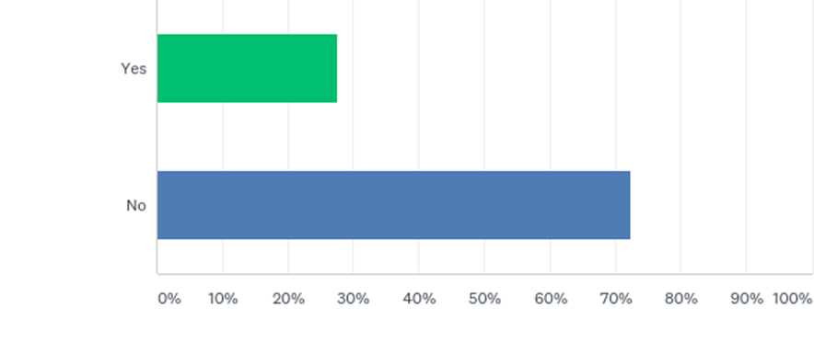

**Paraphernalia Items Visible**

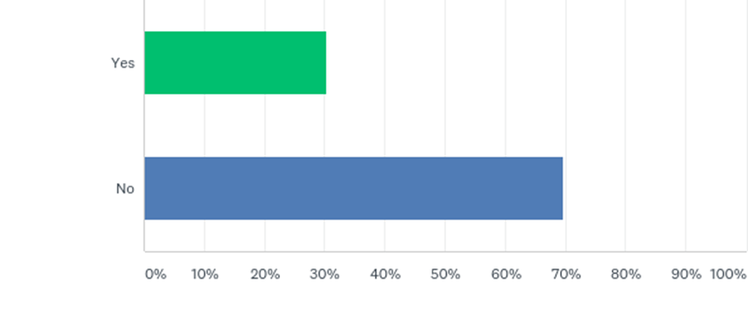

**Substances Available for Purchase**

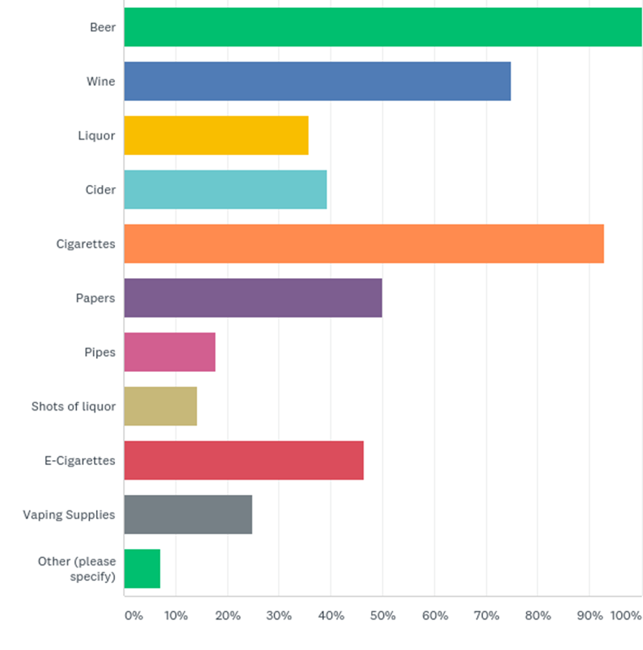

# Comments from Surveyors

“Upon visiting a gas station in Washington Court House, we encountered a large variety of drug paraphernalia. It was displayed in a glass case, in the front of store, by check-out, for convenient viewing and buying purposes. The store attendant was inquisitive as to what we were doing. The youth was carrying a clip board. I explained what our purpose was and he wanted to see the survey questions. I showed him the survey, he was ok with that and we proceeded out the door.”

“I was surprised at the number of individuals in the community doing the right thing! Many of the places we visited had We ID signs. For the most part, staff was helpful and appreciative of the work we are doing. Some clerks even posed for pictures with the youth.”

“The place that we visited did not have a bunch of ads. I had an assumption going into this project that items like rolling papers were widely available. I was happy to learn that they were not.”

To listen to more quotes and to see our debrief meeting, please visit our YouTube page at <https://www.youtube.com/watch?v=a_ODeT2bgXM&feature=youtu.be>.

# Fayette County Prevention Coalition Recommendations for Retailers

* Paraphernalia items should be behind the counter and not prominently displayed.
* All retailers should have signs stating that they ID and encourage others not to purchase alcohol for minors.
* Retailers should place alcohol where it can be closely monitored by staff.
* When all other factors were controlled, higher initial levels of drinking and excessive drinking were observed among youths residing in zip codes with higher alcohol outlet densities.
* The coalition is concerned with the ability of drive throughs to sell shots of liquor. Especially when in the proximity of the school.
* Retail Managers should train and stress the importance of checking identification. The earlier one access substances, the more likely they are to develop addiction.

**Locations Scanned**

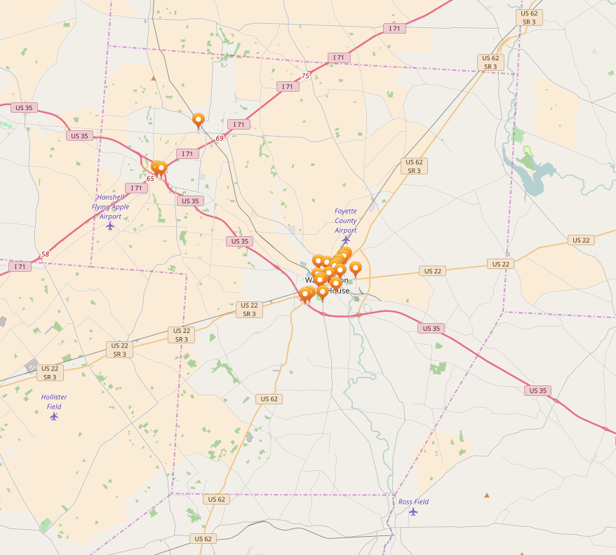

Map of Fayette County

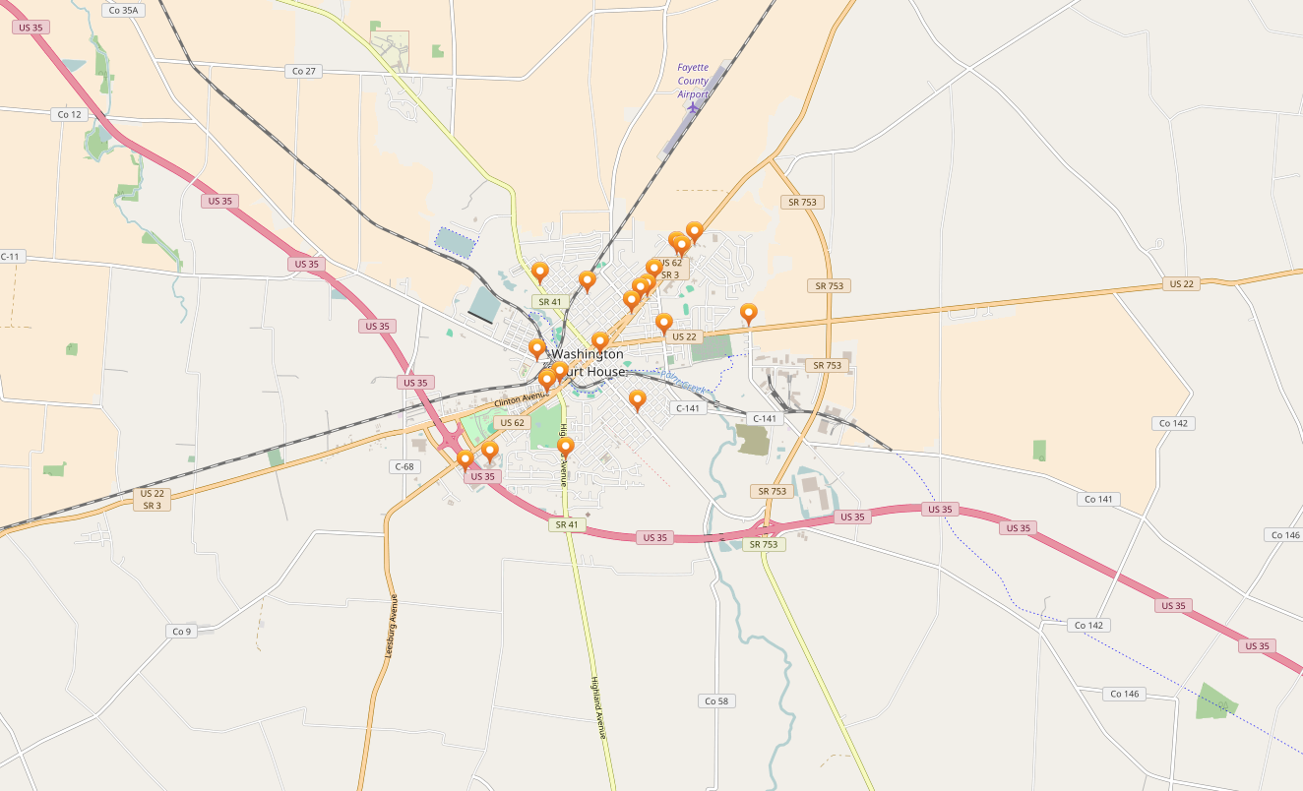

Map of Washington Court House