Region 16 Economic & Demographic Profile

Population Profile
Data Indicators
- Population Change  - Age and Gender Demographics  - Race Demographics  - Veterans, Age and Gender Demographics  - Poverty  - Poverty Rate Change | - Households in Poverty  - Poverty Rate (ACS)  - Families in Poverty by Family Type  - Family Poverty Rate by Family Type  - Poverty Rate Change (Age 0-17)  - Poverty Rate Change (Age 0-4) | - Poverty Rate Change (Age 5-17)  - Child Poverty Rate (ACS) Ages 0-17  - Child Poverty Rate (ACS) Ages 0-4  - Child Poverty Rate (ACS) Ages 5-17  - Seniors in Poverty

Population Change
Population change within the report area from 2000-2015 is shown below. During the fourteen-year period, total population estimates for the report area grew by 4.98 percent, increasing from 235,923 persons in 2000 to 247,680 persons in 2015.
Report Area Total Population, 2015 ACS Total Population, 2000 Census Population Change from 2000-2015 Census/ACS Percent Change from 2000-2015 Census/ACS  Report Area 247,680 235,923 11,757 4.98%  Clinton County, OH 41,892 40,543 1,349 3.33%  Fayette County, OH 28,769 28,433 336 1.18%  Highland County, OH 43,170 40,875 2,295 5.61%  Pickaway County, OH 56,515 52,727 3,788 7.18%  Ross County, OH 77,334 73,345 3,989 5.44%  Ohio 11,575,977 11,353,140 222,837 1.96%  United States 316,515,021 281,421,906 35,093,115 12.47%  Data Source: US Census Bureau, American Community Survey. US Census Bureau, Decennial Census. 2011-15. Source geography: County | Percent Change in Population  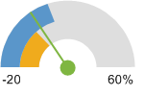  Report Area (4.98%)  Ohio (1.96%)  United States (12.47%)
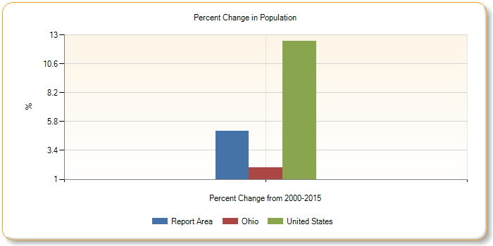
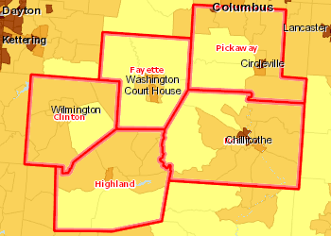 | Population, Density (Persons per Sq Mile) by Tract, ACS 2011-15  Over 5,000  1,001 - 5,000  501 - 1,000  51 - 500  Under 51  No Data or Data Suppressed  Report Area
Age and Gender Demographics
Population by gender within the report area is shown below. According to ACS 2011-2015 5 year population estimates for the report area, the female population comprised 49.1% of the report area, while the male population represented 50.9%.
Report Area | 0 to 4  Male | 0 to 4  Female | 5 to 17  Male | 5 to 17  Female | 18 to 64  Male | 18 to 64  Female | Over 64  Male | Over 64  Female
Report Area | 7,487 | 6,950 | 22,463 | 20,449 | 80,006 | 72,962 | 15,474 | 20,614
Clinton County, OH | 1,392 | 1,206 | 3,991 | 3,569 | 12,592 | 12,964 | 2,547 | 3,439
Fayette County, OH | 970 | 816 | 2,690 | 2,431 | 8,453 | 8,762 | 1,905 | 2,570
Highland County, OH | 1,374 | 1,325 | 4,134 | 3,712 | 12,609 | 12,877 | 2,975 | 3,948
Pickaway County, OH | 1,588 | 1,535 | 5,024 | 4,620 | 19,633 | 16,148 | 3,359 | 4,346
Ross County, OH | 2,163 | 2,068 | 6,624 | 6,117 | 26,719 | 22,211 | 4,688 | 6,311
Ohio | 356,598 | 339,398 | 1,002,343 | 957,680 | 3,551,864 | 3,620,813 | 671,470 | 995,193
United States | 10,175,713 | 9,736,305 | 27,479,063 | 26,292,744 | 98,539,826 | 99,675,893 | 17,538,907 | 25,075,799
Data Source: US Census Bureau, American Community Survey. 2011-15. Source geography: County
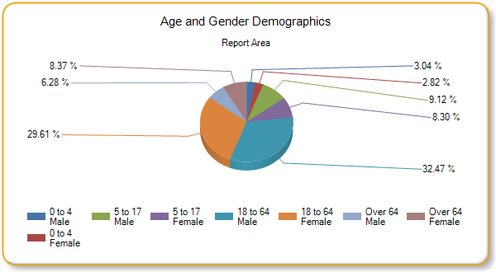
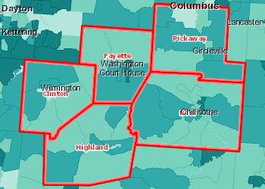 | Median Age by Tract, ACS 2011-15  Over 45.0  40.1 - 45.0  35.1 - 40.0  Under 35.1  No Data or Data Suppressed  Report Area

Adult Ages (18 - 65)
Report Area | 18 to 24  Male | 18 to 24  Female | 25 to 34  Male | 25 to 34  Female | 35 to 44  Male | 35 to 44  Female | 45 to 54  Male | 45 to 54  Female | 55 to 64  Male | 55 to 64  Female
Report Area | 11,271 | 9,770 | 15,957 | 13,805 | 17,471 | 15,395 | 18,947 | 17,356 | 16,360 | 16,636
Clinton County, OH | 2,022 | 2,011 | 2,332 | 2,423 | 2,495 | 2,612 | 2,943 | 3,024 | 2,800 | 2,894
Fayette County, OH | 1,115 | 1,084 | 1,617 | 1,683 | 1,823 | 1,802 | 2,051 | 2,102 | 1,847 | 2,091
Highland County, OH | 1,719 | 1,655 | 2,476 | 2,478 | 2,703 | 2,717 | 2,978 | 3,035 | 2,733 | 2,992
Pickaway County, OH | 3,045 | 2,168 | 4,153 | 3,019 | 4,425 | 3,633 | 4,444 | 3,815 | 3,566 | 3,513
Ross County, OH | 3,370 | 2,852 | 5,379 | 4,202 | 6,025 | 4,631 | 6,531 | 5,380 | 5,414 | 5,146
Ohio | 559,031 | 543,419 | 726,403 | 726,850 | 706,851 | 715,886 | 805,949 | 832,631 | 753,630 | 802,027
United States | 16,071,993 | 15,296,681 | 21,615,387 | 21,266,262 | 20,230,555 | 20,421,355 | 21,623,393 | 22,272,465 | 18,998,498 | 20,419,130
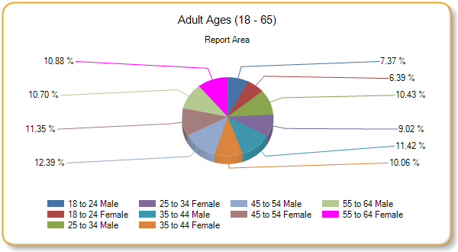
Hispanic Ages (Male and Female Combined)
Report Area | 0 to 4 | 5 to 17 | 18 to 24 | 25 to 34 | 35 to 44 | 45 to 54 | 55 to 64 | Over 65
Report Area | 356 | 861 | 407 | 469 | 435 | 307 | 104 | 211
Clinton County, OH | 39 | 254 | 62 | 62 | 177 | 27 | 15 | 36
Fayette County, OH | 68 | 132 | 21 | 118 | 75 | 73 | 33 | 6
Highland County, OH | 58 | 58 | 57 | 53 | 21 | 48 | 22 | 35
Pickaway County, OH | 138 | 119 | 140 | 151 | 102 | 58 | 3 | 13
Ross County, OH | 53 | 298 | 127 | 85 | 60 | 101 | 31 | 121
Ohio | 43,406 | 102,513 | 47,369 | 64,426 | 52,762 | 37,049 | 24,473 | 18,972
United States | 5,130,888 | 12,626,575 | 6,522,443 | 8,747,116 | 7,861,007 | 6,120,657 | 3,868,608 | 3,354,911
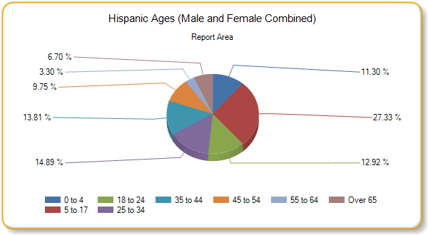
Race Demographics
Population by gender within the report area is shown below. According to ACS 2011-2015 5 year population estimates, the white population comprised 93.62% of the report area, black population represented 3.27%, and other races combined were 3.11%. Persons identifying themselves as mixed race made up 2.54% of the population.
Report Area | White  Total | Black  Total | American  Indian  Total | Asian  Total | Native  Hawaiian  Total | Mixed  Race  Total
Report Area | 231,301 | 8,069 | 334 | 1,035 | 35 | 6,277
Clinton County, OH | 39,655 | 1,040 | 38 | 121 | 0 | 914
Fayette County, OH | 27,181 | 554 | 32 | 186 | 0 | 630
Highland County, OH | 41,542 | 596 | 42 | 151 | 0 | 822
Pickaway County, OH | 53,064 | 1,837 | 185 | 166 | 1 | 1,204
Ross County, OH | 69,859 | 4,042 | 37 | 411 | 34 | 2,707
Ohio | 9,538,328 | 1,412,045 | 21,646 | 216,170 | 3,060 | 287,212
United States | 232,943,055 | 39,908,095 | 2,569,170 | 16,235,305 | 546,255 | 9,447,883
Data Source: US Census Bureau, American Community Survey. 2011-15. Source geography: County
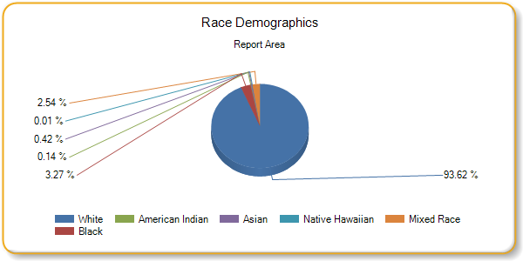
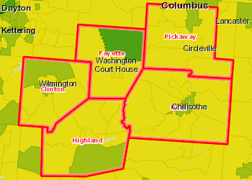 | Population, Minority (Non-White), Percent by Tract, ACS 2011-15  Over 10.0%  5.1 - 10.0%  2.1 - 5.0%  Under 2.1%  No Hispanic Population Reported  No Data or Data Suppressed  Report Area

Race Demographics - Male
Report Area | White  Male | Black  Male | American  Indian  Male | Asian  Total | Native  Hawaiian  Male | Mixed  Race  Male
Report Area | 116,072 | 5,982 | 150 | 429 | 7 | 3,680
Clinton County, OH | 19,568 | 541 | 14 | 54 | 0 | 453
Fayette County, OH | 13,348 | 299 | 32 | 68 | 0 | 323
Highland County, OH | 20,348 | 314 | 5 | 58 | 0 | 577
Pickaway County, OH | 27,233 | 1,650 | 66 | 84 | 0 | 786
Ross County, OH | 35,575 | 3,178 | 33 | 165 | 7 | 1,541
Ohio | 4,679,245 | 672,371 | 11,087 | 102,528 | 1,486 | 143,865
United States | 115,075,680 | 19,056,501 | 1,273,660 | 7,702,678 | 273,551 | 4,705,947

Ethnicity Demographics - Male
Report Area | Total Males Hispanic / Latino | Total Males Not Hispanic / Latino | Percent Males Hispanic / Latino | Percent Males Not Hispanic / Latino
Report Area | 1,999 | 124,706 | 1.58% | 98.42%
Clinton County, OH | 488 | 20,226 | 2.36% | 97.64%
Fayette County, OH | 287 | 13,903 | 2.02% | 97.98%
Highland County, OH | 248 | 21,060 | 1.16% | 98.84%
Pickaway County, OH | 456 | 29,410 | 1.53% | 98.47%
Ross County, OH | 520 | 40,107 | 1.28% | 98.72%
Ohio | 201,278 | 5,461,615 | 3.55% | 96.45%
United States | 27,444,307 | 128,289,973 | 17.62% | 82.38%
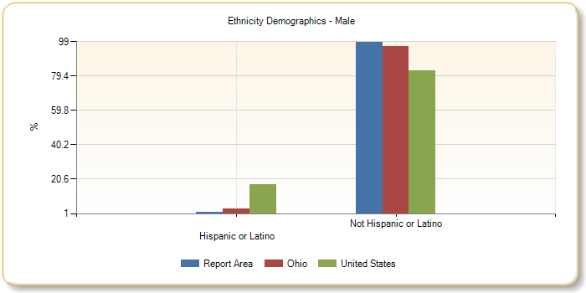
Race Demographics - Female
Report Area | White  Female | Black  Female | American  Indian  Female | Asian  Female | Native  Hawaiian  Female | Mixed  Race  Female
Report Area | 115,229 | 2,087 | 184 | 606 | 28 | 2,597
Clinton County, OH | 20,087 | 499 | 24 | 67 | 0 | 461
Fayette County, OH | 13,833 | 255 | 0 | 118 | 0 | 307
Highland County, OH | 21,194 | 282 | 37 | 93 | 0 | 245
Pickaway County, OH | 25,831 | 187 | 119 | 82 | 1 | 418
Ross County, OH | 34,284 | 864 | 4 | 246 | 27 | 1,166
Ohio | 4,859,083 | 739,674 | 10,559 | 113,642 | 1,574 | 143,347
United States | 117,867,375 | 20,851,594 | 1,295,510 | 8,532,627 | 272,704 | 4,741,936

Ethnicity Demographics - Female
Report Area | Total Females Hispanic / Latino | Total Females Not Hispanic / Latino | Percent Females Hispanic / Latino | Percent Females Not Hispanic / Latino
Report Area | 1,151 | 119,824 | 0.95% | 99.05%
Clinton County, OH | 184 | 20,994 | 0.87% | 99.13%
Fayette County, OH | 239 | 14,340 | 1.64% | 98.36%
Highland County, OH | 104 | 21,758 | 0.48% | 99.52%
Pickaway County, OH | 268 | 26,381 | 1.01% | 98.99%
Ross County, OH | 356 | 36,351 | 0.97% | 99.03%
Ohio | 189,692 | 5,723,392 | 3.21% | 96.79%
United States | 26,787,898 | 133,992,843 | 16.66% | 83.34%
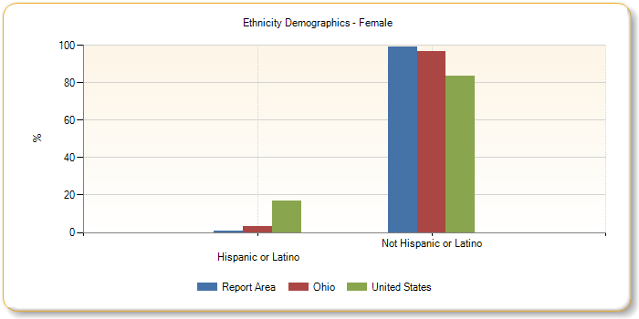
Veterans, Age and Gender Demographics
Veterans, Age and Gender Demographics show the number of veterans living in the report area. According to the American Community Survey (ACS), 10.24% of the adult population in the report area are veterans, which is more than the national average of 8.32%.
Report Area | Veterans  Total | Veterans  Male | Veterans  Female | % Pop over 18  Total | % Pop over 18  Males | % Pop over 18  Females
Report Area | 19,477 | 18,416 | 1,061 | 10.24% | 19.05% | 1.13%
Clinton County, OH | 3,292 | 3,116 | 176 | 10.37% | 20.32% | 1.07%
Fayette County, OH | 2,266 | 2,101 | 165 | 10.38% | 20.02% | 1.46%
Highland County, OH | 3,360 | 3,189 | 171 | 10.3% | 20.18% | 1.02%
Pickaway County, OH | 4,211 | 3,977 | 234 | 9.63% | 17.12% | 1.14%
Ross County, OH | 6,348 | 6,033 | 315 | 10.52% | 18.96% | 1.1%
Ohio | 806,531 | 754,674 | 51,857 | 9.05% | 17.56% | 1.12%
United States | 20,108,332 | 18,529,804 | 1,578,528 | 8.32% | 15.81% | 1.27%
Data Source: US Census Bureau, American Community Survey. 2011-15. Source geography: County
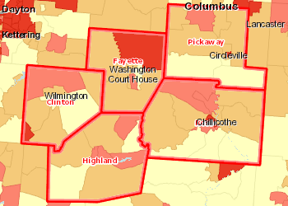 | Veterans, Percent of Total Population by Tract, ACS 2011-15  Over 13%  11.1 - 13.0%  9.1 - 11.0%  Under 9.1%  No Data or Data Suppressed  Report Area

Veterans by Age
Report Area | Veteran Age  Males  18-34 | Veteran Age  Females  18-34 | Veteran Age  Males  35-54 | Veteran Age  Females  35-54 | Veteran Age  Males  55-64 | Veteran Age  Females  55-64 | Veteran Age  Males  Over 65 | Veteran Age  Females  Over 65
Report Area | 965 | 106 | 5,177 | 533 | 4,139 | 269 | 8,135 | 153
Clinton County, OH | 243 | 37 | 945 | 68 | 723 | 28 | 1,205 | 43
Fayette County, OH | 155 | 28 | 592 | 63 | 406 | 31 | 948 | 43
Highland County, OH | 75 | 11 | 873 | 86 | 708 | 57 | 1,533 | 17
Pickaway County, OH | 169 | 21 | 970 | 185 | 994 | 24 | 1,844 | 4
Ross County, OH | 323 | 9 | 1,797 | 131 | 1,308 | 129 | 2,605 | 46
Ohio | 45,822 | 8,473 | 173,716 | 23,620 | 163,874 | 9,823 | 371,262 | 9,941
United States | 1,390,821 | 319,891 | 4,215,934 | 687,067 | 3,835,781 | 301,390 | 9,087,268 | 270,180
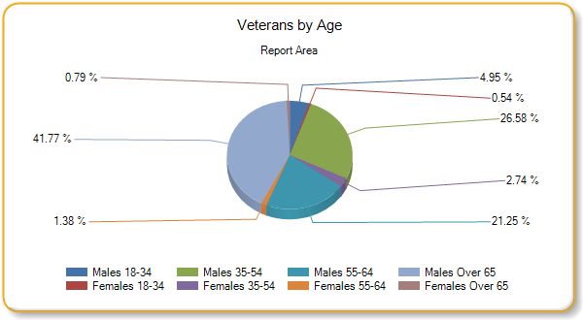

Poverty
2015 poverty estimates show a total of 36,828 persons living below the poverty level in the report area. Poverty information is at 100% of the federal poverty income guidelines
Report Area All Ages No of Persons All Ages Poverty Rate Age 0-17 No of Persons Age 0-17 Poverty Rate Age 5-17 No of Persons Age 5-17 Poverty Rate  Report Area 36,828 15.71% 12,961 22.60% 8,787 20.48%  Clinton County, OH 5,513 13.6% 2,051 21.1% 1,459 20.7%  Fayette County, OH 4,575 16.3% 1,743 26.2% 1,128 22.9%  Highland County, OH 7,598 17.9% 2,824 27.6% 1,914 25.2%  Pickaway County, OH 6,474 12.4% 2,150 17.6% 1,408 15.4%  Ross County, OH 12,668 17.8% 4,193 25.9% 2,878 23.9%  Ohio 3,340,968 14.79% 1,093,935 20.59% 730,942 18.65%  United States 46,153,077 14.70% 15,000,273 20.36% 10,245,028 19.05%  Data Source: US Census Bureau, Small Area Income Poverty Estimates. 2015. Source geography: County | All Ages  Poverty Rate  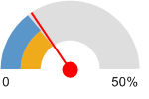  Report Area (15.71%)  Ohio (14.79%)  United States (14.70%)
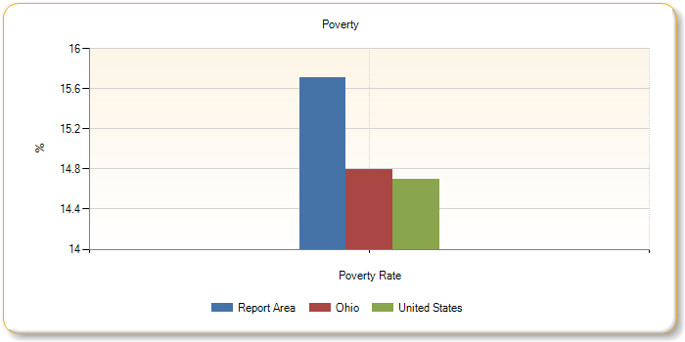
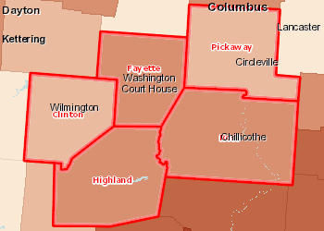 | Population Below the Poverty Level, Percent by County, SAIPE 2015  Over 22.0%  18.1 - 22.0%  15.1 - 18.0%  12.1 - 15.0%  Under 12.1%  Report Area

Poverty Rate Change
Poverty rate change in the report area from 2000 to 2015 is shown below. According to the U.S. Census, the poverty rate for the area increased by 4.96%, compared to a national increase of 3.4%.
Report Area Persons in Poverty 2000 Poverty Rate 2000 Persons in Poverty 2015 Poverty Rate 2015 Change in Poverty Rate 2000-2015  Report Area 24,116 10.75% 36,828 15.71% 4.96%  Clinton County, OH 3,370 8.4% 5,513 13.6% 5.2%  Fayette County, OH 2,775 10% 4,575 16.3% 6.3%  Highland County, OH 4,578 11.2% 7,598 17.9% 6.7%  Pickaway County, OH 4,555 9.8% 6,474 12.4% 2.6%  Ross County, OH 8,838 12.8% 12,668 17.8% 5%  Ohio 2,176,762 9.78% 3,340,968 14.79% 5.01%  United States 31,581,086 11.3% 46,153,077 14.7% 3.4%  Data Source: US Census Bureau, Small Area Income Poverty Estimates. 2015. Source geography: county | Change in Poverty Rate  2000-2015  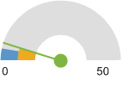  Report Area (4.96)  Ohio (5.01)  United States (3.4)
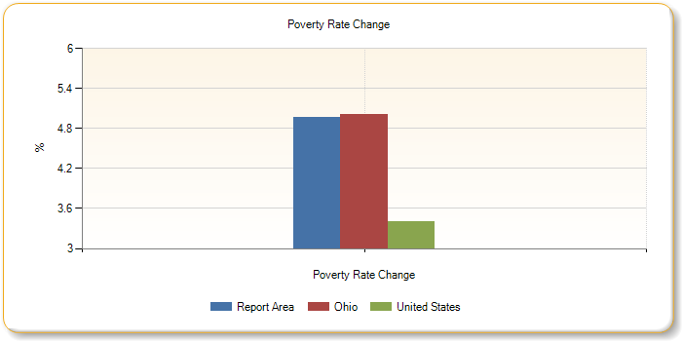
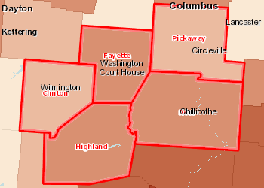 | Population Below the Poverty Level, Percent by County, SAIPE 2015  Over 22.0%  18.1 - 22.0%  15.1 - 18.0%  12.1 - 15.0%  Under 12.1%  Report Area

Households in Poverty
The number and percentage of households in poverty are shown in the report area. In 2015, it is estimated that there were 14,618 households, or 15.87%, living in poverty within the report area.
Report Area Total Households Households in Poverty Percent Households in Poverty  Report Area 92,087 14,618 15.87%  Clinton County, OH 16,073 2,512 15.6%  Fayette County, OH 11,589 2,015 17.4%  Highland County, OH 16,696 3,095 18.5%  Pickaway County, OH 19,460 2,233 11.5%  Ross County, OH 28,269 4,763 16.9%  Ohio 4,585,084 685,358 15%  United States 116,926,305 16,811,595 14.4%  Data Source: US Census Bureau, American Community Survey. 2011-15. Source geography: County | Percent Households  in Poverty  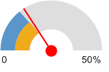  Report Area (15.87%)  Ohio (15%)  United States (14.4%)
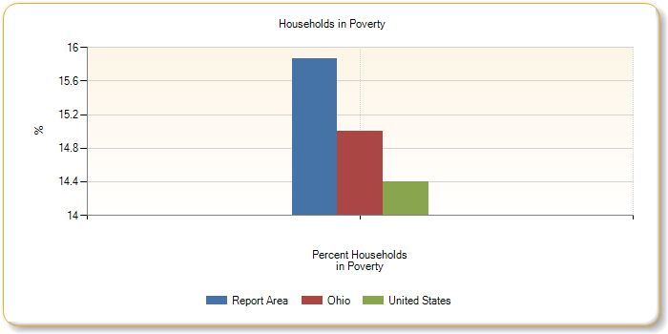
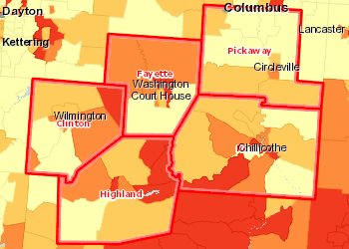 | Households Living Below the Poverty Level, Percent by Tract, ACS 2011-15  Over 20.0%  15.1 - 20.0%  10.1 - 15.0%  Under 10.1%  No Data or Data Suppressed  Report Area

Poverty Rate (ACS)
The following report section shows population estimates for all persons in poverty for report area. According to the American Community Survey 5 year estimates, an average of 17.27 percent of all persons lived in a state of poverty during the 2011 - 2015 period. The poverty rate for all persons living in the report area is greater than the national average of 15.47 percent.
Report Area Total Population Population in Poverty Percent Population in Poverty  Report Area 234,301 40,469 17.27%  Clinton County, OH 40,527 6,425 15.85%  Fayette County, OH 28,105 5,185 18.45%  Highland County, OH 42,574 8,604 20.21%  Pickaway County, OH 51,856 6,509 12.55%  Ross County, OH 71,239 13,746 19.3%  Ohio 11,258,461 1,775,836 15.77%  United States 308,619,550 47,749,043 15.47%  Data Source: US Census Bureau, American Community Survey. 2011-15. Source geography: Tract | Percent Population in Poverty  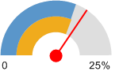  Report Area (17.27%)  Ohio (15.77%)  United States (15.47%)

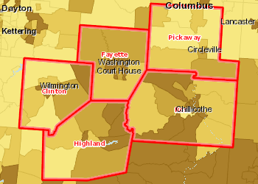 | Population Below the Poverty Level, Percent by Tract, ACS 2011-15  Over 20.0%  15.1 - 20.0%  10.1 - 15.0%  Under 10.1%  No Data or Data Suppressed  Report Area

Population in Poverty by Gender
Report Area | Total Male | Total Female | Percent Male | Percent Female
Report Area | 18,343 | 22,126 | 15.86% | 18.65%
Clinton County, OH | 3,000 | 3,425 | 14.92% | 16.77%
Fayette County, OH | 2,461 | 2,724 | 17.79% | 19.09%
Highland County, OH | 3,780 | 4,824 | 17.97% | 22.39%
Pickaway County, OH | 3,040 | 3,469 | 11.84% | 13.25%
Ross County, OH | 6,062 | 7,684 | 17.32% | 21.2%
Ohio | 791,554 | 984,282 | 14.42% | 17.06%
United States | 21,410,511 | 26,338,532 | 14.18% | 16.71%
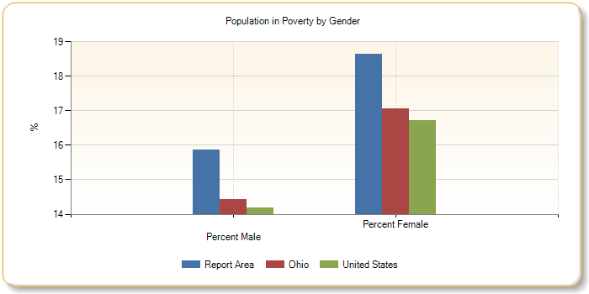
Population in Poverty by Ethnicity Alone
Report Area | Total Hispanic / Latino | Total Not Hispanic / Latino | Percent Hispanic / Latino | Percent Not Hispanic / Latino
Report Area | 789 | 39,680 | 28.62% | 17.14%
Clinton County, OH | 251 | 6,174 | 39.34% | 15.48%
Fayette County, OH | 271 | 4,914 | 52.62% | 17.81%
Highland County, OH | 79 | 8,525 | 22.83% | 20.19%
Pickaway County, OH | 104 | 6,405 | 18.98% | 12.48%
Ross County, OH | 84 | 13,662 | 11.83% | 19.37%
Ohio | 106,544 | 1,669,292 | 28.12% | 15.34%
United States | 12,915,617 | 34,833,426 | 24.3% | 13.63%
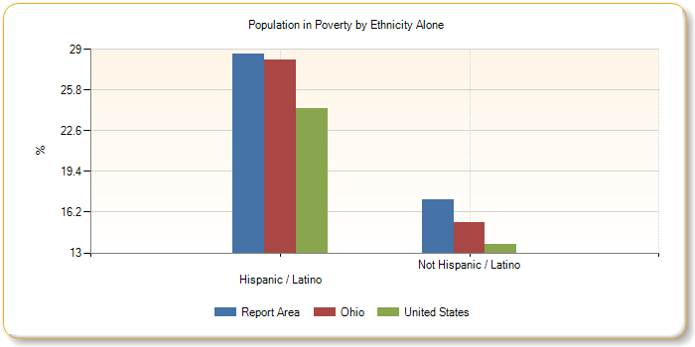
Population in Poverty Race Alone, Percent
Report Area | White | Black or African American | Native American / Alaska Native | Asian | Native Hawaiian / Pacific Islander | Some Other Race | Multiple Race
Report Area | 16.69% | 32.28% | 41.47% | 14.07% | 51.43% | 50.54% | 24.7%
Clinton County, OH | 15.13% | 30.94% | 15.79% | 20.91% | no data | 74.19% | 23.78%
Fayette County, OH | 18.03% | 23.75% | 53.13% | 5.38% | no data | 62.37% | 21.25%
Highland County, OH | 19.79% | 28.8% | 11.9% | 38.41% | no data | 0% | 33.68%
Pickaway County, OH | 12.49% | 28.07% | 50.91% | 2.56% | 0% | 0% | 6.91%
Ross County, OH | 18.32% | 36.38% | 54.55% | 11.58% | 52.94% | 39.89% | 30.3%
Ohio | 12.6% | 34.16% | 29.54% | 12.91% | 25.28% | 27.58% | 29.96%
United States | 12.7% | 27% | 28.3% | 12.57% | 20.96% | 26.53% | 19.94%
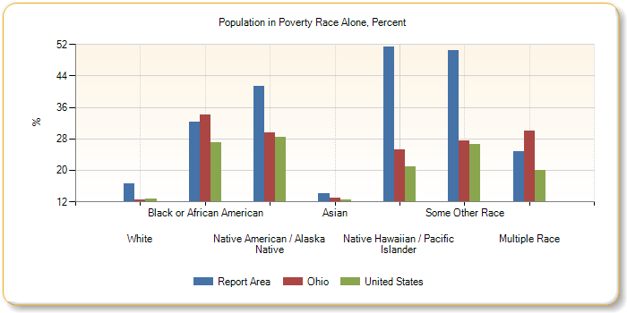
Population in Poverty by Race Alone, Total
Report Area | White | Black or African American | Native American / Alaska Native | Asian | Native Hawaiian / Pacific Islander | Some Other Race | Multiple Race
Report Area | 37,130 | 1,380 | 124 | 142 | 18 | 283 | 1,392
Clinton County, OH | 5,828 | 276 | 6 | 23 | 0 | 92 | 200
Fayette County, OH | 4,795 | 114 | 17 | 10 | 0 | 116 | 133
Highland County, OH | 8,122 | 161 | 5 | 58 | 0 | 0 | 258
Pickaway County, OH | 6,273 | 80 | 84 | 4 | 0 | 0 | 68
Ross County, OH | 12,112 | 749 | 12 | 47 | 18 | 75 | 733
Ohio | 1,172,207 | 461,129 | 6,103 | 27,017 | 744 | 25,973 | 82,663
United States | 28,923,918 | 10,321,254 | 702,127 | 2,000,884 | 111,137 | 3,865,363 | 1,824,360
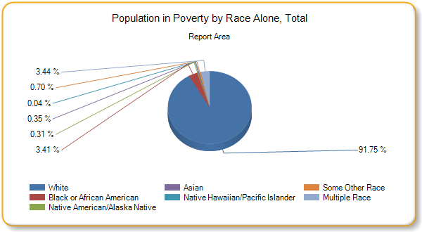
Families in Poverty by Family Type
The number of families in poverty by type are shown in the report area. According to ACS 2011-2015 5 year estimates for the report area, there were 8,548 families living in poverty.
Report Area | Total Families | Families in Poverty  Total | Families in Poverty  Married Couples | Families in Poverty  Male Householder | Families in Poverty  Female Householder
Report Area | 63,774 | 8,548 | 3,134 | 891 | 4,523
Clinton County, OH | 11,097 | 1,437 | 510 | 175 | 752
Fayette County, OH | 7,669 | 1,189 | 432 | 138 | 619
Highland County, OH | 11,239 | 1,796 | 729 | 225 | 842
Pickaway County, OH | 14,161 | 1,373 | 527 | 103 | 743
Ross County, OH | 19,608 | 2,753 | 936 | 250 | 1,567
Ohio | 2,937,598 | 338,872 | 99,139 | 37,775 | 201,958
United States | 77,260,546 | 8,761,164 | 3,171,327 | 941,758 | 4,648,079
Data Source: US Census Bureau, American Community Survey. 2011-15. Source geography: County
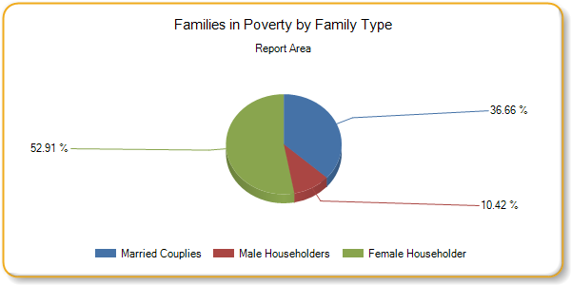
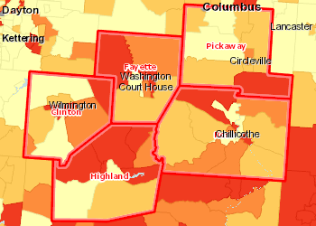 | Married Family Households Living Below the Poverty Level, Percent by Tract, ACS 2011-15  Over 9.0%  6.1 - 9.0%  3.1 - 6.0%  Under 3.1%  No Married Families Reported  No Data or Data Suppressed  Report Area

Family Poverty Rate by Family Type
The percentage of households in poverty by household type are shown for the report area. It is estimated that 13.4% of all households were living in poverty within the report area, compared to the national average of 11.3%. Of the households in poverty, female headed households represented 7.1% of all households in poverty, compared to 4.9% and 1.4% of households headed by males and married couples, respectively.
Report Area Poverty Rate All Types Percent of Poverty Married Couples Percent of Poverty Male Householder Percent of Poverty Female Householder  Report Area 13.4% 4.9% 1.4% 7.1%  Clinton County, OH 12.9% 35.5% 12.2% 52.3%  Fayette County, OH 15.5% 36.3% 11.6% 52.1%  Highland County, OH 16% 40.6% 12.5% 46.9%  Pickaway County, OH 9.7% 38.4% 7.5% 54.1%  Ross County, OH 14% 34% 9.1% 56.9%  Ohio 11.5% 29.3% 11.1% 59.6%  United States 11.3% 36.2% 10.7% 53.1%  Data Source: US Census Bureau, American Community Survey. 2011-15. Source geography: County | Percent of Poverty  Female Householder  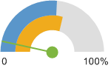  Report Area (7.1%)  Ohio (59.6%)  United States (53.1%)
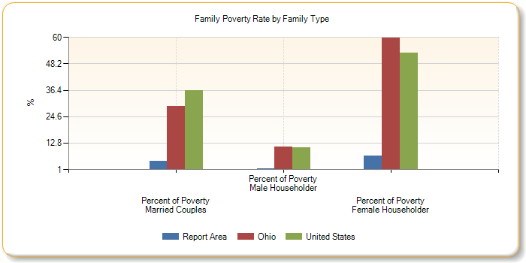
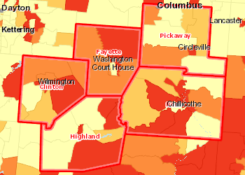 | Single Parent Family Households Living Below the Poverty Level, Percent by Tract, ACS 2011-15  Over 37.0%  30.1 - 37.0%  23.1 - 30.0%  Under 23.1%  No 1 Parent Households Reported  No Data or Data Suppressed  Report Area

Poverty Rate Change (Age 0-17)
The poverty rate change for all children in the report area from 2000 to 2015 is shown below. According to the U.S. Census, the poverty rate for the area increased by 8.7%, compared to a national increase of 4.5%.
Report Area Poverty Age 0-17 2000 Poverty Rate Age 0-17 2000 Poverty Age 0-17 2015 Poverty Rate Age 0-17 2015 Difference in Rate Age 0-17 2000 - 2015  Report Area 8,666 14.9% 12,961 23.6% 8.7%  Clinton County, OH 1,238 11.7% 2,051 21.1% 9.4%  Fayette County, OH 1,010 14.5% 1,743 26.2% 11.7%  Highland County, OH 1,813 16.8% 2,824 27.6% 10.8%  Pickaway County, OH 1,640 13.2% 2,150 17.6% 4.4%  Ross County, OH 2,965 17.1% 4,193 25.9% 8.8%  Ohio 800,882 14.1% 1,093,935 21.2% 7.1%  United States 34,759,369 16.2% 44,997,842 20.7% 4.5%  Data Source: US Census Bureau, Small Area Income Poverty Estimates. 2015. Source geography: County | Poverty Rate Change Age 0-17  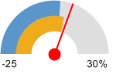  Report Area (8.7%)  Ohio (7.1%)  United States (4.5%)
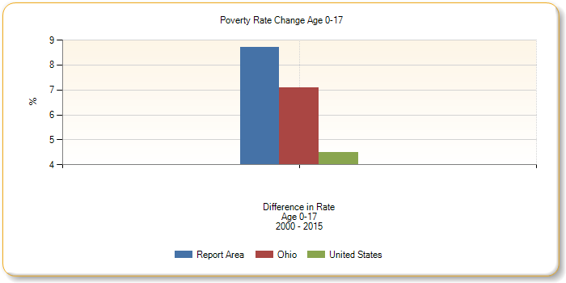
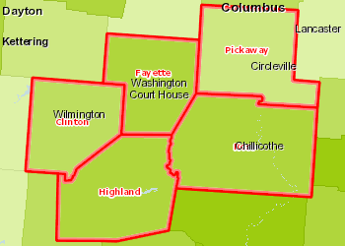 | Population Below the Poverty Level, Children (Age 0-18), Percent by County, SAIPE 2015  Over 30.0%  25.1 - 30.0%  10.1 - 25.0%  15.1 - 20.0%  Under 15.1%  Report Area

Poverty Rate Change (Age 0-4)
The poverty rate change for all children (age 0 - 4) in the report area from 2000 to 2015 is shown below. The U.S. Census Bureau's Small Area Income and Poverty Estimates only calculates poverty for this age on the state and national levels. The national poverty rate change for this age group increased by 4.1% over the described time period.
Report Area Poverty Age 0-4 2000 Poverty Rate Age 0-4 2000 Poverty Age 0-4 2015 Poverty Rate Age 0-4 2015 Difference in Rate Age 0-4 2000 - 2015  Report Area no data no data no data no data no data  Clinton County, OH no data no data no data no data no data  Fayette County, OH no data no data no data no data no data  Highland County, OH no data no data no data no data no data  Pickaway County, OH no data no data no data no data no data  Ross County, OH no data no data no data no data no data  Ohio 143,552 19.2% 170,403 25.1% 5.9%  United States 7,166,195 18.7% 8,896,424 22.8% 4.1%  Data Source: US Census Bureau, Small Area Income Poverty Estimates. 2015. Source geography: State | Poverty Rate Change Age 0-4  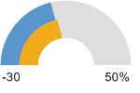  Ohio (5.9%)  United States (4.1%)
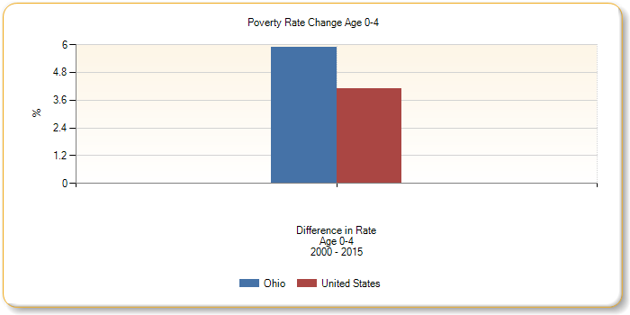
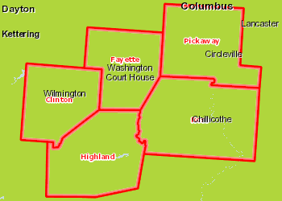 | Population Below the Poverty Level, Children (Age 0-4), Percent by State, SAIPE 2015  Over 30.0%  25.1 - 30.0%  10.1 - 25.0%  15.1 - 20.0%  Under 15.1%  Report Area

Poverty Rate Change (Age 5-17)
The poverty rate change for all children in the report area from 2000 to 2015 is shown below. According to the U.S. Census, the poverty rate for the area increased by 9% , compared to a national increase of 4.9%.
Report Area Poverty Age 5-17 2000 Poverty Rate Age 5-17 2000 Poverty Age 5-17 2015 Poverty Rate Age 5-17 2015 Difference in Rate Age 5-17 2000 - 2015  Report Area 5,290 12.6% 8,787 21.6% 9%  Clinton County, OH 765 10.1% 1,459 20.7% 10.6%  Fayette County, OH 606 12.1% 1,128 22.9% 10.8%  Highland County, OH 1,125 14.4% 1,914 25.2% 10.8%  Pickaway County, OH 1,032 11.4% 1,408 15.4% 4%  Ross County, OH 1,762 14% 2,878 23.9% 9.9%  Ohio 479,422 11.7% 730,942 19.3% 7.6%  United States 22,608,374 14.6% 30,733,123 19.5% 4.9%  Data Source: US Census Bureau, Small Area Income Poverty Estimates. 2015. Source geography: County | Poverty Rate Change Age5-17  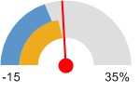  Report Area (9%)  Ohio (7.6%)  United States (4.9%)
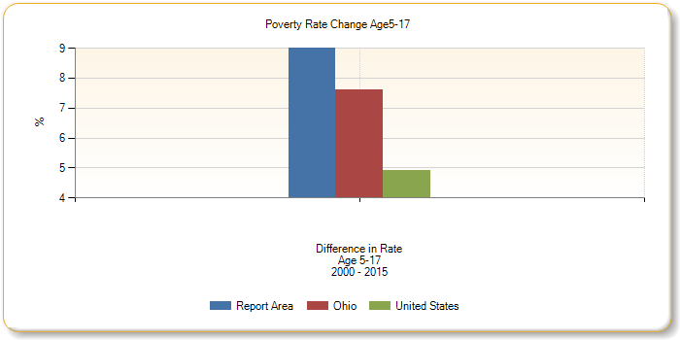
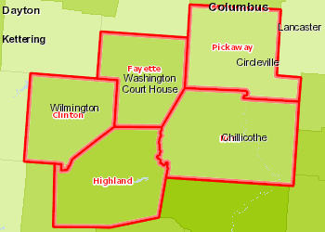 | Population Below the Poverty Level, Children (Age 5-17), Percent by County, SAIPE 2015  Over 30.0%  25.1 - 30.0%  10.1 - 25.0%  15.1 - 20.0%  Under 15.1%  Report Area

Child Poverty Rate (ACS) Ages 0-17
Population and poverty estimates for children age 0-17 are shown for the report area. According to the American Community Survey 5 year data, an average of 25% percent of children lived in a state of poverty during the survey calendar year. The poverty rate for children living in the report area is greater than the national average of 21.7 percent.
Report Area Ages 0-17 Total Population Ages 0-17 In Poverty Ages 0-17 Poverty Rate  Report Area 55,913 13,966 25%  Clinton County, OH 9,958 2,163 21.7%  Fayette County, OH 6,704 1,878 28%  Highland County, OH 10,365 3,050 29.4%  Pickaway County, OH 12,295 2,236 18.2%  Ross County, OH 16,591 4,639 28%  Ohio 2,611,137 595,193 22.8%  United States 72,540,829 15,760,766 21.7%  Data Source: US Census Bureau, American Community Survey. 2011-15. Source geography: County | Ages 0-17 Poverty Rate  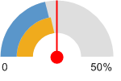  Report Area (25%)  Ohio (22.8%)  United States (21.7%)
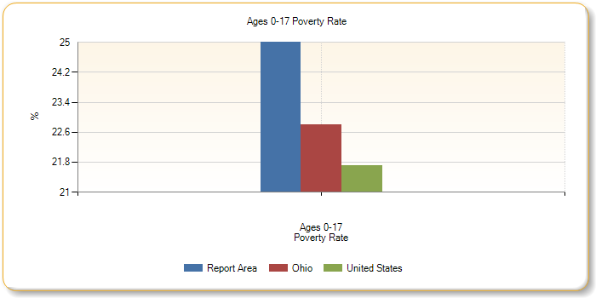
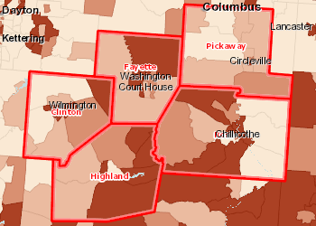 | Population Below the Poverty Level, Children (Age 0-17), Percent by Tract, ACS 2011-15  Over 30.0%  22.6 - 30.0%  15.1 - 22.5%  Under 15.1%  No Population Age 0-17 Reported  No Data or Data Suppressed  Report Area

Children in Poverty by Gender: Age 0 - 17
Report Area | Total Male | Total Female | Percent Male | Percent Female
Report Area | 7,522 | 6,444 | 25.91% | 23.97%
Clinton County, OH | 1,209 | 954 | 22.97% | 20.32%
Fayette County, OH | 1,042 | 836 | 29.38% | 26.48%
Highland County, OH | 1,582 | 1,468 | 29.35% | 29.51%
Pickaway County, OH | 1,373 | 863 | 21.72% | 14.44%
Ross County, OH | 2,316 | 2,323 | 27.22% | 28.74%
Ohio | 303,506 | 291,687 | 22.74% | 22.86%
United States | 8,006,400 | 7,754,366 | 21.61% | 21.85%
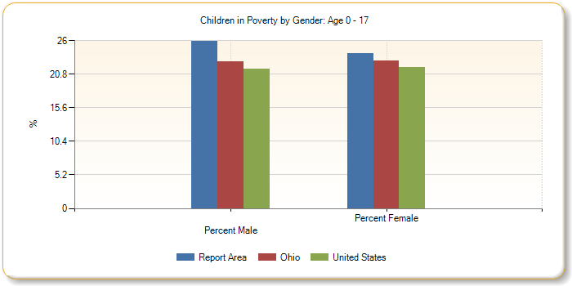
Children in Poverty by Ethnicity Alone: Age 0 - 17
Report Area | Total Hispanic / Latino | Total Not Hispanic / Latino | Percent Hispanic / Latino | Percent Not Hispanic or Latino
Report Area | 342 | 13,624 | 28.45% | 24.9%
Clinton County, OH | 130 | 2,033 | 44.37% | 21.03%
Fayette County, OH | 152 | 1,726 | 80.42% | 26.49%
Highland County, OH | 9 | 3,041 | 7.76% | 29.67%
Pickaway County, OH | 40 | 2,196 | 15.69% | 18.24%
Ross County, OH | 11 | 4,628 | 3.15% | 28.49%
Ohio | 51,322 | 543,871 | 35.83% | 22.04%
United States | 5,646,834 | 10,113,932 | 32.29% | 18.37%
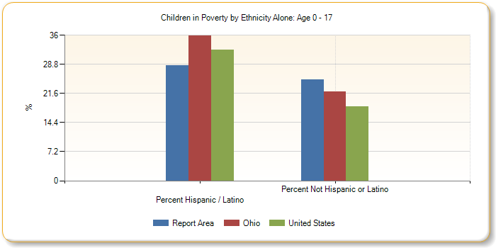
Children in Poverty by Race Alone, Percent: Age 0 - 17
Report Area | Non-Hispanic White | Black or African American | Native American / Alaska Native | Asian | Native Hawaiian / Pacific Islander | Some Other Race | Multiple Race
Report Area | 24.22% | 41.1% | 100% | 15.98% | no data | 75.35% | 28.36%
Clinton County, OH | 20.34% | 29.71% | no data | 35.29% | no data | 100% | 26.42%
Fayette County, OH | 26.41% | 44.44% | no data | 0% | no data | 82.08% | 29.28%
Highland County, OH | 28.99% | 16.79% | no data | 45.24% | no data | no data | 48.32%
Pickaway County, OH | 19.03% | 10.61% | 100% | 0% | no data | 0% | 3.59%
Ross County, OH | 26.52% | 63.91% | no data | 0% | no data | 45.24% | 35.45%
Ohio | 16.37% | 48.65% | 36.32% | 9.94% | 36.55% | 34.95% | 34.84%
United States | 13.07% | 38.31% | 36.05% | 12.9% | 28.12% | 35.88% | 22.39%
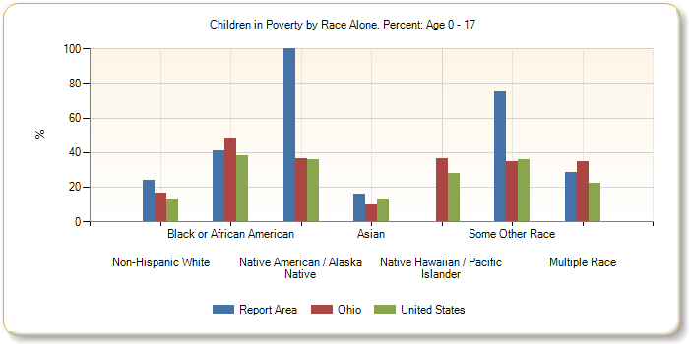
Children in Poverty by Race Alone, Total: Age 0 - 17
Report Area | Non-Hispanic White | Black or African American | Native American / Alaska Native | Asian | Native Hawaiian / Pacific Islander | Some Other Race | Multiple Race
Report Area | 12,349 | 344 | 16 | 31 | 0 | 162 | 899
Clinton County, OH | 1,807 | 71 | 0 | 12 | 0 | 56 | 144
Fayette County, OH | 1,592 | 28 | 0 | 0 | 0 | 87 | 106
Highland County, OH | 2,842 | 22 | 0 | 19 | 0 | 0 | 158
Pickaway County, OH | 2,184 | 7 | 16 | 0 | 0 | 0 | 22
Ross County, OH | 3,924 | 216 | 0 | 0 | 0 | 19 | 469
Ohio | 313,223 | 182,719 | 1,509 | 4,754 | 269 | 10,876 | 51,928
United States | 4,946,654 | 3,928,519 | 251,937 | 432,552 | 41,057 | 1,615,988 | 970,189
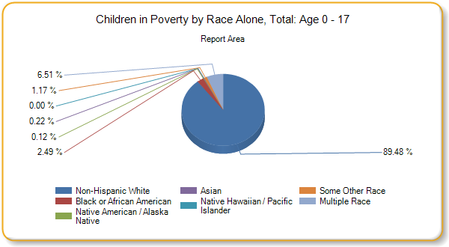
Child Poverty Rate (ACS) Ages 0-4
Population and poverty estimates for children age 0-4 are shown for the report area. According to the American Community Survey 5 year data, an average of 29.1% percent of children lived in a state of poverty during the survey calendar year. The poverty rate for children living in the report area is greater than the national average of 24.5 percent.
Report Area Ages 0-4 Total Population Ages 0-4 In Poverty Ages 0-4 Poverty Rate  Report Area 13,924 4,048 29.1%  Clinton County, OH 2,493 686 27.5%  Fayette County, OH 1,762 644 36.5%  Highland County, OH 2,619 873 33.3%  Pickaway County, OH 3,008 628 20.9%  Ross County, OH 4,042 1,217 30.1%  Ohio 685,110 186,775 27.3%  United States 19,605,884 4,795,039 24.5%  Data Source: US Census Bureau, American Community Survey. 2011-15. Source geography: County | Ages 0-4 Poverty Rate  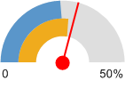  Report Area (29.1%)  Ohio (27.3%)  United States (24.5%)
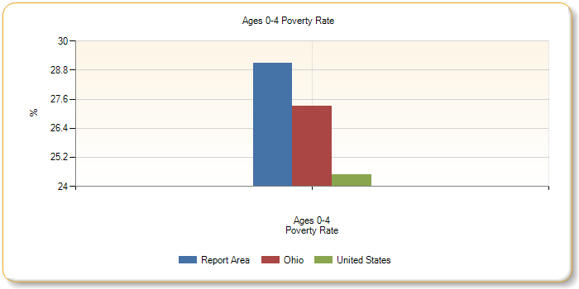
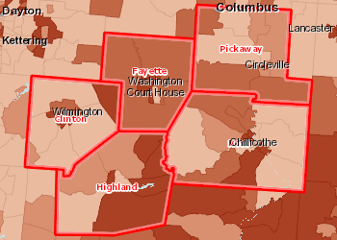 | Population Below the Poverty Level, Children (Age 0-4), Percent by Tract, ACS 2011-15  Over 37.0%  27.1 - 37.0%  17.1 - 27.0%  Under 17.1%  No Population Age 0-4 Reported  No Data or Data Suppressed  Report Area
Children in Poverty by Gender: Age 0 - 4
Report Area | Total Male | Total Female | Percent Male | Percent Female
Report Area | 2,174 | 1,874 | 30.56% | 27.52%
Clinton County, OH | 304 | 382 | 23.46% | 31.91%
Fayette County, OH | 405 | 239 | 42.5% | 29.54%
Highland County, OH | 469 | 404 | 35.26% | 31.34%
Pickaway County, OH | 416 | 212 | 27.12% | 14.38%
Ross County, OH | 580 | 637 | 28.99% | 31.21%
Ohio | 96,026 | 90,749 | 27.38% | 27.14%
United States | 2,442,509 | 2,352,530 | 24.38% | 24.54%
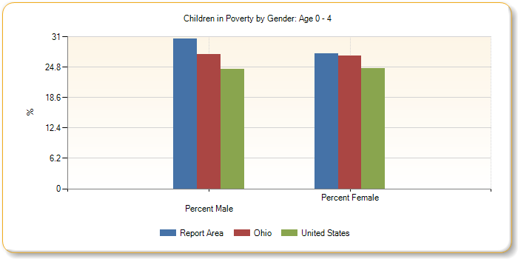
Children in Poverty by Ethnicity Alone: Age 0 - 4
Report Area | Total Hispanic / Latino | Total Not Hispanic / Latino | Percent Hispanic / Latino | Percent Not Hispanic or Latino
Report Area | 86 | 3,962 | 24.16% | 29.2%
Clinton County, OH | 11 | 675 | 28.21% | 27.51%
Fayette County, OH | 58 | 586 | 85.29% | 34.59%
Highland County, OH | 0 | 873 | 0% | 34.09%
Pickaway County, OH | 17 | 611 | 12.32% | 21.29%
Ross County, OH | 0 | 1,217 | 0% | 30.51%
Ohio | 17,276 | 169,499 | 40.42% | 26.39%
United States | 1,754,438 | 3,040,601 | 34.77% | 20.88%
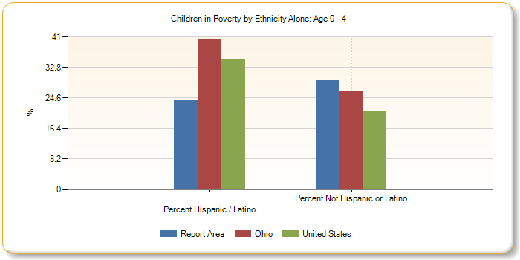
Children in Poverty by Race Alone, Percent: Age 0 - 4
Report Area | Non-Hispanic White | Black or African American | Native American / Alaska Native | Asian | Native Hawaiian / Pacific Islander | Some Other Race | Multiple Race
Report Area | 27.95% | 49.76% | no data | 25.93% | no data | 80.85% | 38.8%
Clinton County, OH | 26.23% | 52.56% | no data | no data | no data | no data | 34.78%
Fayette County, OH | 33.71% | 100% | no data | 0% | no data | 76.32% | 50%
Highland County, OH | 31.82% | 12.9% | no data | 100% | no data | no data | 75%
Pickaway County, OH | 21.98% | 100% | no data | no data | no data | no data | 8.85%
Ross County, OH | 28.45% | 73.33% | no data | 0% | no data | 100% | 43.5%
Ohio | 19.47% | 56.12% | 31.04% | 10.33% | 49.07% | 40.63% | 40.84%
United States | 14.9% | 43.46% | 40.83% | 12.19% | 30.61% | 38.48% | 24.88%
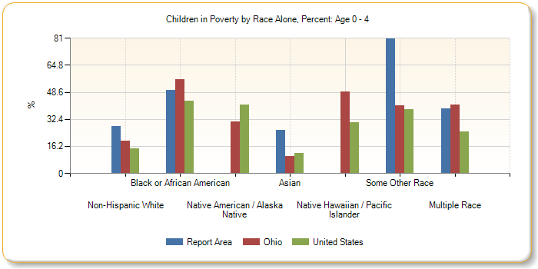
Children in Poverty by Race Alone, Total: Age 0 - 4
Report Area | Non-Hispanic White | Black or African American | Native American / Alaska Native | Asian | Native Hawaiian / Pacific Islander | Some Other Race | Multiple Race
Report Area | 3,544 | 102 | 0 | 14 | 0 | 38 | 310
Clinton County, OH | 602 | 41 | 0 | 0 | 0 | 0 | 32
Fayette County, OH | 531 | 13 | 0 | 0 | 0 | 29 | 42
Highland County, OH | 776 | 8 | 0 | 14 | 0 | 0 | 75
Pickaway County, OH | 604 | 7 | 0 | 0 | 0 | 0 | 17
Ross County, OH | 1,031 | 33 | 0 | 0 | 0 | 9 | 144
Ohio | 94,520 | 57,695 | 266 | 1,318 | 79 | 3,491 | 19,812
United States | 1,460,186 | 1,197,280 | 74,554 | 109,637 | 11,980 | 488,524 | 351,121
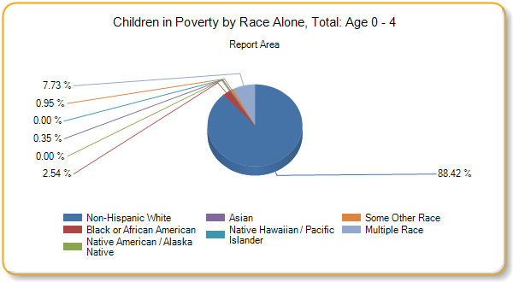
Child Poverty Rate (ACS) Ages 5-17
Population and poverty estimates for children age 5-17 are shown for the report area. According to the American Community Survey 5 year data, an average of 23.6% percent of children lived in a state of poverty during the survey calendar year. The poverty rate for children living in the report area is greater than the national average of 20.7 percent.
Report Area Ages 5-17 Total Population Ages 5-17 In Poverty Ages 5-17 Poverty Rate  Report Area 41,989 9,918 23.6%  Clinton County, OH 7,465 1,477 19.8%  Fayette County, OH 4,942 1,234 25%  Highland County, OH 7,746 2,177 28.1%  Pickaway County, OH 9,287 1,608 17.3%  Ross County, OH 12,549 3,422 27.3%  Ohio 1,926,027 408,418 21.2%  United States 52,934,945 10,965,727 20.7%  Data Source: US Census Bureau, American Community Survey. 2011-15. Source geography: County | Ages 5-17 Poverty Rate  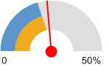  Report Area (23.6%)  Ohio (21.2%)  United States (20.7%)
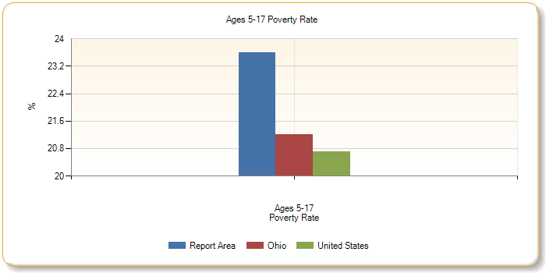
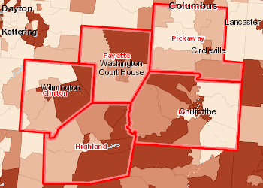 | Population Below the Poverty Level, Children (Age 5-17), Percent by Tract, ACS 2011-15  Over 29.0%  21.1 - 29.0%  13.1 - 21.0%  Under 13.1%  No Population Age 5-17 Reported  No Data or Data Suppressed  Report Area

Children in Poverty by Gender: Age 5 - 17
Report Area | Total Male | Total Female | Percent Male | Percent Female
Report Area | 5,348 | 4,570 | 24.4% | 22.77%
Clinton County, OH | 905 | 572 | 22.81% | 16.36%
Fayette County, OH | 637 | 597 | 24.56% | 25.43%
Highland County, OH | 1,113 | 1,064 | 27.41% | 28.87%
Pickaway County, OH | 957 | 651 | 20% | 14.46%
Ross County, OH | 1,736 | 1,686 | 26.68% | 27.9%
Ohio | 207,480 | 200,938 | 21.08% | 21.33%
United States | 5,563,891 | 5,401,836 | 20.58% | 20.85%
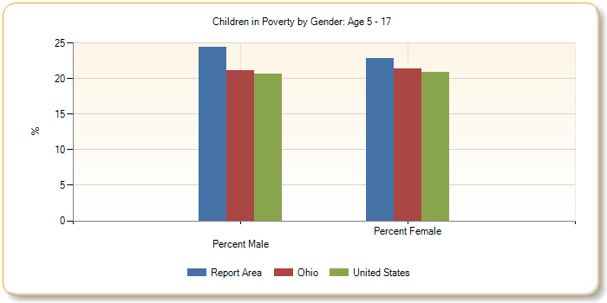
Children in Poverty by Ethnicity Alone: Age 5 - 17
Report Area | Total Hispanic / Latino | Total Not Hispanic / Latino | Percent Hispanic / Latino | Percent Not Hispanic or Latino
Report Area | 256 | 9,662 | 30.26% | 23.48%
Clinton County, OH | 119 | 1,358 | 46.85% | 18.83%
Fayette County, OH | 94 | 1,140 | 77.69% | 23.65%
Highland County, OH | 9 | 2,168 | 15.52% | 28.2%
Pickaway County, OH | 23 | 1,585 | 19.66% | 17.28%
Ross County, OH | 11 | 3,411 | 3.72% | 27.84%
Ohio | 34,046 | 374,372 | 33.88% | 20.51%
United States | 3,892,396 | 7,073,331 | 31.29% | 17.47%
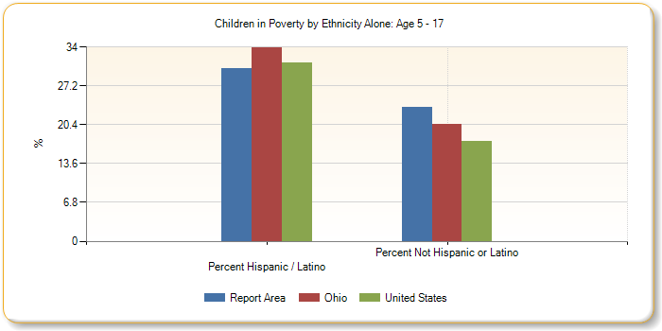
Children in Poverty by Race Alone, Percent: Age 5 - 17
Report Area | Non-Hispanic White | Black or African American | Native American / Alaska Native | Asian | Native Hawaiian / Pacific Islander | Some Other Race | Multiple Race
Report Area | 22.99% | 38.29% | 100% | 12.14% | no data | 73.81% | 24.84%
Clinton County, OH | 18.29% | 18.63% | no data | 35.29% | no data | 100% | 24.72%
Fayette County, OH | 23.83% | 30% | no data | 0% | no data | 85.29% | 23.02%
Highland County, OH | 28.06% | 20.29% | no data | 17.86% | no data | no data | 36.56%
Pickaway County, OH | 18.11% | 0% | 100% | 0% | no data | 0% | 1.19%
Ross County, OH | 25.89% | 62.46% | no data | 0% | no data | 30.3% | 32.76%
Ohio | 15.32% | 45.84% | 37.69% | 9.79% | 33.04% | 32.79% | 31.95%
United States | 12.43% | 36.42% | 34.36% | 13.16% | 27.21% | 34.86% | 21.19%
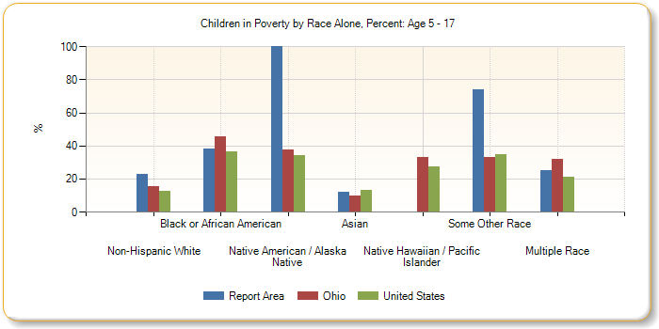
Children in Poverty by Race Alone, Total: Age 5 - 17
Report Area | Non-Hispanic White | Black or African American | Native American / Alaska Native | Asian | Native Hawaiian / Pacific Islander | Some Other Race | Multiple Race
Report Area | 8,805 | 242 | 16 | 17 | 0 | 124 | 589
Clinton County, OH | 1,205 | 30 | 0 | 12 | 0 | 56 | 112
Fayette County, OH | 1,061 | 15 | 0 | 0 | 0 | 58 | 64
Highland County, OH | 2,066 | 14 | 0 | 5 | 0 | 0 | 83
Pickaway County, OH | 1,580 | 0 | 16 | 0 | 0 | 0 | 5
Ross County, OH | 2,893 | 183 | 0 | 0 | 0 | 10 | 325
Ohio | 218,703 | 125,024 | 1,243 | 3,436 | 190 | 7,385 | 32,116
United States | 3,486,468 | 2,731,239 | 177,383 | 322,915 | 29,077 | 1,127,464 | 619,068
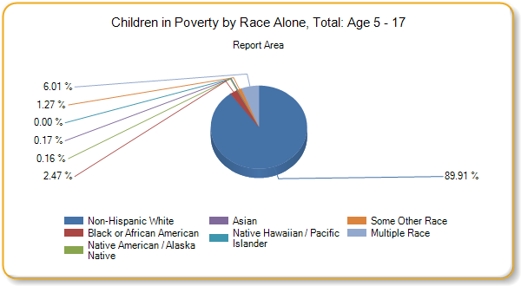
Seniors in Poverty
Poverty rates for seniors (persons age 65 and over) are shown below. According to American Community Survey estimates, there were 3,032 seniors, or 8.5% percent, living in poverty within the report area.
Report Area Ages 65 and Up Total Population Ages 65 and Up In Poverty Ages 65 and Up Poverty Rate  Report Area 35,656 3,032 8.5%  Clinton County, OH 5,967 453 7.6%  Fayette County, OH 4,390 382 8.7%  Highland County, OH 6,848 645 9.4%  Pickaway County, OH 7,554 536 7.1%  Ross County, OH 10,897 1,016 9.3%  Ohio 1,678,131 133,882 8%  United States 43,313,536 4,058,359 9.4%  Data Source: US Census Bureau, American Community Survey. 2011-15. Source geography: county | Ages 65 and Up Poverty Rate  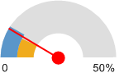  Report Area (8.5%)  Ohio (8%)  United States (9.4%)
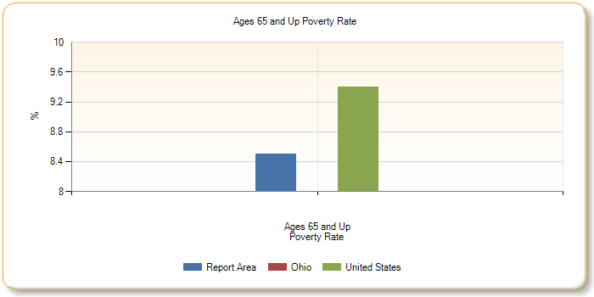
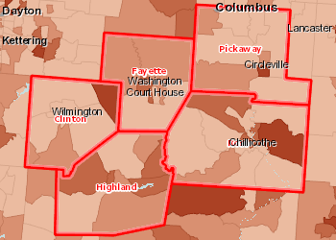 | Population Below the Poverty Level, Senior (Age 65 ), Percent by Tract, ACS 2011-15  Over 17.0%  12.1 - 17.0%  7.1 - 12.0%  Under 7.1%  No Population Age 65 Reported  No Data or Data Suppressed  Report Area

Poverty by Gender: Age 65 and Up
Report Area | Total Male | Total Female | Percent Male | Percent Female
Report Area | 1,003 | 2,029 | 6.22% | 10.38%
Clinton County, OH | 144 | 309 | 5.34% | 9.45%
Fayette County, OH | 142 | 240 | 7.2% | 9.93%
Highland County, OH | 233 | 412 | 7.44% | 11.08%
Pickaway County, OH | 184 | 352 | 5.42% | 8.46%
Ross County, OH | 300 | 716 | 6.1% | 11.98%
Ohio | 43,121 | 90,761 | 5.89% | 9.59%
United States | 1,385,728 | 2,672,631 | 7.25% | 11.04%
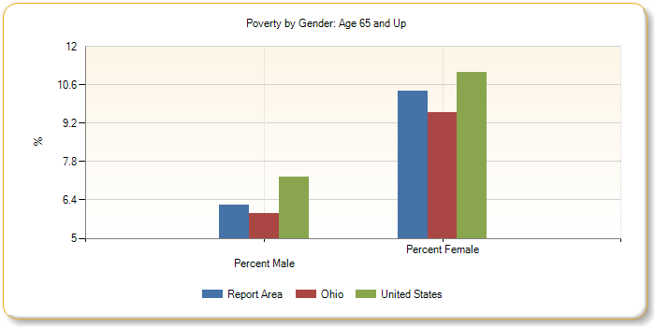

Poverty by Ethnicity Alone: Age 65 and Up
Report Area | Total Hispanic / Latino | Total Not Hispanic / Latino | Percent Hispanic / Latino | Percent Not Hispanic or Latino
Report Area | 34 | 2,998 | 17.17% | 8.46%
Clinton County, OH | 0 | 453 | 0% | 7.64%
Fayette County, OH | 0 | 382 | 0% | 8.71%
Highland County, OH | 16 | 629 | 45.71% | 9.23%
Pickaway County, OH | 0 | 536 | no data | 7.1%
Ross County, OH | 18 | 998 | 14.88% | 9.26%
Ohio | 2,621 | 131,261 | 14.22% | 7.91%
United States | 632,589 | 3,425,770 | 19.23% | 8.56%
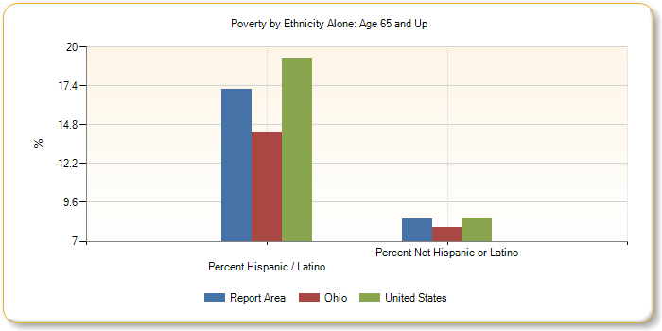
Poverty by Race Alone, Percent: Age 65 and Up
Report Area | Non-Hispanic White | Black or African American | Native American / Alaska Native | Asian | Native Hawaiian / Pacific Islander | Some Other Race | Multiple Race
Report Area | 8.22% | 20.29% | 4.88% | 8.8% | 94.74% | 0% | 10.16%
Clinton County, OH | 7.62% | 11.7% | 0% | 0% | no data | no data | 0%
Fayette County, OH | 8.42% | 33.33% | no data | 100% | no data | 0% | 0%
Highland County, OH | 9.05% | 11.93% | 0% | 0% | no data | 0% | 50%
Pickaway County, OH | 7.01% | 0% | 14.29% | 100% | 0% | no data | 18.18%
Ross County, OH | 8.83% | 23.92% | no data | 0% | 100% | no data | 7.28%
Ohio | 6.93% | 17.32% | 13.04% | 10.75% | 43.72% | 22.02% | 14.05%
United States | 7.21% | 18.03% | 18.69% | 13.23% | 13.73% | 22.51% | 14.12%
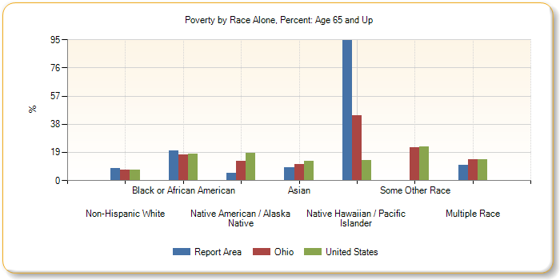

Poverty by Race Alone, Total: Age 65 and Up
Report Area | Non-Hispanic White | Black or African American | Native American / Alaska Native | Asian | Native Hawaiian / Pacific Islander | Some Other Race | Multiple Race
Report Area | 2,827 | 126 | 2 | 11 | 18 | 0 | 32
Clinton County, OH | 442 | 11 | 0 | 0 | 0 | 0 | 0
Fayette County, OH | 359 | 13 | 0 | 10 | 0 | 0 | 0
Highland County, OH | 603 | 13 | 0 | 0 | 0 | 0 | 13
Pickaway County, OH | 525 | 0 | 2 | 1 | 0 | 0 | 8
Ross County, OH | 898 | 89 | 0 | 0 | 18 | 0 | 11
Ohio | 103,159 | 24,575 | 286 | 1,897 | 80 | 689 | 1,459
United States | 2,452,162 | 674,448 | 40,402 | 227,773 | 5,046 | 153,622 | 62,253
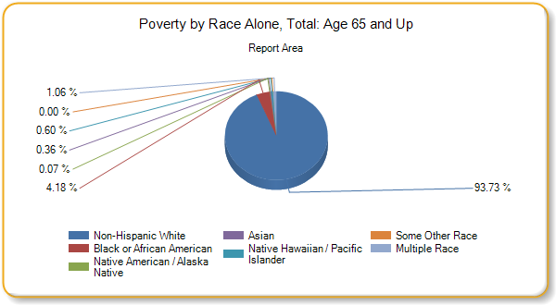

Employment
Current Unemployment
Labor force, employment, and unemployment data for each county in the report area is provided in the table below. Overall, the report area experienced an average 5.2% percent unemployment rate in April 2017.
Report Area Labor Force Number Employed Number Unemployed Unemployment Rate  Report Area 108,345 102,728 5,617 5.2%  Clinton County, OH 17,176 16,206 970 5.6%  Fayette County, OH 14,491 13,871 620 4.3%  Highland County, OH 17,190 16,142 1,048 6.1%  Pickaway County, OH 25,932 24,744 1,188 4.6%  Ross County, OH 33,556 31,765 1,791 5.3%  Ohio 5,706,644 5,434,335 272,309 4.8%  United States 159,211,358 151,689,735 7,521,623 4.7%  Data Source: US Department of Labor, Bureau of Labor Statistics. 2017 - April. Source geography: County | Unemployment Rate  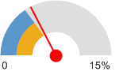  Report Area (5.2%)  Ohio (4.8%)  United States (4.7%)
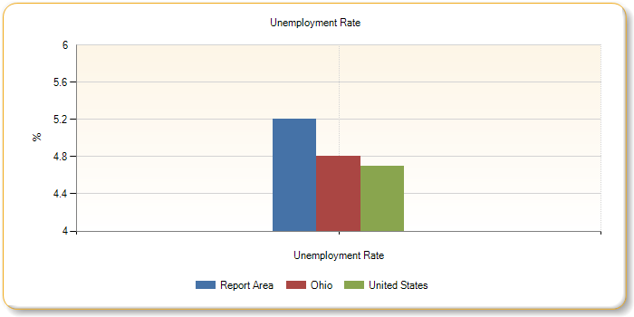
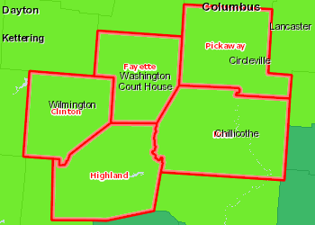 | Unemployment, Rate by County, BLS 2017 - April  Over 12.0%  9.1 - 12.0%  6.1 - 9.0%  3.1 - 6.0%  Under 3.1%  Report Area

Unemployment Change
Unemployment change within the report area during the 1-year period from April 2016 to April 2017 is shown in the chart below. According to the U.S. Department of Labor, unemployment for this one year period grew from 5,545 persons to 5,617 persons, a rate change of -0.02% percent.
Report Area Unemployment April 2016 Unemployment April 2017 Unemployment Rate April 2016 Unemployment Rate April 2017 Rate Change  Report Area 5,545 5,617 5.2% 5.18% -0.02%  Clinton County, OH 1,013 970 6.08% 5.65% -0.43%  Fayette County, OH 659 620 4.75% 4.28% -0.47%  Highland County, OH 1,032 1,048 6.05% 6.1% 0.04%  Pickaway County, OH 1,132 1,188 4.44% 4.58% 0.14%  Ross County, OH 1,709 1,791 5.1% 5.34% 0.23%  Ohio 263,315 272,309 4.64% 4.77% 0.13%  United States 8,097,377 7,521,623 5.14% 4.72% -0.42%  Data Source: US Department of Labor, Bureau of Labor Statistics. 2017 - April. Source geography: County | Rate Change  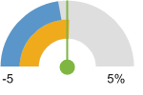  Report Area (-0.02%)  Ohio (0.13%)  United States (-0.42%)
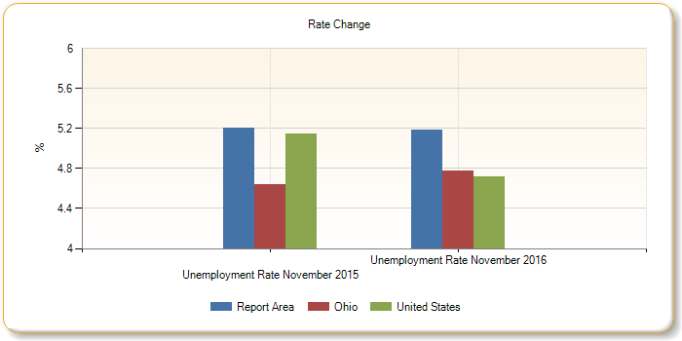
Unemployment, Rate by County, BLS 2017 - April
Over 12.0%
9.1 - 12.0%
6.1 - 9.0%
3.1 - 6.0%
Under 3.1%
Report Area

Household Income
Median annual household incomes in the report area for 2015 are shown in the table below. Since this reports a median amount, a "Report Area" value is not able to be calculated.
Report Area | Median Household Income
Clinton County, OH | $47,055
Fayette County, OH | $45,068
Highland County, OH | $41,494
Pickaway County, OH | $58,472
Ross County, OH | $45,615
Ohio | $51,086
United States | $55,775
Data Source: US Census Bureau, Small Area Income Poverty Estimates. 2015. Source geography: County
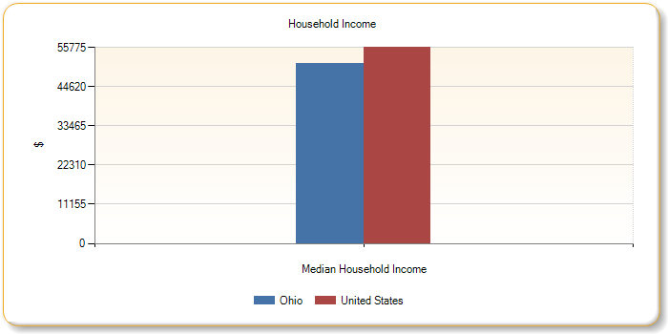
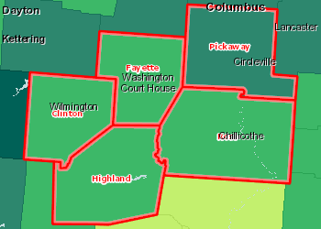 | Median Household Income by County, SAIPE 2015  Over $70,000  $50,001 - $70,000  $40,001 - $50,000  Under $40,001  Report Area

Commuter Travel Patterns
This table shows the method of transportation workers used to travel to work for the report area. Of the 100,194 workers in the report area, 84.6% drove to work alone while 9.2% carpooled. 0.5% of all workers reported that they used some form of public transportation, while others used some optional means including 2% walking or riding bicycles, and 0.9% used taxicabs to travel to work.
Report Area Workers 16 and Up Percent Drive Alone Percent Carpool Percent Public Transportation Percent Bicycle or Walk Percent Taxi or Other Percent Work at Home  Report Area 100,194 84.6% 9.2% 0.5% 2% 0.9% 2.9%  Clinton County, OH 17,994 84.9% 7% 0.3% 3% 1.3% 3.5%  Fayette County, OH 12,166 85% 8.9% 0.5% 2.1% 0.8% 2.7%  Highland County, OH 16,587 80.3% 12.2% 0.8% 1.9% 0.8% 4%  Pickaway County, OH 24,111 86.4% 8.3% 0.1% 1.4% 0.6% 3.3%  Ross County, OH 29,336 85.2% 9.6% 0.7% 1.8% 0.9% 1.8%  Ohio 5,263,292 83.4% 7.9% 1.7% 2.6% 0.8% 3.5%  United States 143,621,171 76.4% 9.5% 5.1% 3.4% 1.2% 4.4%  Data Source: US Census Bureau, American Community Survey. 2011-15. Source geography: County | Percent  Drive Alone  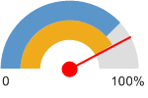  Report Area (84.6%)  Ohio (83.4%)  United States (76.4%)
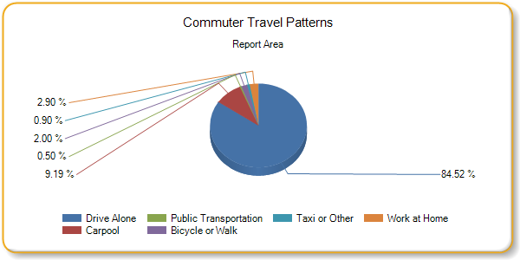
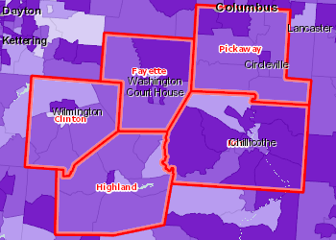 | Workers Traveling to Work by Car, Percent by Tract, ACS 2011-15  Over 95.0%  91.1 - 95.0%  87.1 - 91.0%  Under 87.1%  No Data or Data Suppressed  Report Area
Non-Hispanic Commuters
Report Area | Workers 16 and Up | Travel by Car | Use Public Transit | Bike/Walk | Work from Home
Report Area | 100,194 | 93.77% | 0.47% | 2.83% | 2.93%
Clinton County, OH | 17,994 | 91.95% | 0.33% | 4.27% | 3.46%
Fayette County, OH | 12,166 | 93.92% | 0.46% | 2.94% | 2.68%
Highland County, OH | 16,587 | 92.56% | 0.8% | 2.65% | 3.99%
Pickaway County, OH | 24,111 | 94.6% | 0.13% | 1.93% | 3.34%
Ross County, OH | 29,336 | 94.83% | 0.66% | 2.74% | 1.77%
Ohio | 5,107,312 | 91.45% | 1.63% | 3.36% | 3.56%
United States | 143,621,171 | 85.86% | 5.13% | 4.59% | 4.42%

White Non-Hispanic Commuters
Report Area | Workers 16 and Up | Travel by Car | Use Public Transit | Bike/Walk | Work from Home
Report Area | 83,116 | 93.26% | 0.47% | 2.83% | 3.44%
Clinton County, OH | 17,522 | 93.11% | 0.15% | 3.38% | 3.36%
Fayette County, OH | 11,546 | 93.72% | 0.68% | 2.78% | 2.82%
Highland County, OH | 11,454 | 91.1% | 0.57% | 2.55% | 5.78%
Pickaway County, OH | 15,442 | 91.83% | 0.33% | 2.75% | 5.1%
Ross County, OH | 27,152 | 94.88% | 0.63% | 2.67% | 1.82%
Ohio | 4,420,486 | 92.41% | 0.83% | 3.09% | 3.67%
United States | no data | no data | no data | no data | no data

Hispanic Commuters
Report Area | Workers 16 and Up | Travel by Car | Use Public Transit | Bike/Walk | Work from Home
Report Area | 0 | 0% | 0% | 0% | 0%
Clinton County, OH | no data | no data | no data | no data | no data
Fayette County, OH | no data | no data | no data | no data | no data
Highland County, OH | no data | no data | no data | no data | no data
Pickaway County, OH | no data | no data | no data | no data | no data
Ross County, OH | no data | no data | no data | no data | no data
Ohio | 155,980 | 89.14% | 2.6% | 5.68% | 2.58%
United States | no data | no data | no data | no data | no data
Travel Time to Work
Travel times for workers who travel (do not work at home) to work is shown for the report area. The median commute time, according to the American Community Survey (ACS), for the report area of 26.19 minutes is longer than the national median commute time of 24.78 minutes.
Report Area Workers 16 and Up Travel Time in Minutes (Percent of Workers) Less than 10 Travel Time in Minutes (Percent of Workers) 10 to 30 Travel Time in Minutes (Percent of Workers) 30 to 60 Travel Time in Minutes (Percent of Workers) More than 60 Average Commute Time (mins)  Report Area 100,194 16.31 44.19 26.52 10.06 26.19  Clinton County, OH 17,994 19.71 43.62 25.92 10.76 25.54  Fayette County, OH 12,166 25.34 42.79 23.67 8.21 22.58  Highland County, OH 16,587 15.83 40.98 27.76 15.43 29.27  Pickaway County, OH 24,111 13.61 39.42 40.79 6.18 26.8  Ross County, OH 29,336 14.65 55.24 18.53 11.58 25.86  Ohio 5,263,292 14.62 55.09 25.31 4.98 22.42  United States 143,621,171 13.06 50.34 28.11 8.49 24.78  Data Source: US Census Bureau, American Community Survey. 2011-15. Source geography: County | Average Commute Time (mins)  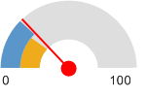  Report Area (26.19)  Ohio (22.42)  United States (24.78)
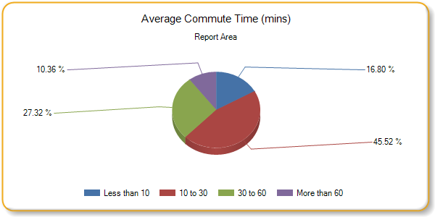
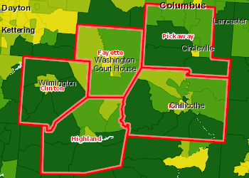 | Average Work Commute Time (Minutes), Average by Tract, ACS 2011-15  Over 28 Minutes  25 - 28 Minutes  21 - 24 Minutes  Under 21 Minutes  No Data or Data Suppressed  Report Area

Thirteen Month Unemployment Rates
Unemployment change within the report area from April 2016 to April 2017 is shown in the chart below. According to the U.S. Department of Labor, unemployment for this thirteen month period fell from 5.2% percent to 4.3% percent.
Report Area | Apr. 2016 | May 2016 | June 2016 | July 2016 | Aug. 2016 | Sep. 2016 | Oct. 2016 | Nov. 2016 | Dec. 2016 | Jan. 2017 | Feb. 2017 | Mar. 2017 | Apr. 2017
Report Area | 5.2% | 4.6% | 5.2% | 5.2% | 5% | 5.1% | 4.9% | 4.9% | 5.2% | 6.5% | 6% | 5.2% | 4.3%
Clinton County, OH | 5.6% | 5% | 5.6% | 5.9% | 5.6% | 5.7% | 5.5% | 5.1% | 5.4% | 6.9% | 6.4% | 5.4% | 4.6%
Fayette County, OH | 4.3% | 3.9% | 4.3% | 4.3% | 4% | 4.2% | 4% | 3.8% | 4.1% | 5.4% | 4.9% | 4.3% | 3.4%
Highland County, OH | 6.1% | 5.4% | 6% | 6.2% | 5.9% | 6.1% | 5.8% | 5.7% | 6.4% | 7.9% | 7% | 6.1% | 4.8%
Pickaway County, OH | 4.6% | 4.1% | 4.8% | 4.6% | 4.4% | 4.6% | 4.4% | 4.5% | 4.7% | 6% | 5.6% | 4.7% | 3.9%
Ross County, OH | 5.3% | 4.8% | 5.3% | 5.1% | 5.1% | 5.1% | 4.9% | 5.2% | 5.4% | 6.6% | 6.2% | 5.4% | 4.4%
Ohio | 4.8% | 4.4% | 5% | 5% | 4.8% | 4.9% | 4.7% | 4.5% | 4.8% | 6% | 5.9% | 5.2% | 4.4%
United States | 4.7% | 4.6% | 5.1% | 5.2% | 5.1% | 4.9% | 4.7% | 4.5% | 4.6% | 5.2% | 5% | 4.6% | 4.2%
Data Source: US Department of Labor, Bureau of Labor Statistics. 2017 - April. Source geography: County
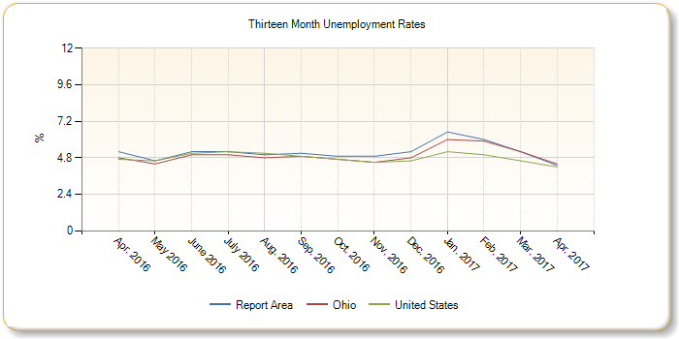
Unemployment, Rate by County, BLS 2017 - April
Over 12.0%
9.1 - 12.0%
6.1 - 9.0%
3.1 - 6.0%
Under 3.1%
Report Area

Five Year Unemployment Rate
Unemployment change within the report area from April 2013 to April 2017 is shown in the chart below. According to the U.S. Department of Labor, unemployment for this five year period fell from 8.33% percent to 5.18% percent.
Report Area April 2013 April 2014 April 2015 April 2016 April 2017  Report Area 8.33% 8.28% 6.11% 5.2% 5.18%  Clinton County, OH 10.01% 9.86% 7.27% 6.08% 5.65%  Fayette County, OH 7.83% 7.39% 5.61% 4.75% 4.28%  Highland County, OH 9.69% 9.55% 7.2% 6.05% 6.1%  Pickaway County, OH 7.04% 6.9% 5.02% 4.44% 4.58%  Ross County, OH 7.94% 8.25% 6% 5.1% 5.34%  Ohio 6.95% 6.91% 5.24% 4.64% 4.77%  United States 7.79% 7.16% 5.92% 5.14% 4.72%  Data Source: US Department of Labor, Bureau of Labor Statistics. 2017 - April. Source geography: County | April  2017  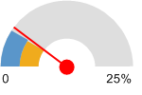  Report Area (5.18%)  Ohio (4.77%)  United States (4.72%)
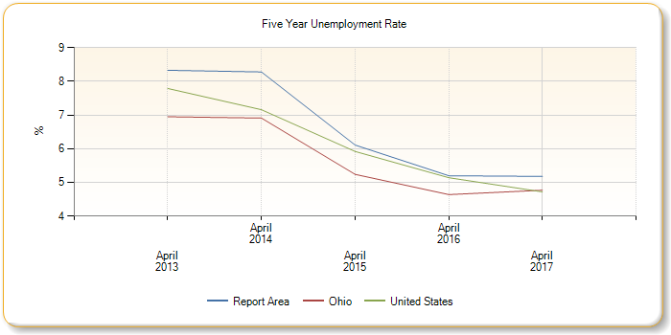
Unemployment, Rate by County, BLS 2017 - April
Over 12.0%
9.1 - 12.0%
6.1 - 9.0%
3.1 - 6.0%
Under 3.1%
Report Area

Education
Educational Attainment
Educational Attainment shows the distribution of educational attainment levels in the report area. Educational attainment is calculated for persons over 25, and is an estimated average for the period from 2011 to 2015.
Report Area Percent No High School Diploma Percent High School Only Percent Some College Percent Associates Degree Percent Bachelors Degree Percent Graduate or Professional Degree  Report Area 14.34% 42.97% 19.37% 8.41% 9.72% 5.19%  Clinton County, OH 12.02% 40.6% 22.7% 8.9% 10.3% 5.5%  Fayette County, OH 14.61% 46.7% 16.5% 8.1% 10.4% 3.7%  Highland County, OH 15.52% 43.1% 20.6% 8.6% 7.5% 4.6%  Pickaway County, OH 13.56% 42.9% 19.8% 6.7% 11.2% 5.9%  Ross County, OH 15.35% 42.8% 17.7% 9.4% 9.3% 5.4%  Ohio 10.87% 34.2% 20.7% 8.2% 16.4% 9.7%  United States 13.35% 27.8% 21.1% 8.1% 18.5% 11.3%  Data Source: US Census Bureau, American Community Survey. 2011-15. Source geography: County | Percent Population with No High School Diploma  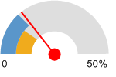  Report Area (14.34%)  Ohio (10.87%)  United States (13.35%)
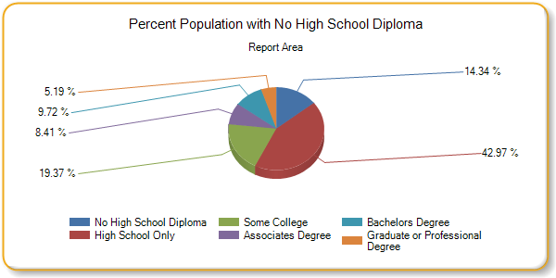
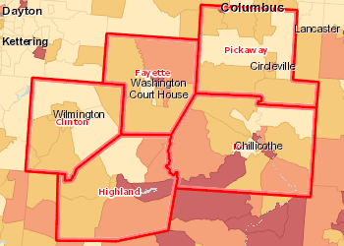 | Population with No High School Diploma (Age 18 ), Percent by Tract, ACS 2011-15  Over 21.0%  16.1 - 21.0%  11.1 - 16.0%  Under 11.1%  No Data or Data Suppressed  Report Area

Adult Literacy
The National Center for Education Statistics (NCES) produces estimates for adult literacy based on educational attainment, poverty, and other factors in each county.
Report Area Estimated Population over 16 Percent Lacking Literacy Skills  Report Area 177,646 10.02%  Clinton County, OH 31,659 9%  Fayette County, OH 21,539 11%  Highland County, OH 31,992 11%  Pickaway County, OH 37,471 9%  Ross County, OH 54,985 11%  Ohio 8,715,916 9%  United States 219,016,209 14.64%  Data Source: National Center for Education Statistics, NCES - Estimates of Low Literacy. Source geography: County | Percentage of Adults Lacking Literacy Skills  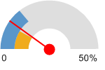  Report Area (10.02%)  Ohio (9%)  United States (14.64%)
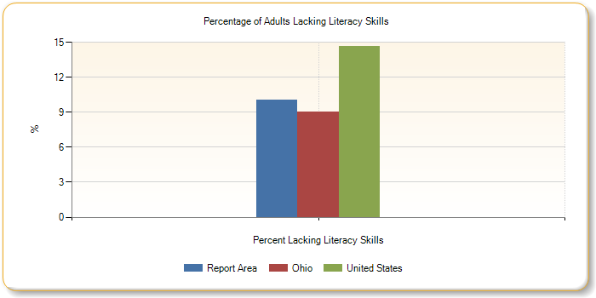
Veterans - Educational Attainment
Veterans Educational Attainment contrasts the distribution of educational attainment levels between military veterans and non-veterans in the region. Educational attainment is calculated for persons over 25, and is an estimated average for the period from 2011 to 2015.
Report Area | Veterans  % No Diploma | Veterans  % High School  Diploma | Veterans  % Some College  Diploma | Veterans  % Bachelors  or Higher  Diploma | Non-Veterans  % No Diploma | Non-Veterans  % High School  Diploma | Non-Veterans  % Some College  Diploma | Non-Veterans  % Bachelors  or Higher  Diploma
Report Area | 10.24% | 44.55% | 31.87% | 13.34% | 14.88% | 42.79% | 27.23% | 15.11%
Clinton County, OH | 8.93% | 37.61% | 38.99% | 14.46% | 12.44% | 41.02% | 30.55% | 16%
Fayette County, OH | 10.5% | 49.14% | 25.97% | 14.39% | 15.16% | 46.51% | 24.29% | 14.04%
Highland County, OH | 10.64% | 45.07% | 32.34% | 11.95% | 16.15% | 42.88% | 28.82% | 12.15%
Pickaway County, OH | 10.59% | 43.89% | 31.99% | 13.54% | 13.94% | 42.76% | 25.79% | 17.51%
Ross County, OH | 10.37% | 46.69% | 29.94% | 13% | 16.01% | 42.3% | 26.76% | 14.92%
Ohio | 8.83% | 37.28% | 33.8% | 20.1% | 11.11% | 33.82% | 28.32% | 26.76%
United States | 7.11% | 29.05% | 36.85% | 27% | 14.04% | 27.68% | 28.24% | 30.03%
Note: This indicator is compared with the state average.
Data Source: US Census Bureau, American Community Survey. 2011-15. Source geography: County
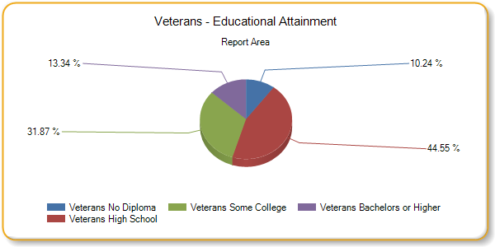
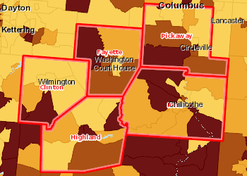 | No High School Diploma, Veterans, Percent by Tract, ACS 2011-15  Over 14.0%  11.1 - 14.0%  8.1 - 11.0%  Under 8.1%  Of Veterans Age 25 , No Population with No High School Diploma  No Data or Data Suppressed  Report Area

Housing
Housing Age
Total housing units, median year built and median age in 2015 for the report area are shown below. Housing units used in housing age include only those where the year built is known.
Report Area | Total Housing Units | Median Year Built | Median Age (from 2015)
Report Area | 103,086 |  | no data
Clinton County, OH | 18,063 | 1975 | 39
Fayette County, OH | 12,668 | 1970 | 44
Highland County, OH | 19,256 | 1979 | 35
Pickaway County, OH | 21,182 | 1976 | 38
Ross County, OH | 31,917 | 1972 | 42
Ohio | 5,140,902 | 1967 | 47
United States | 133,351,840 | 1976 | 38
Data Source: US Census Bureau, American Community Survey. 2011-15. Source geography: County
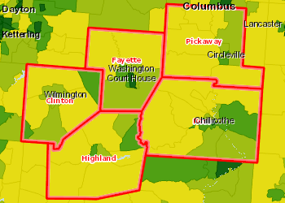 | Housing Constructed Before 1960, Percent by Tract, ACS 2011-15  Over 45.0%  30.1 - 45.0%  20.1 - 30.0%  Under 20.1%  No Data or Data Suppressed  Report Area

Homeowners
The U.S. Census Bureau estimated there were 62,815 homeowners in the report area in 2000, and 72.37% owner occupied homes in the report area for the 5 year estimated period from 2011 - 2015.
Report Area Owner Occupied Homes 2000 Owner Occupied Homes 2000 Owner Occupied Homes 2015 Owner Occupied Homes 2015  Report Area 62,815 72.37% 63,740 61.83%  Clinton County, OH 10,615 68.86% 10,354 57.32%  Fayette County, OH 7,361 66.59% 6,963 54.97%  Highland County, OH 11,744 75.34% 11,785 61.2%  Pickaway County, OH 13,137 74.65% 14,363 67.81%  Ross County, OH 19,958 73.55% 20,275 63.52%  Ohio 3,072,522 69.11% 3,040,444 59.14%  United States 69,815,753 66.19% 74,712,091 56.03%  Data Source: US Census Bureau, American Community Survey. 2011-15. Source geography: County | Owner Occupied Homes  2015  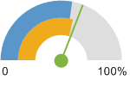  Report Area (61.83%)  Ohio (59.14%)  United States (56.03%)
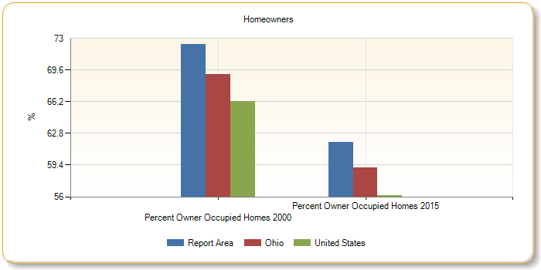
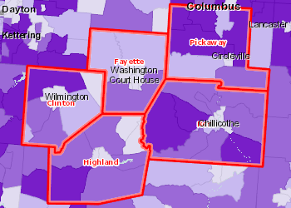 | Owner-Occupied Housing Units, Percent by Tract, ACS 2011-15  Over 82.0%  74.1 - 82.0%  66.1 - 74.0%  Under 66.1%  No Data or Data Suppressed  Report Area

Vacancy Rates
The U.S. Postal Service provided information quarterly to the U.S. Department of Housing and Urban Development on addresses identified as vacant in the previous quarter. Residential and business vacancy rates for the report area in the first quarter of 2015 are reported.
For this reporting period, a total of 4,069 residential addresses were identified as vacant in the report area, a vacancy rate of 3.8%, and 786 business addresses were also reported as vacant, a rate of 10.4% .
Report Area Residential Addresses Vacant Residential Addresses Residential Vacancy Rate Business Addresses Vacant Business Addresses Business Vacancy Rate  Report Area 107,420 4,069 3.8% 7,540 786 10.4%  Clinton County, OH 18,310 806 4.4% 1,262 184 14.6%  Fayette County, OH 13,172 389 3% 1,219 95 7.8%  Highland County, OH 19,126 1,425 7.5% 1,136 212 18.7%  Pickaway County, OH 22,981 431 1.9% 1,527 102 6.7%  Ross County, OH 33,831 1,018 3% 2,396 193 8.1%  Ohio 5,473,762 218,352 4% 454,618 54,797 12.1%  United States 146,832,025 3,825,190 2.6% 13,835,679 1,232,945 8.9%  Data Source: US Department of Housing and Urban Development. 2016-Q4. Source geography: County | Residential Vacancy Rate  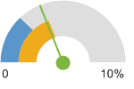  Report Area (3.8%)  Ohio (4%)  United States (2.6%)
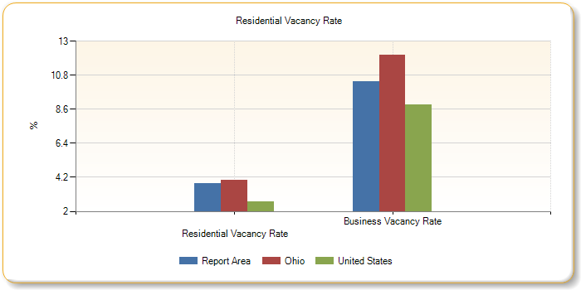
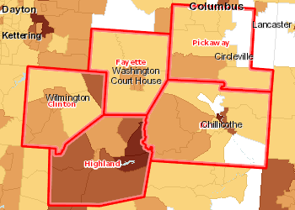 | Residential Vacancies, Percent by Tract, HUD 2016-Q4  Over 10.0%  5.1 - 10.0%  2.1 - 5.0%  Under 2.1%  No Residential Vacancies  No Residential Addresses or No Data  Report Area

Number of Unsafe, Unsanitary Homes
The number and percentage of occupied housing units without plumbing are shown for the report area. U.S. Census data shows 593 housing units in the report area were without plumbing in 2000 and ACS five year estimates show 372 housing units in the report area were without plumbing in 2015.
Report Area Occupied Housing Units 2000 Housing Units without Plumbing 2000 Percent without Plumbing 2000 Occupied Housing Units 2015 Housing Units without Plumbing 2015 Percent without Plumbing 2015  Report Area 86,792 593 0.68% 92,087 372 0.4%  Clinton County, OH 15,416 101 0.61% 16,073 33 0.21%  Fayette County, OH 11,054 19 0.16% 11,589 39 0.34%  Highland County, OH 15,587 123 0.7% 16,696 107 0.64%  Pickaway County, OH 17,599 73 0.39% 19,460 45 0.23%  Ross County, OH 27,136 277 0.94% 28,269 148 0.52%  Ohio 4,445,773 19,407 0.41% 4,585,084 18,687 0.41%  United States 106,741,426 736,626 0.69% 116,916,306 498,998 0.43%  Data Source: US Census Bureau, American Community Survey. US Census Bureau, Decennial Census. 2011-15. Source geography: County | Percentage of Housing Units Without Complete Plumbing Facilities  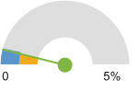  Report Area (0.4%)  Ohio (0.41%)  United States (0.43%)
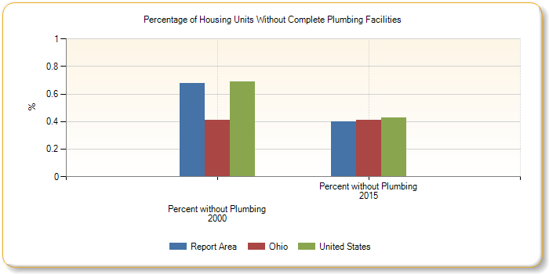
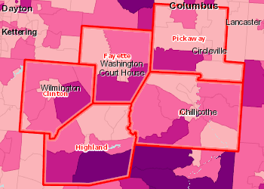 | Housing Units Lacking Complete Plumbing Facilities, Percent by Tract, ACS 2011-15  Over 2.0%  1.1 - 2.0%  0.1 - 1.0%  0.0%  No Data or Data Suppressed  Report Area

Income
Income Levels
Two common measures of income are Median Household Income and Per Capita Income, based on U.S. Census Bureau estimates. Both measures are shown for the report area below. The average Per Capita income for the report area is $22,294.62, compared to a national average of $28,930.
Report Area | Median Household Income | Per Capita Income
Report Area | no data | $22,294.62
Clinton County, OH | $46,787 | $23,039
Fayette County, OH | $40,503 | $21,632
Highland County, OH | $39,858 | $20,240
Pickaway County, OH | $57,439 | $24,921
Ross County, OH | $43,345 | $21,365
Ohio | $49,429 | $26,953
United States | $53,889 | $28,930
Data Source: US Census Bureau, American Community Survey. 2011-15. Source geography: County
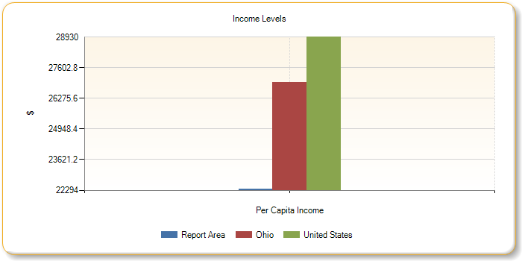
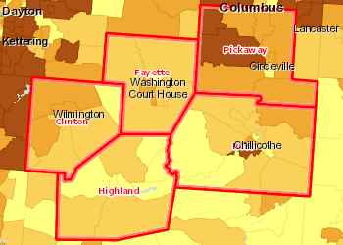 | Per Capita Income by Tract, ACS 2011-15  Over 30,000  25,001 - 30,000  20,001 - 25,000  Under 20,001  No Data or Data Suppressed  Report Area

Household Income
Median annual household incomes in the report area for 2015 are shown in the table below. Since this reports a median amount, a "Report Area" value is not able to be calculated.
Report Area | Median Household Income
Clinton County, OH | $47,055
Fayette County, OH | $45,068
Highland County, OH | $41,494
Pickaway County, OH | $58,472
Ross County, OH | $45,615
Ohio | $51,086
United States | $55,775
Data Source: US Census Bureau, Small Area Income Poverty Estimates. 2015. Source geography: County
Median Household Income by County, SAIPE 2015
Over $70,000
$50,001 - $70,000
$40,001 - $50,000
Under $40,001
Report Area

Nutrition
Free and Reduced Lunch Program
The following report shows that 19,151 students (or 48.28 percent) were eligible for free or reduced price lunches during the 2013 - 2014 school year, which is more than the national average of 52.35 percent.
Report Area Total Students Number Free/Reduced Price Lunch Eligible Percent Free/Reduced Price Lunch Eligible  Report Area 39,667 19,151 48.28%  Clinton County, OH 7,327 3,547 48.41%  Fayette County, OH 4,846 2,854 58.89%  Highland County, OH 7,141 3,109 43.54%  Pickaway County, OH 9,063 4,050 44.69%  Ross County, OH 11,290 5,591 49.52%  Ohio 1,723,451 776,616 45.06%  United States 50,436,641 26,213,915 52.12%  Data Source: National Center for Education Statistics, NCES - Common Core of Data. 2014-15. Source geography: Address | Percent Students Eligible for Free or Reduced Price Lunch  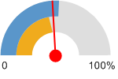  Report Area (48.28%)  Ohio (45.06%)  United States (52.12%)

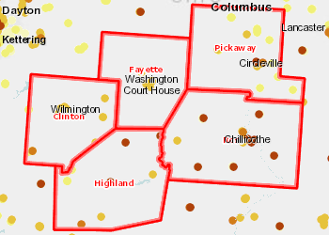 | Students Eligible for Free or Reduced-Price Lunch, NCES CCD 2014-15  Under 90.1%  75.1% - 90.0%  50.1% - 75.0%  20.1% - 50.0%  Under 20.1%  Not Reported  Report Area

Children Eligible for Free Lunch (Alone) by Year, 2009-10 through 2012-13
The table below shows local, state, and National trends in student free and reduced lunch eligibility.
Note: Data for the 2011-12 school year are omitted due to lack of data for some states.
Report Area | 2010-11 | 2012-13 | 2013-14 | 2014-15
Report Area | 45.12% | 45.65% | 47.69% | 48.28%
Clinton County, OH | 45.12% | 48.1% | 48.95% | 48.41%
Fayette County, OH | 50.09% | 54.06% | 55.88% | 58.89%
Highland County, OH | 43.11% | 44.38% | 43.95% | 43.54%
Pickaway County, OH | 42.52% | 41.6% | 46.02% | 44.69%
Ross County, OH | 46.42% | 44.19% | 47.05% | 49.52%
Ohio | 42.63% | 40.72% | 44.59% | 45.06%
United States | 48.15% | 51.32% | 51.99% | 51.8%
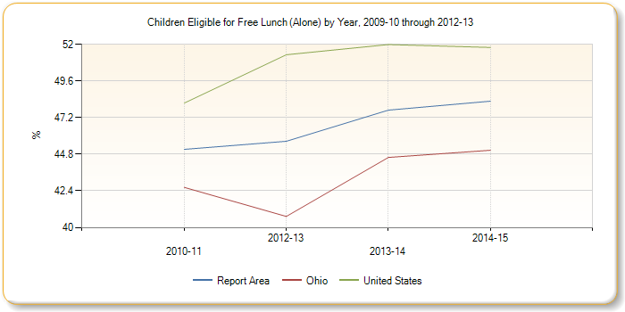

Households Receiving SNAP by Poverty Status (ACS)
The below table shows that according to the American Community Survey (ACS), 17,357 households (or 18.8%) received SNAP payments during 2015. During this same period there were 5,312 households with income levels below the poverty level that were not receiving SNAP payments.
Report Area | Households  Receiving SNAP  Total | Households  Receiving SNAP  Percent | Households  Receiving SNAP  Income Below  Poverty | Households  Receiving SNAP  Income Above  Poverty | Households Not  Receiving SNAP  Total | Households Not  Receiving SNAP  Percent | Households Not  Receiving SNAP  Income Below  Poverty | Households Not  Receiving SNAP  Income Above  Poverty
Report Area | 17,357 | 18.8% | 9,306 | 8,051 | 74,730 | 81.2% | 5,312 | 69,418
Clinton County, OH | 2,658 | 16.54% | 1,449 | 1,209 | 13,415 | 83.46% | 1,063 | 12,352
Fayette County, OH | 2,232 | 19.26% | 1,265 | 967 | 9,357 | 80.74% | 750 | 8,607
Highland County, OH | 3,620 | 21.68% | 1,952 | 1,668 | 13,076 | 78.32% | 1,143 | 11,933
Pickaway County, OH | 3,085 | 15.85% | 1,566 | 1,519 | 16,375 | 84.15% | 667 | 15,708
Ross County, OH | 5,762 | 20.38% | 3,074 | 2,688 | 22,507 | 79.62% | 1,689 | 20,818
Ohio | 688,962 | 15.03% | 384,009 | 304,953 | 3,896,122 | 84.97% | 301,349 | 3,594,773
United States | 15,399,651 | 13.17% | 7,892,966 | 7,506,685 | 101,526,654 | 86.83% | 8,918,629 | 92,608,025
Data Source: US Census Bureau, American Community Survey. 2011-15. Source geography: County
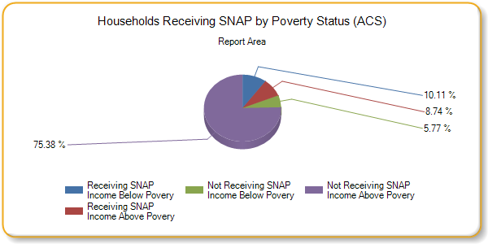
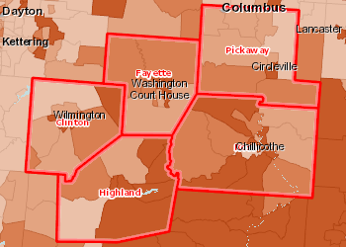 | Households Receiving SNAP Benefits, Percent by Tract, ACS 2011-15  Over 19.0%  14.1 - 19.0%  9.1 - 14.0%  Under 9.1%  No Data or Data Suppressed  Report Area

Health Care
Federally Qualified Health Centers
Federally Qualified Health Centers in this selected area.
County | Provider Number | FQHC Name | Address | City | Phone
Clinton County | PN: 361985 | HEALTHSOURCE WILMINGTON | 781 WEST LOCUST STREET | WILMINGTON | (513) 576-7700
Clinton County | PN: 361032 | PRIMARY HEALTH SOLUTIONS | 953 SOUTH STREET | WILMINGTON | (513) 454-1468
Fayette County | PN: 361853 | WASHINGTON COURT HOUSE FAMILY HLTH CTR | 308 HIGHLAND AVE, SUITE H | WASHINGTON COURT HOUSE | (513) 752-8500
Highland County | PN: 361808 | GREENFIELD FAMILY HEALTH CENTER | 1075 NORTH WASHINGTON STREET | GREENFIELD | (937) 981-7707
Highland County | PN: 361890 | HILLSBORO HEALTH CENTER | 104 ERIN COURT | HILLSBORO | (937) 393-5781
Highland County | PN: 361115 | HIGHLAND HEALTH PROVIDERS CORP | 1487 NORTH HIGH STREET | HILLSBORO | (937) 393-3406
Pickaway County | PN: 361044 | COLUMBUS NEIGHBORHOOD HEALTH CENTER CIRCLEVILLE | 600 NORTH PICKAWAY STREET SUITE 300 MO BLDG | CIRCLEVILLE | (740) 207-4202
Ross County | PN: 361826 | ROSS COUNTY AMBULATORY CLINIC | 425 CHESTNUT STREET | CHILLICOTHE | (614) 773-4366
Data Source: US Department of Health Human Services, Center for Medicare Medicaid Services, Provider of Services File. Dec. 2016. Source geography: County
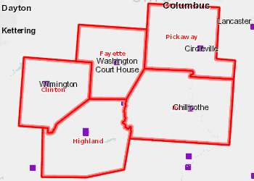 | Federally Qualified Health Centers, POS Dec. 2016  Report Area

Medicare and Medicaid Providers
This indicator displays the economic resilience index and the rescaled indicators that comprise the score. Values are coded into a scale ranging from zero (lowest resilience) to one (highest resilience).
Note: State-level values are population-weighted averages. The United States value is the median value for all counties.
Report Area | Proprietor Income Score | Proprietor Employment Score | Establishment Births Score | Employment Diversity Score | Labor Force Participation Score | Economic Resilience Index Score
Report Area | 0.34 | 0.31 | 0.41 | 0.79 | 0.47 | 0.47
Clinton County, OH | 0.55 | 0.28 | 0.36 | 0.85 | 0.60 | 0.53
Fayette County, OH | 0.30 | 0.42 | 0.39 | 0.80 | 0.54 | 0.49
Highland County, OH | 0.30 | 0.38 | 0.35 | 0.67 | 0.46 | 0.43
Pickaway County, OH | 0.34 | 0.34 | 0.47 | 0.91 | 0.46 | 0.51
Ross County, OH | 0.26 | 0.23 | 0.43 | 0.75 | 0.39 | 0.41
Ohio | 0.46 | 0.28 | 0.44 | 0.90 | 0.59 | 0.53
Data Source: Missouri EPSCoR. 2015. Source geography: County
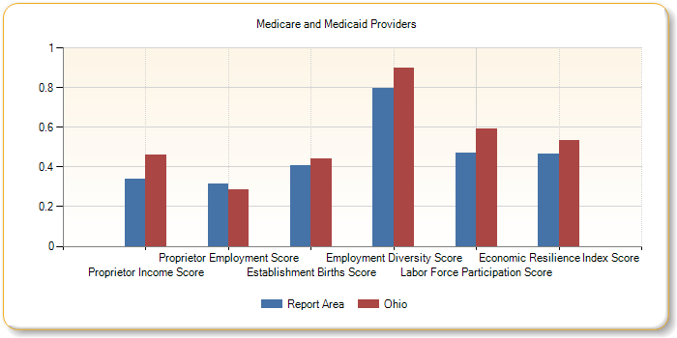
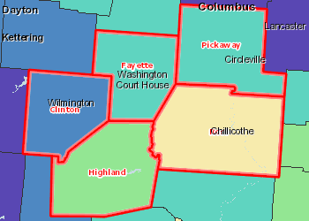 | Resilience Index - Economics by County, EPSCOR 2015  Over 0.56  0.52 - 0.56  0.48 - 0.51  0.43 - 0.47  Under 0.42  Report Area

Persons Receiving Medicare
The total number of persons receiving Medicare is shown, broken down by number over 65 and number of disabled persons receiving Medicare for the report area. The U.S. Department of Health and Human Services reported that a total of 48,248 persons were receiving Medicare benefits in the report area in 2015. A large number of individuals in our society are aware that persons over 65 years of age receive Medicare; however, many of them are unaware that disabled persons also receive Medicare benefits. A total of 9,593 disabled persons in the report area received Medicare benefits in 2015.
Report Area | Persons Over 65 Receiving Medicare | Disabled Persons Receiving Medicare | Total Persons Receiving Medicare
Report Area | 38,655 | 9,593 | 48,248
Clinton County, OH | 7,134 | 1,587 | 8,721
Fayette County, OH | 4,298 | 1,056 | 5,354
Highland County, OH | 6,281 | 1,573 | 7,854
Pickaway County, OH | 8,066 | 1,519 | 9,585
Ross County, OH | 12,876 | 3,858 | 16,734
Ohio | 3,600,368 | 713,475 | 4,313,839
United States | 46,727,720 | 8,856,429 | 55,584,149
Data Source: Centers for Medicare and Medicaid Services. 2011-15. Source geography: County
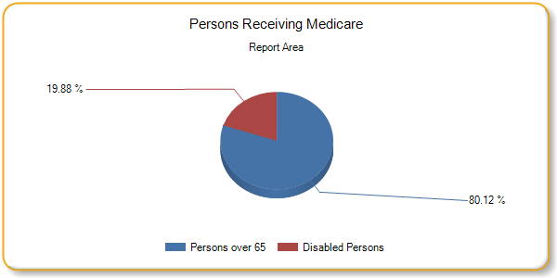
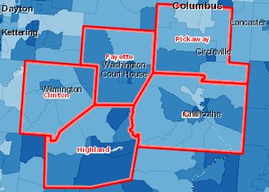 | Insured, Medicare, Percent by Tract, ACS 2011-15  Over 25.0%  20.1 - 25.0%  15.1 - 20.0%  Under 15.1%  No Data or Data Suppressed  Report Area
Uninsured Population
The uninsured population is calculated by estimating the number of persons eligible for insurance (generally those under 65) minus the estimated number of insured persons.
Report Area Insurance Population (2015 Estimate) Number Insured Number Uninsured Percent Uninsured  Report Area 247,680 182,129 14,953 6.04%  Clinton County, OH 41,892 31,760 2,558 7.5%  Fayette County, OH 28,769 21,523 1,928 8.2%  Highland County, OH 43,170 32,126 3,056 8.7%  Pickaway County, OH 56,515 41,472 2,878 6.5%  Ross County, OH 77,334 55,248 4,533 7.6%  Ohio 11,575,977 8,792,642 735,492 6.35%  United States 316,515,021 237,874,187 29,165,227 9.21%  Data Source: US Census Bureau, American Community Survey. US Census Bureau, Small Area Health Insurance Estimates. 2015. Source geography: County | Percent Uninsured  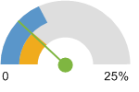  Report Area (6.04%)  Ohio (6.35%)  United States (9.21%)
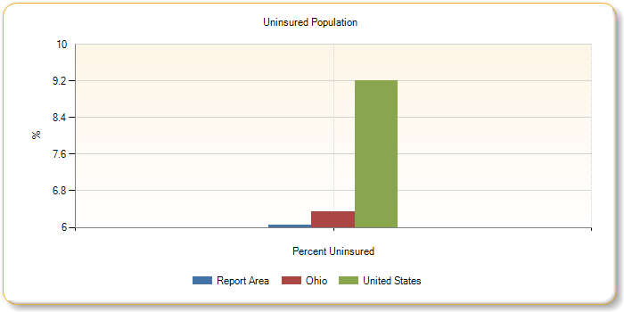
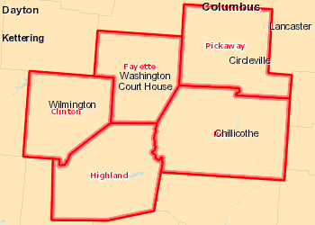 | Uninsured Population, Percent by County, SAHIE 2015  Over 25.0%  20.1 - 25.0%  15.1 - 20.0%  Under 15.1%  No Data or Data Suppressed  Report Area
Please see Community Needs Assessment Online Tool footnotes for information about the data background, analysis methodologies and other related notes.
Report prepared by Community Commons, June 26, 2017.

