2017
Mekia Rhoades
CAC of Fayette County
1/1/2017
Coordinated Public Transit-Human Services Transportation Plan
Table of Contents
Chapter 1 - INTRODUCTION 3
BACKGROUND & PURPOSE 3
Transportation for Elderly Persons and Persons with Disabilities (Section 5310) 4
Rural Transit Program (Section 5311) 5
Grants for Bus and Bus Facilities (Section 5339) 5
Chapter 2 - INVENTORY AND ANALYSIS OF EXISTING CONDITIONS 6
POPULATION 6
INDUSTRY AND LABOR FORCE 12
ECONOMIC PROFILE 14
MAJOR TRIP GENERATORS 16
SUMMARY 21
CHAPTER 3 - INVENTORY OF EXISTNG TRANSPORTATION 22
Outreach Efforts 22
INVENTORY OF EXISTING TRANSPORTATION SERVICES – COMPREHENSIVE SURVEY RESULTS 23
TRANSPORTATION PROVIDER SURVEY & INTERVIEW RESULTS 24
SUMMARY 26
CHAPTER 4 - EXISTING MOBILITY RESOURCES 28
TRANSPORTATION PROVIDER INVENTORY 28
THIRD PARTY CONTRACTS 29
OPERATING STATISTICS 29
STAFFING 29
VEHICLE UTILIZATION 30
SUMMARY 33
CHAPTER 5 - NEEDS ASSESMENT 34
CHALLENGES TO COORDINATING TRANSPORTATION 34
GAPS IN THE EXISTING TRANSPORTATION STRUCTURE 35
SUMMARY 35
CHAPTER 6 - GOALS, OBJECTIVES AND IMPLEMENTATION STRATEGIES/ALTERNATIVES 36
GOAL # 1: IMPROVE COMMUNITY AWARNESS OF AVAILBLE TRANSPORTATION RESOURCES FOR FAYETTE COUNTY RESIDENTS. 36
GOAL # 2: PROVIDE AFFORDABLE, OUT-OF-COUNTY TRANSPORTATION 37
GOAL # 3: PROVIDE MORE SAME DAY GENERAL PUBLIC SERVICE WITH A RESERVATION 38
GOAL #4: COORDINATE EMERGENCY PREPAREDNESS, INCIDENT MANAGEMENT & RESPONSE COMMITTEE 40
GOAL #5: CONDUCT A FEASIBILTY STUDY TO PROVIDE A PARK-AND-RIDE PROGRAM AND VANPOOLING WITHIN FAYETTE COUNTY AND SURROUNDING COUNTIES THAT HAVE HIGH UNEMPLOYMENT RATES. 42
GOAL #6: CREATE TRANSPORTATION OPTIONS FOR OUT-OF-TOWN MEDICAL APPOINTMENTS 43
APPENDIX #1 - 2017 INCLUSION AND PARTICIPATION PLAN Introduction 44
PURPOSE: 44
PARTICIPATION: 45
APPENDIX #2 - COORDINATED PLAN APPROVAL & ADOPTION 47
APPENDIX #3 – MEETING SIGN-IN SHEETS 48
APPENDIX #4 – SURVEYS 57
APPENIX #5 – LEGAL NOTICE AFFIDAVIT 77

Chapter 1 - INTRODUCTION

This Fayette County Coordinated Public Transit-Human Services Transportation Plan (HSTP) contains information, analysis, findings, an evaluation of community characteristics, a stakeholder assessment, and an inventory of existing transportation services. It also provides a description of the unmet transportation needs in Fayette County as determined through various analytical methods such as human service agency and transportation provider surveys, demographic research, local meetings and one-on-one interviews, and conversations with local stakeholders. A series of recommendations is included to address current and projected unmet transportation needs for people with low incomes, older adults, and individuals with disabilities. The intent of this planning process is to create a guide for local decision-makers as they consider advances in the coordination of transportation resources within the county.
Organization and operational strategies are recommended based upon the information and feedback generated during the data analysis and community outreach activities. Community outreach activities are outlined in Appendix C. The Community Action Commission of Fayette County (CAC) and the other project steering committee members were invited to review the contents of this document and provide input to assist in the development of a financially feasible implementation timeline and milestones.
This HSTP document also meets the requirements for the Federal Transit Administration’s (FTA) coordinated transportation plan as set forth in the Safe, Accountable, Flexible, and Efficient Transportation Equity Act: A Legacy for Users (SAFETEA-LU) guidelines.

BACKGROUND & PURPOSE
In August of 2005, Congress passed the Safe, Accountable, Flexible, Efficient, Transportation, Equity Act: A Legacy for Users (SAFETEA-LU), reauthorizing the surface transportation act. As part of this reauthorization, grantees under the Elderly Individuals and Individuals with Disabilities (Section 5310), Job Access and Reverse Commute (JARC) (Section 5316), and New Freedom Initiative (Section 5317) grant programs must meet certain requirements in order to receive funding for fiscal year 2007 (October 1, 2006) and beyond.
On July 6, 2012 the Moving Ahead for Progress in the 21st Century Act (MAP-21) was signed into law by President Obama. MAP-21 funds service transportation programs at over $105 billion for fiscal years 2013 and 2014. This funding replaces the Job Access and Reverse Commute Program (JARC) as of October 1, 2013 and the New Freedom Program in 2012. ODOT will no longer accept new applications for the JARC program or the New Freedom program.

Funding for public transportation is now funded through the Rural Transit Program (Section 5311), this funding is used to assist with operating and capital expenses in the provision of public transportation services in rural and small urban areas. Specialized Transportation Program (Section 5310) is still used to enhance mobility for seniors and persons with disabilities by providing Federal Transit Administration funds for programs in rural and small urban areas.
One of the SAFETEA-LU requirements is that projects from the programs listed above must be a part of a “locally developed Coordinated Public Transit-Human Services Transportation Plan”. This Transportation Plan is required to be developed through a process that includes representatives from public, private, and non-profit transportation services, human services providers, and the general public.
Transportation coordination has been occurring across the nation because the benefits of coordination are clear. According to the Federal Coordinating Council on Access and Mobility’s (CCAM) United We Ride information on its website, nationally, $700 million could be saved if transportation providers would coordinated their individual resources which are dedicated to providing transportation. This conservative estimate is based on a study conducted by the National Academy of Science’s Transportation Research Board (TRB), but it highlights the fact that transportation resources (funding, people, vehicles and services) could be more effectively utilized to provide more transportation for communities.
Transportation is the vital link to jobs, medical care, and community support services. Without it, citizens cannot be productive because they do not have reliable access to employment centers; health care becomes more expensive as citizens are admitted to hospitals with serious health problems because they were without necessary resources to travel to preventative care appointments, etc. The lack of affordable and useable transportation options prevents many citizens from achieving economic and personal independence (CCAM, 2006). Transportation coordination can help provide more trips for agency clients and the general public, and link them to life-supporting employment and services.
Transportation coordination, while making sense from an efficiency and resource utilization standpoint, is also becoming a national mandate. During the last few years, the Federal Transit Administration CCAM developed a national campaign entitled “United We Ride” to help promote transportation coordination. A “United We Ride” website has been posted as a resource for any organization with an interest in transportation for older adults, people with limited incomes, and persons with disabilities. The website contains “A Framework of Action” for local communities and state governments, coordination planning tools, and a multitude of other coordination resources. State “United We Ride” grants have also been awarded to encourage transportation coordination planning at the state level. Fayette County’s HTSP was developed through federal and state support for coordination on the local level.
As indicated above, the U.S. Congress is also supporting the new emphasis on coordinated human service agency and public transportation efforts with the passage of SAFETEA-LU. Coordinated transportation is now an eligibility requirement for the following FTA funding grant programs:

Transportation for Elderly Persons and Persons with Disabilities (Section 5310)
This program (49 U.S.C. 5310) is intended to enhance mobility for seniors and persons with disabilities by providing Federal Transit Administration funds for programs in rural and small urban areas that serve the special needs of transit-dependent populations beyond traditional public transportation services and Americans with Disabilities Act (ADA) complementary paratransit services. The program provides 80% of cost of capital projects; the remaining 20% must be provided by local funding, which may be derived from other federal (non-U.S. DOT) transportation sources or Federal Lands Highway Program. This program also funds Mobility Management.

Rural Transit Program (Section 5311)
The purpose of this grant is to provide Federal and State funds that are used to assist with operating and capital expenses in the provision of general public transportation services in rural and small urban areas. Section 5311 funds can be used for up to 50% of the net project cost of operating expenses and up to 80% of the cost of capital projects. State General Revenue funds, through the Ohio Public Transportation Grant Program, are also to provide up to 30% of eligible operating costs and up to 10% of the costs of capital projects.

Grants for Bus and Bus Facilities (Section 5339)
The Grants for Buses and Bus Facilities program (49 U.S.C. 5339) makes Federal resources available to States and designated recipients to replace, rehabilitate and purchase buses and related equipment and to construct bus-related facilities including technological changes or innovations to modify low or no emission vehicles or facilities. Funding is provided through formula allocations and competitive grants. A sub-program provides competitive grants for bus and bus facility projects that support low and zero-emission vehicles.
One of the prerequisites to apply for funding under the SAFETEA-LU programs is participation in the creation of a “locally developed Coordinated Public Transit-Human Service Transportation Plan.” This HSTP is the first step for all of the organizations that participated in the plan toward satisfying that application requirement.

Chapter 2 - INVENTORY AND ANALYSIS OF EXISTING CONDITIONS
Fayette County is located geographically in the southwest portion of Ohio, and is bordered by Madison County to the North; Pickaway County to the Northeast; Ross County to the Southeast; Highland County to the South; Clinton County to the Southwest; and Green County to the Northwest. The county was named after Marquis De Lafayette, an officer in the American Revolutionary War, was established March 1, 1810, and is 406.6 square miles.
Attractions in Fayette County include the Fayette County Courthouse, the Fayette County Historical Society Museum, Judy Chapel, the Washington Commentary Fountain, and 14 murals created by Harry Ahysen.
Fayette County has access to several major highways. The county is served by the following: Interstate 71; U.S. Routes 22, 35, and 62 and Ohio Routes 41, 38, 207, 729, 734, and 753.

POPULATION
The population of Fayette County in 2010 was 26,973 with a 2015 estimate of 26,639. The county seat and largest city is Washington Court House with a population of 14,192. The population of the county seat decreased by 173 people between 2010 and 2015. Union and Jefferson Townships are the next largest places in the county. Jeffersonville Village, Wayne, Concord and Paint Townships also contain significant portions of the county’s populations (see exhibit II.1).
Exhibit II.1: Fayette County Cities and Townships
Largest Places | 2010 Census | 2015 Estimate
Washington C.H. City | 14,192 | 14,019
Union Twp. UB | 3,733 | 3,690
Jefferson Twp. UB | 1,419 | 1,399
Wayne Twp. | 1,387 | 1,375
Jeffersonville Village | 1,203 | 1,192
Madison Twp. | 1,122 | 1,105
Perry Twp. | 1,041 | 1,025
Paint Twp. UB | 1,037 | 1,021
Bloomingburg Village | 938 | 921
Concord Twp. | 901 | 892
TOTAL: | 26,973 | 26,639
UB: Unincorporated Balance
Source: ODOD, 2010

Population Growth
Between 2010 and 2015, Fayette County’s population decreased by 1.2% (see exhibit II.2). The population is predicted to decrease again between 2015 and 2040.
Exhibit II.2 Fayette County Population Trends

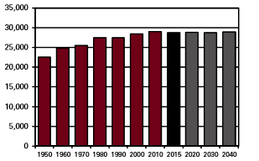

Exhibit II.3 is a map illustrating Fayette County population densities by the 2012 Census Block group. According to the 2012 U.S. Census data, the block groups were high and moderately high population densities were located in downtown Washington Court House. The next highest population densities were also found in and around Washington Court House. Lower density blocks were found throughout the county.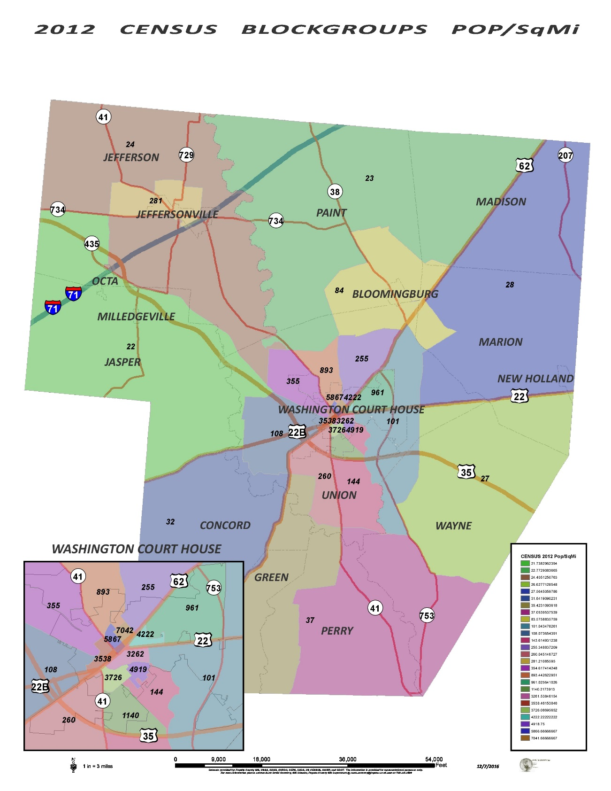
Age Distribution
According to the 2010 Ohio Department of Development, the largest age group was between ages 45 and 64, constituting 28% of the county’s population (see exhibit II.4). The group between the ages 25 to 44 was the second largest, consisting of 24.4% of the population. Approximately 15.7% of the county’s population was 65 and older.
Exhibit II.4 Percent of Population by Age, 2010

Exhibit II.5 shows the distribution of the older population by the 2012 Census Block group as a percent of the total population. The block group with the highest percentages of people age 65 and older (26.25%) were located northeast of Washington Court House. There tend to be a higher percentage of older residents to the West of Washington Court House (18.38%-20.84%). Block groups with lower densities of older adults were found in the Jeffersonville area (11.36%) and extending east.
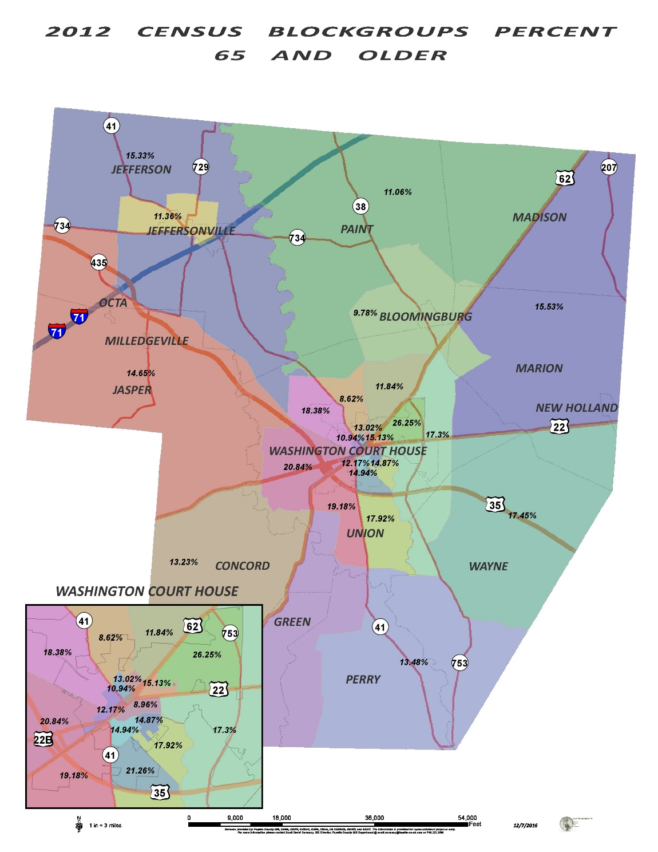

Individuals with Disabilities
Disability incidence data was collected by using the 2010 U.S. Census. The following exhibit (Exhibit II.6) shows the number of people in the county with disabilities by age group, with the highest percentage being in the 18-64 age group. Disabilities include sensory, mental, physical, and self-care limitations.

Exhibit II.6: Population of people with disabilities by age group

INDUSTRY AND LABOR FORCE
Unemployment
According to the Fayette County 2013 Business Retention and Expansion report the unemployment rate for Fayette County is 5.5 percent (Ohio avg. 6.6%; U.S. avg. 6.5%) as of December of 2013. As depicted, unemployment in Fayette County is lower than the average in the state and the national level. Unemployment rates in the county have remained the same from 2007-2013.
Employment and Earnings by Industrial Sector
The manufacturing industry was the county’s largest employer, with 2,972 employees. Retail trade was the second largest employer. State, local, and federal governments employed approximately 1,738 individuals. Exhibit II.7 shows an illustration of individuals employed by the county’s 10 largest employees.
Exhibit II.7: Individuals employed by Fayette County’s Top 10 employers

Exhibit II.8 is a map illustrating Fayette County’s top 10 employers and their location in the county.
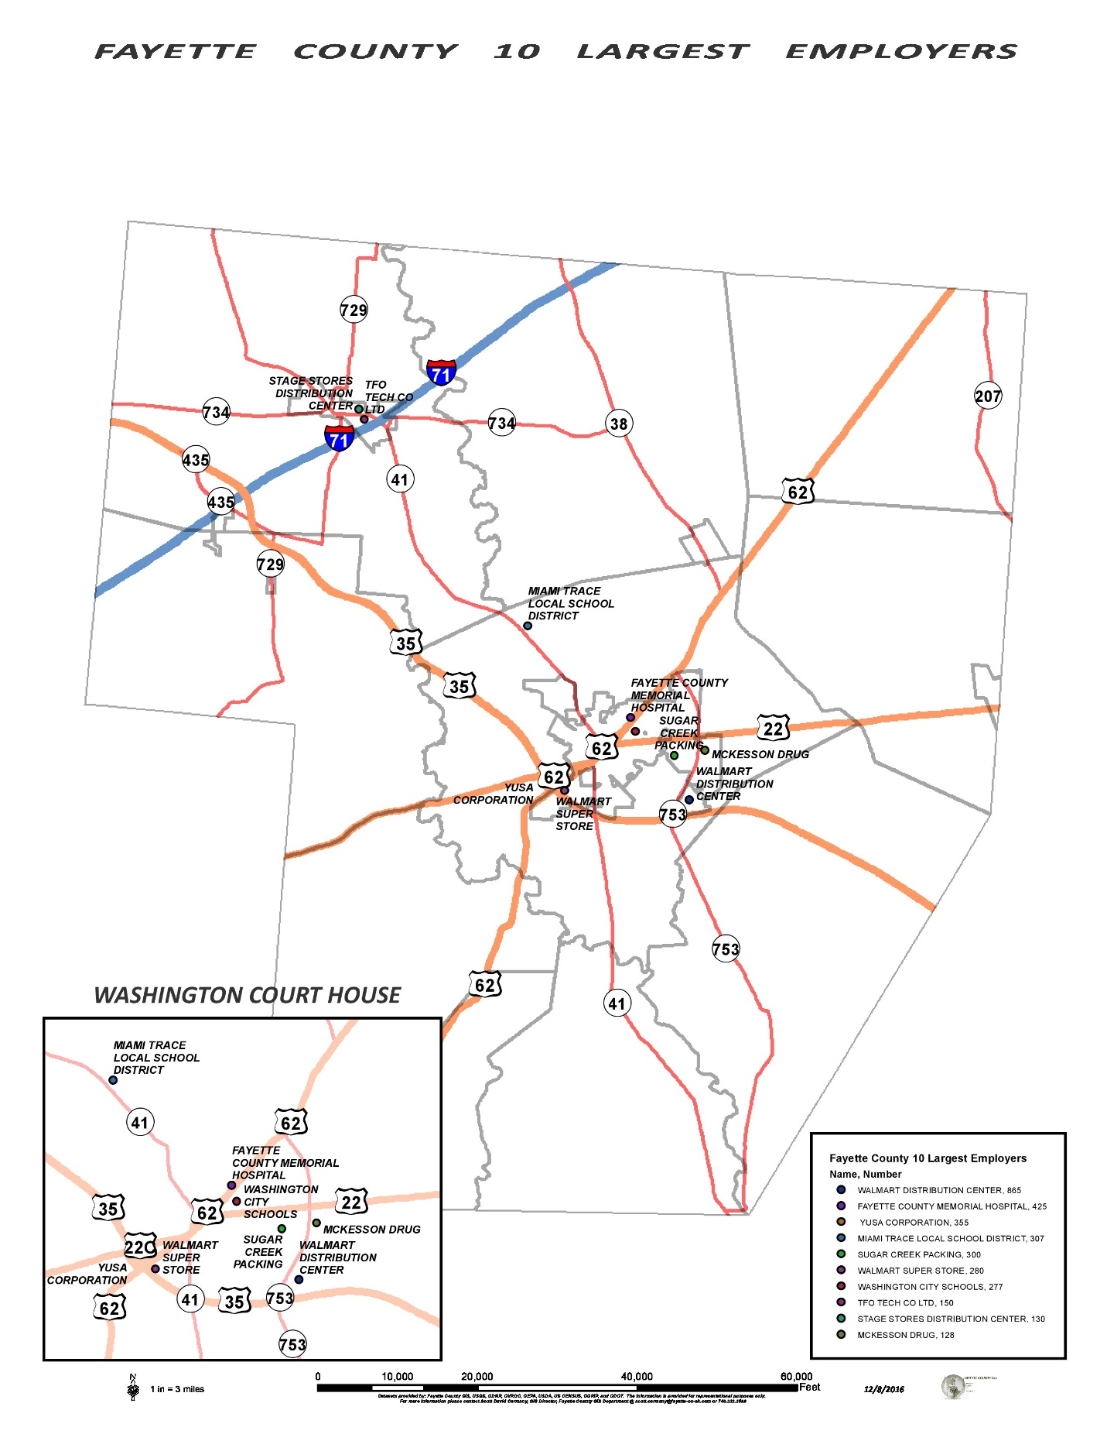

ECONOMIC PROFILE
Household Income Measures
Household income according to the Fayette County profile set the median household income at $40,576. The highest percentage of income was $10,000 to $19,999 with 14.4% of the population earning an income in this range. Exhibit II.9 is a map illustrating the 2010 Census Tracts and Median Household Income in Fayette County.
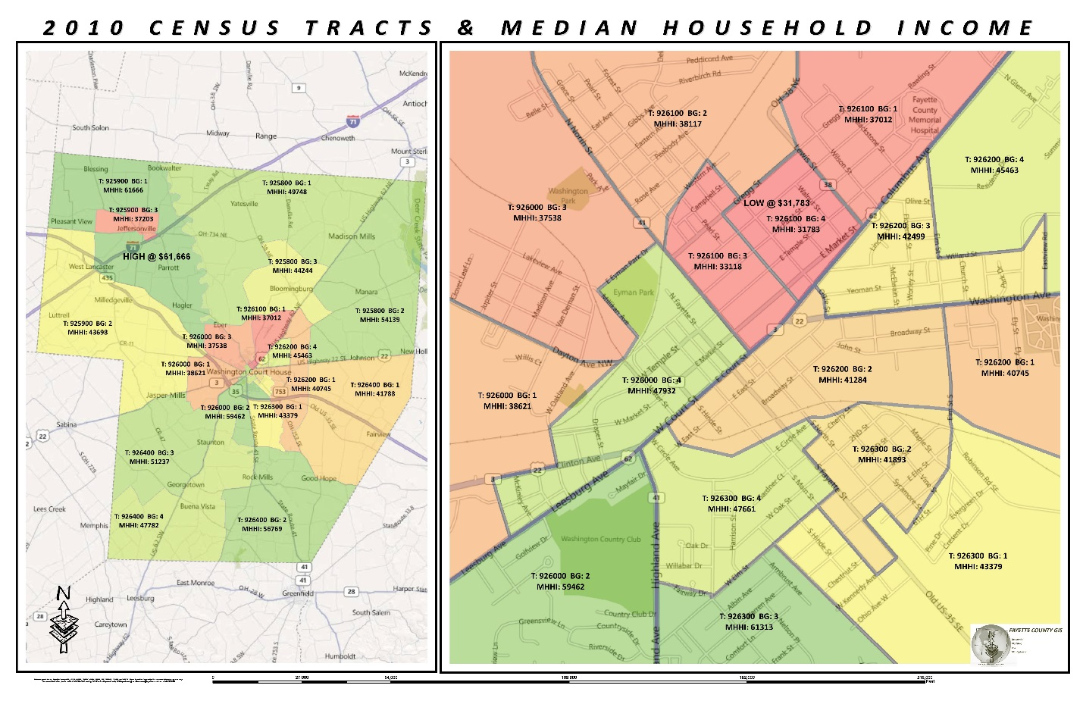

Zero-vehicle occupied housing unit status is another indicator of poverty. Exhibit II.10 is a map that displays a percentage of the population with no vehicle in Fayette County. The highest densities of households with zero vehicles are located north of Washington Court House (33.06%) and the next location being in downtown Washington Court House (22.46%).
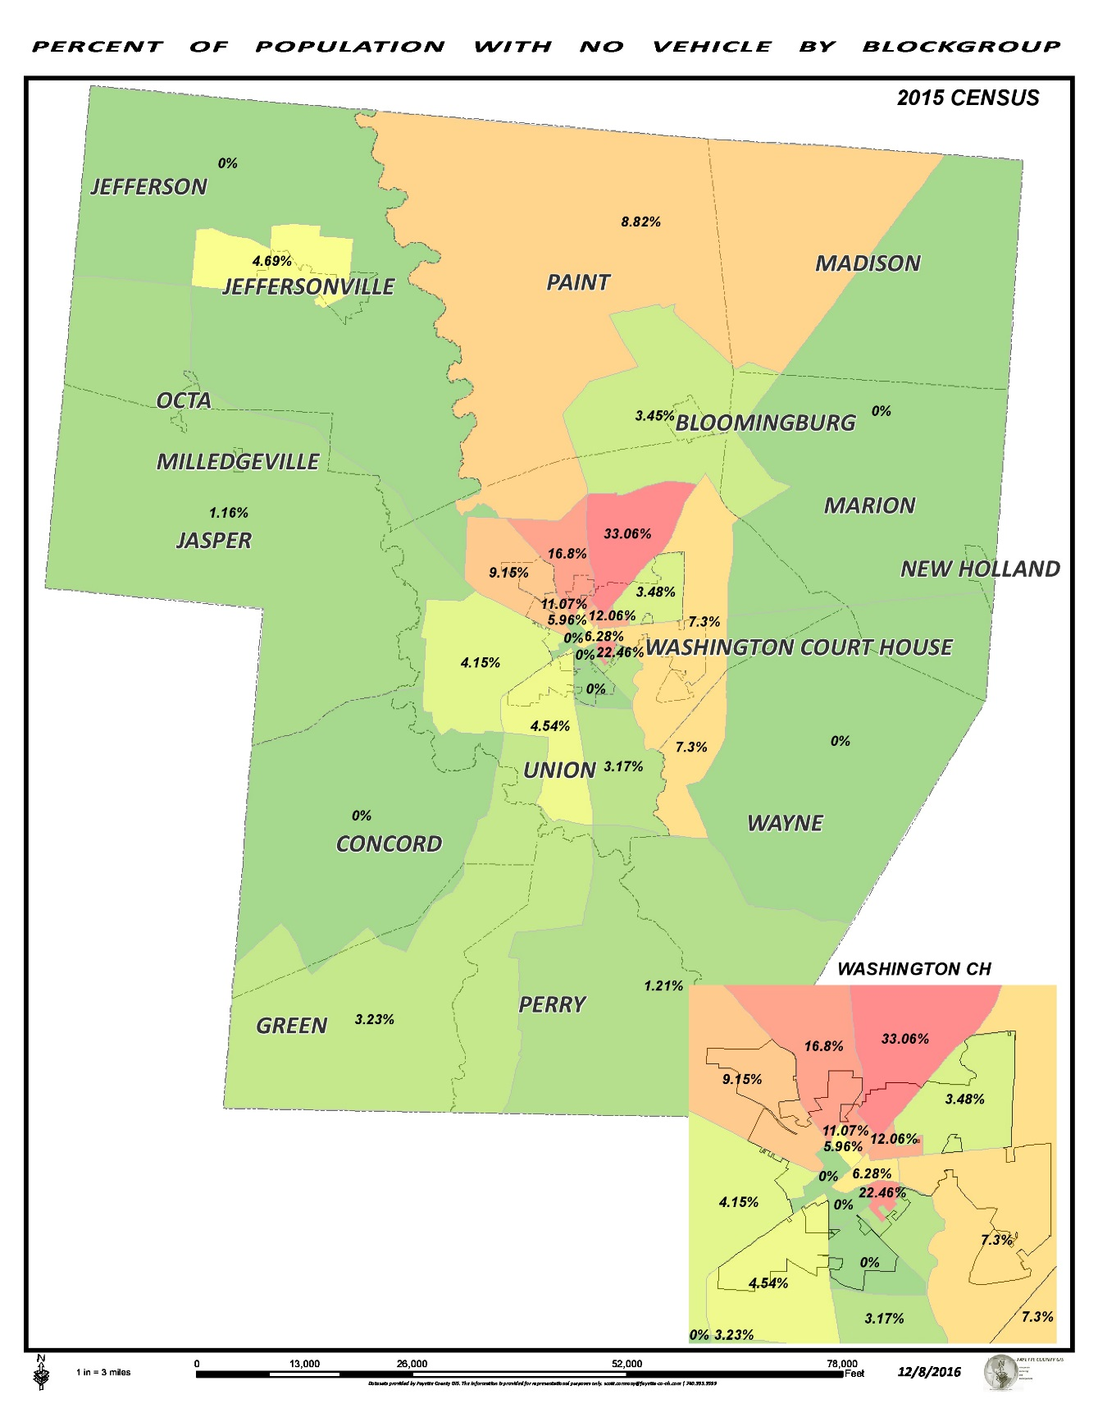
Travel Time to Work
According to the Fayette County profile, most residents travel less than 15 minutes to work (44.8%), with the second largest group traveling 15 to 29 minutes to work (24.9%). Only 7.9% of the population in Fayette County travel 60 minutes or more to work.

MAJOR TRIP GENERATORS
The term “trip generator” is used to describe locations where concentrations of people are likely to live (nursing homes, medical facilities, etc.) or where people are likely to travel to meet their shopping, child care, and health care needs. The following section will discuss health care senior living facilities, quality of life, education, and childcare facilities and their location within the county.
Health Care Facilities
Exhibit II.11 is a map illustrating the geographic location of health care facilities in Fayette County. According to the map most of these facilities (hospitals, pharmacies, doctors, etc.) are located on or around U.S. Route 62.
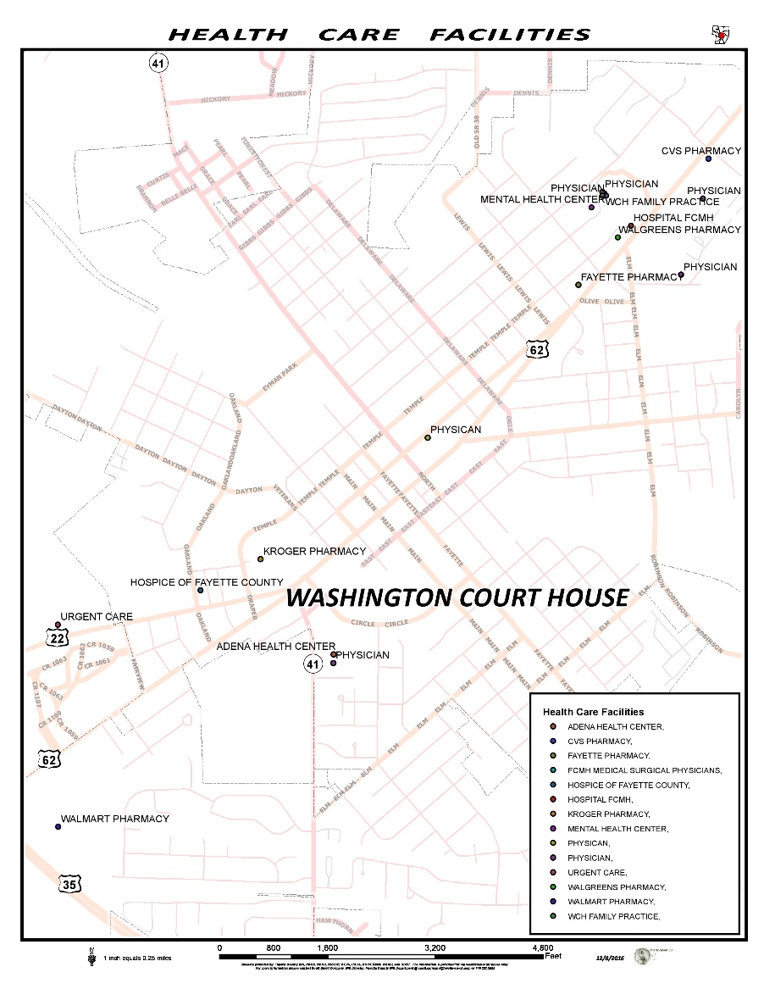
Senior Living Facilities
Exhibit II.12 is a map illustrating the geographic location of senior living facilities (assisted living, nursing homes and etc.). Most of these facilities are located in close proximity to other health care facilities.
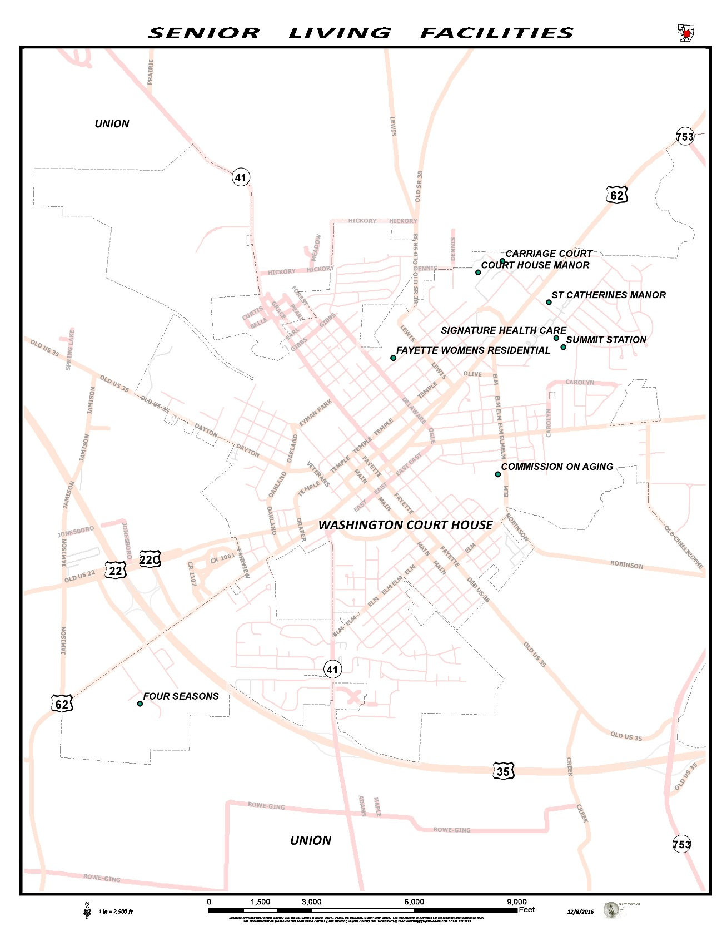
Quality of Life Facilities
Shopping centers, grocery stores, and salons are major trip generators. Exhibit II.13 is a map illustrating the geographic location of most shopping areas and local salons in Fayette County. The Tanger Outlet shopping center is located in Jeffersonville.
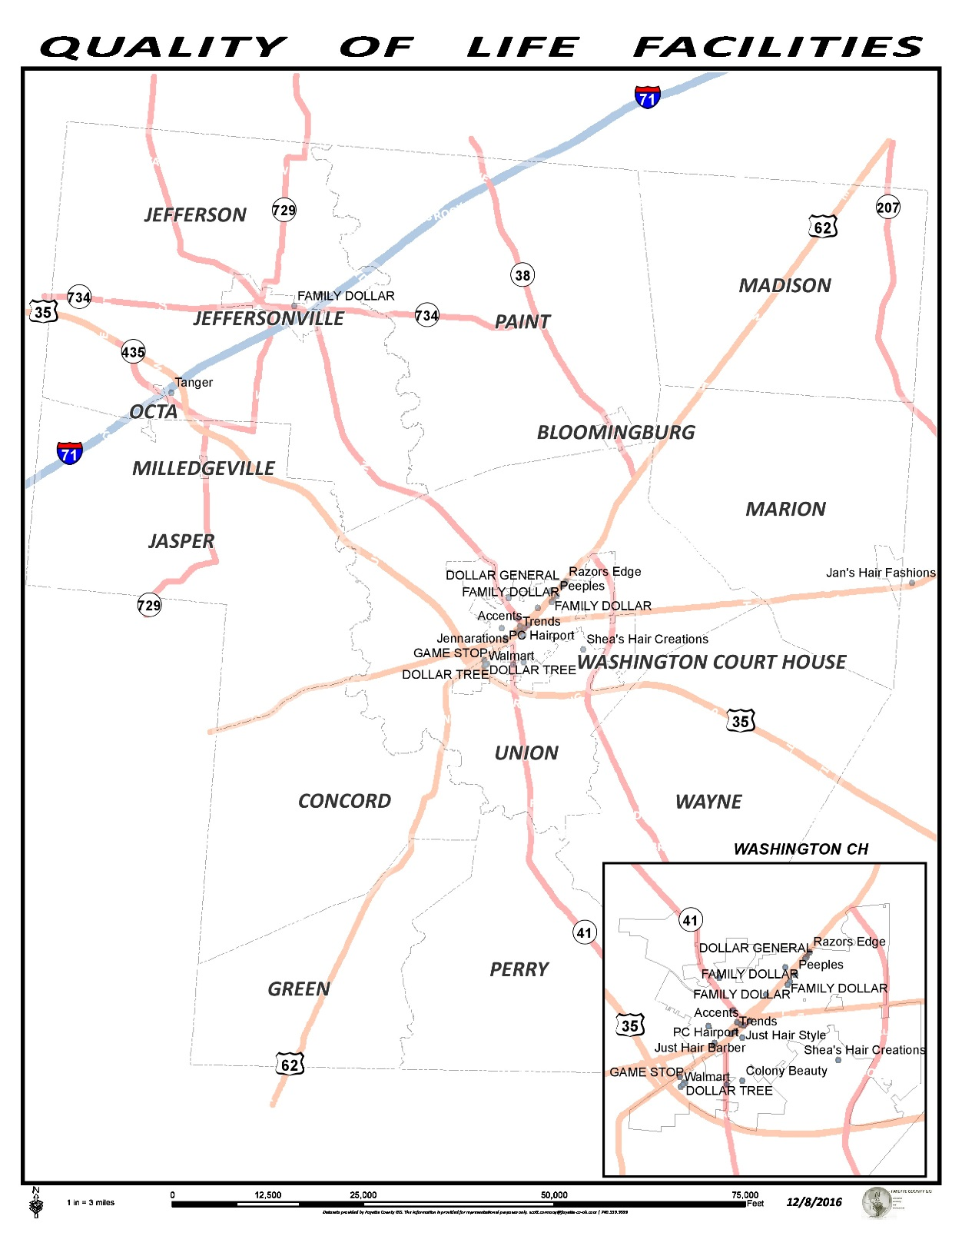

Education Facilities
Exhibit II.14 is a map illustrating the geographic location of the education facilities in Fayette County. Most of the public, private, vocational and colleges are located in Washington Court House.
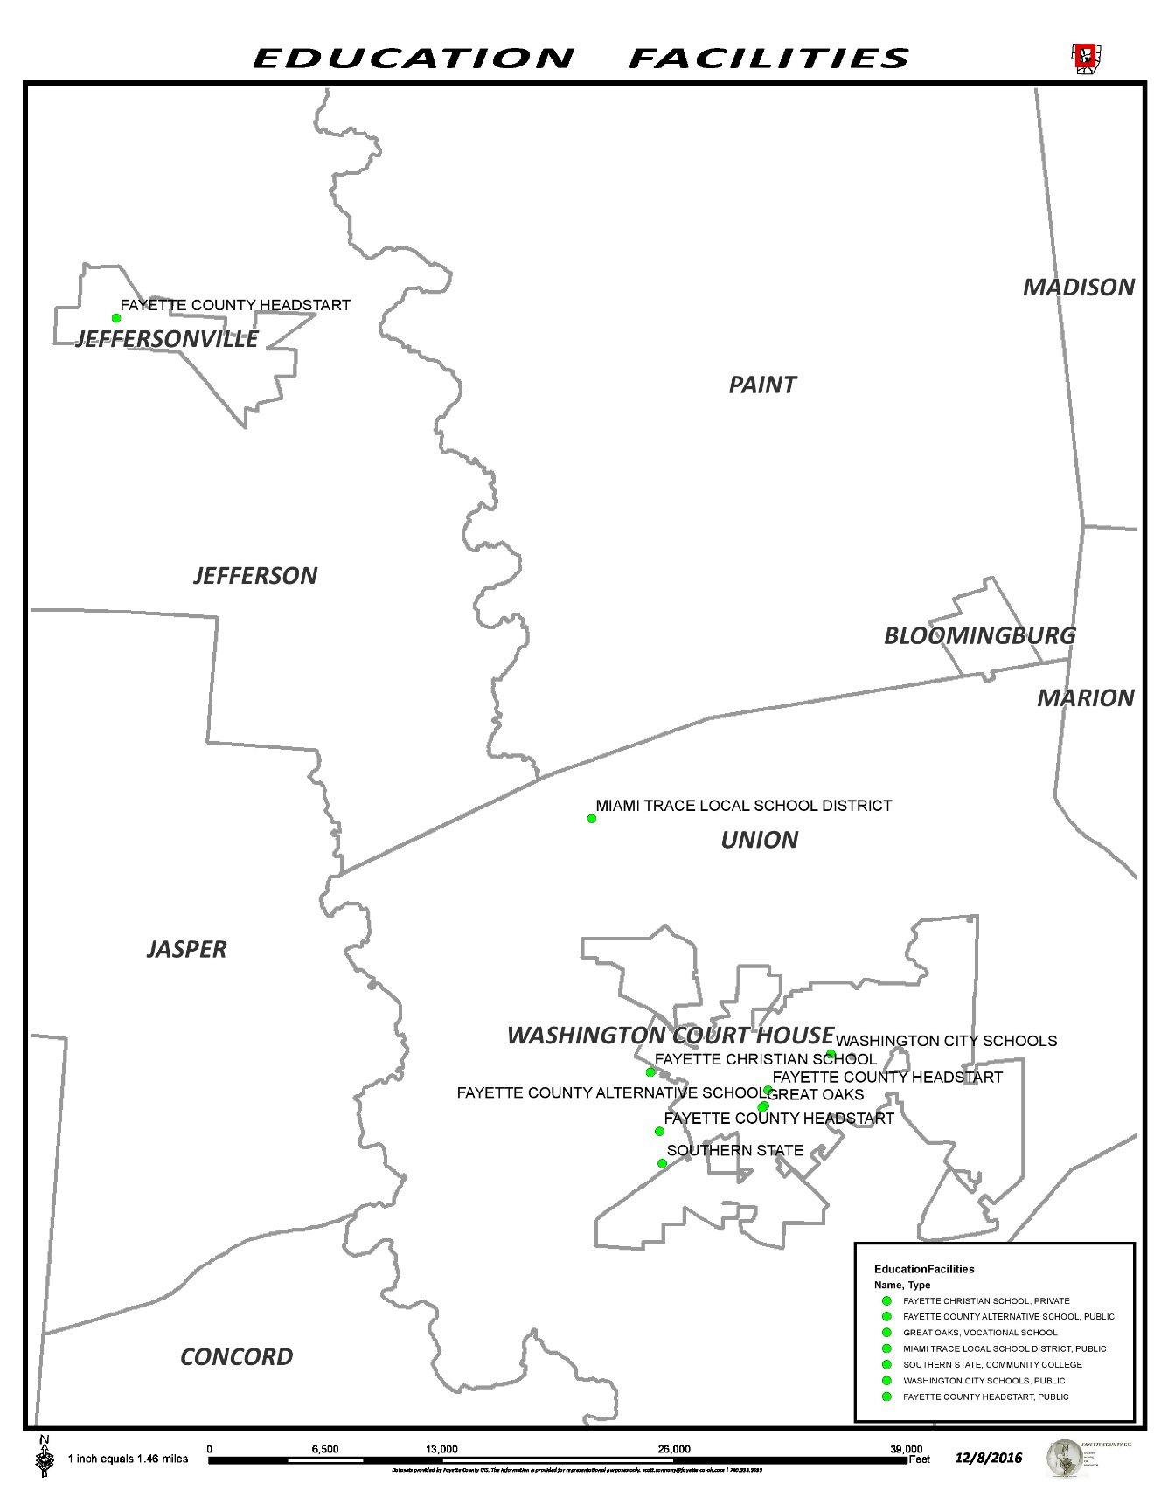
Child Care Facilities
Exhibit II.15 is a map illustrating the location of child care facilities in Fayette County.
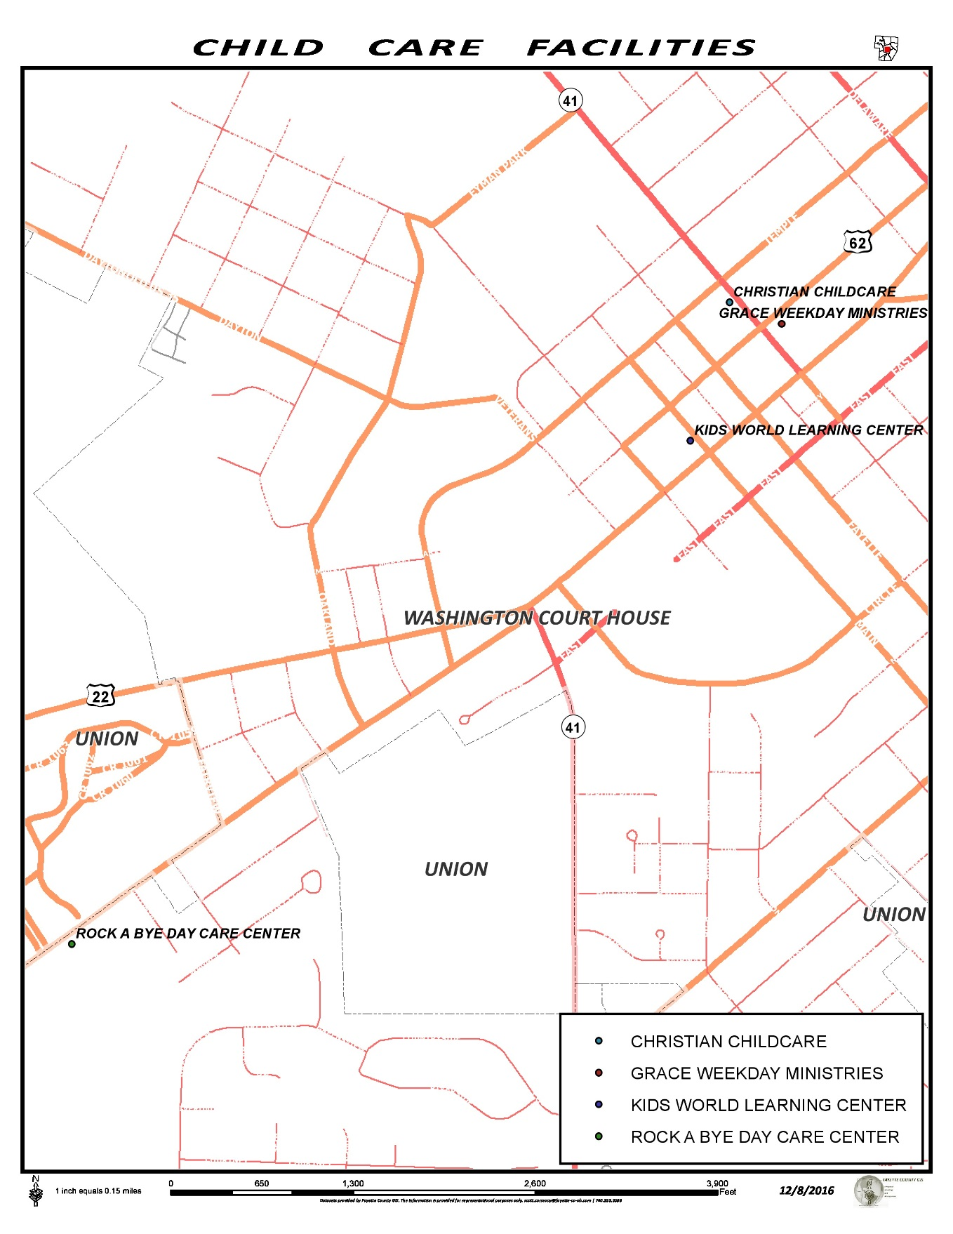

SUMMARY
Fayette County’s population is projected to continue to decrease. According to the 2013 county profile, there were 900 people earning less than $10,000 per year. Although the per-capital personal income continues to grow in the county, these individuals will present ongoing challenges and a need for public transportation.
As Fayette County’s largest age group 45 to 64 years old (28% of the population) moves into retirement, their need for transportation will change. Likewise, the face of the county and the needs for transportation will change further as the age group 18 to 24 (7.7% of the population) joins the labor force.
The highest concentrations of trip generators were found in the heart of Washington Court House. Scattered facilities were located outside of the center of Washington Court House and in Jeffersonville.

CHAPTER 3 - INVENTORY OF EXISTNG TRANSPORTATION

Outreach Efforts
The Community Action Commission of Fayette County contacted local human service agencies, faith based organizations, employers, nursing/assisted living facilities, low income housing facilities and all transportation providers serving Fayette County to gather input and request participation from them. Meetings were set up within the Coordinated Council to discuss the strengths, weaknesses, and the inventory of existing transportation in the county. A summary of the outreach efforts and the results of the surveys is provided in this chapter.
March 15th, 2016 – Introduction meeting:
A meeting was held in the board room at Community Action Commission of Fayette County to introduce the County Coordinated Plan and discuss the importance of the plan in our county. In this meeting the council members discussed ideas to improve transportation and goals they would like to see in the Coordinated Plan. The committee members discussed these goals in detail, the funding required to achieve these goals, time frames for the goals to be met, and the importance of the goal to improve the transportation. We also talked about what a Coordinated Plan is and how coordination in our county works to improve transportation. Outreach efforts were discussed to recruit more people to attend meetings to provide input on the plan. The committee decided on a survey to be distributed throughout the county to stakeholders and other transportation providers. The committee decided to send a separate survey to distribute to the general public and transportation passengers. The Mobility Manager put the surveys together and distributed them to committee members, stakeholders, and the general public.
June 29th, 2016 – Discussion meeting:
A discussion meeting was held within the Coordinated Council to identify the goals to be put in the new Coordinated Plan and survey outreach efforts. The committee recommended that college students be recruited to assist with outreach efforts and research. Unfortunately, we were unable to obtain these the local college, Southern State Community College (SSCC), did not have any interns that were qualified to do the work. The committee members discussed the strengths and weaknesses of transportation and how the new goals would help. Topics of this discussion are outlined below.
- Transportation Strengths
- Affordable fare structure
- Courteous drivers
- Meeting the needs of contracting agencies
- Coordination with other transportation providers
- Transportation Weaknesses
- On time performance
- Evening and weekend hours
- Insufficient out-of-county service
- Long wait times for will call passengers

November 15, 2016 – One-on-One Interviews
Interviews with selected agencies were conducted on November 15th-22nd, 2016. The interview results are summarized in this chapter.

- Head Start – Community Action Commission of Fayette County
- YMCA – Kid’s world of learning
- United Way
- Veterans Services
- Victims Witness
- 3-C Cab
In these interviews, Fayette County Transportation’s strengths, weaknesses, and areas of concern were discussed. On time performance was a concern across the board, with the need of more premium hours and weekend hours being next. An inventory of existing transportation was also taken in these interviews.
November 29th, 2016 – Meeting at Fayette Progressive Industries
A meeting was held at Fayette Progressive Industries with the clients that work there. The clients are a part of the adult work services within the industry and work at the site. Clients working at this site have physical and/or developmental disabilities that keep them from working outside the industry site. At the meeting the clients were shown a copy of the Coordinated Plan and then explained what the plan consists of and the different chapters within the plan. We discussed what coordination was and how it is important in our community. The floor was then open for the clients to discuss their transportation needs and concerns they have with the existing transportation in our community. Clients felt that on time performance and evening and weekend hours were the greatest needs for transportation.
December 1st, 2016 – Meeting at Commission on Aging
A meeting was held at Commission on Aging on December 1st, to discuss the county coordinated plan. Commission on Aging is an agency serving and representing Fayette County residents 60+ years old. They strive to improve their quality of life and keep them living in their homes for as long as possible. COA has a daily lunch they provide to the seniors at little or no cost. The meeting took place before their lunch to explain the coordinated plan and how it is important in our community. We explained the different chapters and discussed the goals that were put into the plan. Once again, on time performance and more evening and weekend hours was the main concern of these individuals. The clients also expressed a need for transportation to community events throughout the year.

INVENTORY OF EXISTING TRANSPORTATION SERVICES – COMPREHENSIVE SURVEY RESULTS
A comprehensive stakeholder survey was sent to twenty-five (25) organizations throughout Fayette County to gain information on existing transportation programs and services. Thirteen (13) agencies responded to the survey, with five (5) agencies being transportation providers. Transportation providers are italicized in the print below.
Survey Respondents
- Fayette County Head Start
- Veterans Services
- Fayette County Commission on Aging
- YMCA-Kid’s World of Learning
- 3-C Cab Company
- Fayette County Memorial Hospital
- The Village Apartment Complex
- Fayette County Health Department
- Hattie Jackson Senior Living
- 4-Season Nursing Facility
- Washington School Apartments
- My Sister’s House Domestic Violence Shelter
- United Way of Fayette County

TRANSPORTATION PROVIDER SURVEY & INTERVIEW RESULTS
The agencies that responded to the survey either provide transportation services or expressed a need for transportation services in Fayette County. Their responses are provided below.
Fayette County Commission on Aging
Fayette County Commission on Aging (COA) is a community-based private non-profit providers of services to residents of Fayette County sixty (60) and older. The major functions of the agency include nutrition, social services, informational/referral, transportation and recreation/social activities. Programs are funded by various agencies, including the Fayette County Commissioners, Area Agency on Aging, Title III-B, and donations.
COA provides transportation for residents ages 60 and older in Fayette County for non-emergency trips. The agency does not require its clients to pay for transportation, but a donation is suggested. The COA shares backup vehicles with the Board of DD. They coordinate with Community Action to transport wheelchair clients when their vehicles are being repaired. They also refer all out of town trips to Community Action.
YMCA – Kid’s World of Learning
The YMCA –Kid’s World of Learning is a private nonprofit organization. Their major function is to provide childcare. They have two (2) locations in the county. Sugar Creek Packing is home to one location, providing child care for infants to preschool age children. The other site is located at the YMCA and provides child care for school aged children.
Transportation is provided to the school aged children to and from the local schools during school months. The YMCA leases a bus from 1st Student Transportation in the summer months for various field trips taken by the children attending the summer camp. No fare is charged to the clients and they must be enrolled in the childcare program to be eligible. Some clients receive child care assistance through Job and Family Services.
YMCA – Kid’s World of Learning believes that transportation coordination is important in the community. They do not set up transportation for their clients, however they do suggest Fayette Transportation or 3-C Cab for their clients that are need of transportation services.

Fayette County Head Start
Fayette County Head Start provides early learning classes for children between the ages of three (3) to five (5) years. This program is operated by the Community Action Commission of Fayette County (CAC).
Fayette County Head Start does not purchase transportation for its clients. The program operates bus routes to pick-up and drop-off children to the early learning centers with six (6) bus drivers dedicated to specifically to transportation. Currently Head Start has seven (7) buses in operation and one (1) bus that is used to take children to dental appointments. The Early Head Start program has two (2) cars used for home visits. In the fiscal year of 2015 Head Start transported 174 kids to and from the learning centers.
The transportation director of Head Start stated that they would like to have a full-time maintenance man on the site during school hours. At this time they are sending the buses to local mechanics to be repaired.
Head Start coordinates transportation with Fayette County Transportation to transport parents to various meetings in the evenings and to transport children to doctors’ appointments. Head Start also provides information and referrals to the parents of the children they serve.
The greatest obstacle for coordination is the restrictions placed on the use of their vehicles. Head Start vehicles require a CDL license, seat belts and a bus monitor. They believe that more funding is needed to improve personal mobility for its clients.
3-C Cab Company
The 3-C Cab Company is a private for profit taxi service in Fayette County. Drivers are independent contractors and lease the vehicle from the company, through an extensive contract. The agreement includes the fare structure and other policies and procedures. 3-C Cab provides immediate response taxi service in Fayette County and to outside destinations. They currently have a contract to provide non-emergency transportation to medical appointments outside the county through Job and Family Services. The local Kroger store has also contracted with 3-C Cab to deliver flowers to customers when they are ordered.
Mandy Pettit, the owner and operator of 3-C Cab feels the coordination in the county is important to ensure no one in the county is without transportation.
Veterans Service Commission
The Veterans Service Commission pledges to serve fellow veterans in Fayette County while holding them in the highest respect and dignity. The organization’s services include transportation, social services, income assistance, and information/referral. Veterans must be honorably discharged to be eligible for assistance from the organization.
Veteran’s Services purchases transportation from Fayette Transportation and 3- C Cab for their clients, giving a 3- day advanced notice for transportation service request. Clients are only allowed transportation service to VA medical centers, unless they are referred by a VA doctor to see a specialist outside of the VA medical center.
Representatives of this organization expressed that the Fayette Transportation drivers need to be more prepared when entering secured medical facilities. They feel that coordination in our county is important to ensure all residents in the county are receiving the transportation they need to improve their quality of life.
Fayette County Transportation
Fayette County Transportation is the county public transportation system, operated by the Community Action Commission of Fayette County, the designated grantee for the county commissioners. This system operates as a demand response transportation service in Fayette County. Fares are $1.00 per one-way trip within the City of Washington Court House, and $1.50 per one way trip for trips into the county. Contract trips, with eligibility requirements, are funded through Medicaid, TANF, Title B of the Older Americans Act, Title XX, and Veterans Services. Pre-purchased tickets are available for clients to or trips can be paid with cash to the driver.
Service is door-to-door. Passengers are permitted to travel with their own personal care attendant if needed. Passengers are required to call for a reservation 24-hours before travel to schedule transportation. Out-of-county non-emergency medical trips are permitted if a referral is received from Fayette County Job and Family Services. Medical trips not funded by JFS have to be approved by another funding source before the trip can be scheduled.
Fayette County Transportation believes that there is good support for coordination in Fayette County. There is strong support from elected officials and other community leaders for the planning of this coordination. Efforts for coordination have been unsuccessful in the past due to statutory restrictions, funding issues, rules on the use of other vehicles, liability and insurance concerns, and turf issues among other providers.

SUMMARY
Invitations to participate in the plan were extended to various organizations including human services agencies, other transportation providers, and stakeholders to obtain information for the plan. Meetings discussing the plan and its importance were held throughout the year. Strengths, weaknesses, and transportation needs were discussed in the meetings.
One-on-one interviews proved to be the best way to obtain information for various parts of the plan. Surveys were filled out by most organizations that received them. Participation from the general public was minimal. Combined results of these activities indicated that agencies and officials are interested in coordination activities that will improve service to older adults, people with disabilities and people with low incomes.

The majority of other transportation providers felt that coordination efforts in Fayette County were better than they have been in the past. They felt that they local providers have a great relationship and work together to ensure transportation needs are being met.
The most common themes expressed by survey and interview participants was the need for more transportation funding, longer daily hours, and more days of service to improve mobility options in Fayette County.
The following chapter outlines the unmet needs and gaps in transportation that have been identified by participating agencies.

CHAPTER 4 - EXISTING MOBILITY RESOURCES

TRANSPORTATION PROVIDER INVENTORY
The following transportation services are currently available to Fayette County residents. Detailed descriptions of the services provided by each organization are included in the Inventory of Existing Transportation chapter.
Fayette County Transportation Program administered and operated by the Community Action Commission of Fayette County, provides general public and contract service.
Fayette County Commission on Aging (COA) provides transportation for Fayette County residents age sixty (60) and older to medical appointments, nutrition sites, grocery shopping, and essential errands. Transportation is only provided in Fayette County.
3-C Cab Company provides taxi services to the general public.
Board of DD provides transportation services to eligible DD consumers. It also provides transportation for preschool aged children in its early intervention program and preschool.
YMCA-Kid’s World of Learning provides transportation for school aged children enrolled in the YMCA childcare program. They provide transportation to and from school during school months and field trips in the summer months.
Fayette County Head Start provides transportation services for children enrolled in early learning programs.
Veteran’s Service Commission provides transportation for veterans.
Fare Structures
Exhibit V.I depicts the fare structure for one-way trips that are provided by the above noted transportation providers.
EXHIBIT V.1: FARE STRUCTURE
AGENCY | DESTINATION | FARE
Fayette Co. Transportation | Within city limits | $1.00
 | Elderly/disabled fare | $0.50
 | Outside city limits | $1.50
 | Elderly/disabled fare | $0.75
3-C Cab Company | Within city limits | $6.00
 | Outside city limits | $6.00+$1 per mile
Commission on Aging | All destinations | Donation requested
Fayette Co. Head Start | Head Start centers | No Charge
YMCA | Daycare related trips | Included in daycare cost
Board of DD | All destinations | No Charge

THIRD PARTY CONTRACTS
Public transit systems use formal contract agreements with local human service agencies, organizations, and business to supplement the local cash match required to provide transit service. The following paragraphs outline existing third party contracts based upon information provided by participating organizations.
- Fayette County Transportation Program has written agency contracts to provide transportation for Fayette County Job and Family Services, Fayette County Veterans’ Service Commission, Sugar Creek Packing Company, TANF, Title XX, Passport, Miami Trace High School, and Central Ohio Area Agency on Aging (COAAA). These contracts provide approximately $227,617 annual revenue for the system.
- 3-C Cab Company has a contract with Fayette County Job and Family Services. The contract amount was not provided.
- Fayette County Commission on Aging has Title III of the Older Americans Act funding for the agency’s transportation program.

OPERATING STATISTICS
Each participating transportation provider’s operating information was requested. The agencies that did not give the information requested are not required to track this information. Therefore, the budget information was difficult to obtain as many agencies do not have a specific transportation budget.
EXHIBIT V.2: SERVICE PROVIDERS’ 2015 OPERATING DATA
System | Service Area | One-Way Trips | Total  Expense | Total Rev. Miles | Total Rev. Hours | Pass.  Per  Hour | Cost per passenger | Cost per Hour
Fayette County Transportation | Fayette  County | 38,030 | $671,348 | N/A | N/A | 15,761 | N/A | N/A
3-C Cab Company | Fayette County | 27,840 | $38,218 | N/A | N/A | N/A | $13.66 | N/A
Fayette County Commission on Aging | Fayette County
Fayette County Head Start | Fayette County |  | $227,260
Fayette County Board of DD | Fayette County

STAFFING
Fayette County Transportation program has eight (8) full-time drivers, four (4) part-time drivers, nine (9) substitute drivers, one (1) full-time transit director, one (1) full-time operations manager, two (2) full-time dispatchers, one (1) full time mechanic and one (1) full-time Mobility Manager.

The 3-C Cab Company contracts with independent drivers. The company has twelve (12) contract drivers.
The Fayette County Commission on Aging has two (2) full-time drivers and one (1) substitute driver.
The Fayette County Head Start transportation program has six (6) full-time drivers and two (2) substitute drivers.

VEHICLE UTILIZATION
The hours and days of the week of available transportation services according to the information provided in the one-on-one interviews or surveys fill out, are listed in the table Exhibit V.3. Agency and public transportation providers generally operate Monday through Friday with the exception of the taxi service, which is available on the weekends.
EXHIBIT V.3: CURRENT PUBLIC AND AGENCY TRANSPORTATION SERVICES
System/Agency | Consumers | Hours of Operation | Days of Operation
Fayette Transportation | General Public  DJFS, TANF, Sugar Creek employees, Title XX, Passport | 8am-4:30pm  5pm-11pm  6am-11pm | Mon.-Fri.  Mon.-Fri.  Sat.-Sun.
3-C Cab Company | General Public  DJFS | 5am-1am  5am-Mon. at 5am | Mon.-Thurs.  Fri.-Mon.
Fayette County Head Start | Head Start Students | 6:30am-5pm | Mon.-Thurs.  During school year
Fayette County Commission on Aging | Older Adults (60+) | 7:30am-5pm | Mon.-Fri.
YMCA | Daycare Consumers | 8am-4pm | Mon.-Fri. during school year, (field trips during summer months).
Vehicle inventory information was requested from each transportation provider within Fayette County.
Results of the inventory requests are provided in Exhibit V.4. This exhibit is a vehicle inventory chart of participating transportation providers throughout the county.

EXHIBIT V.4: CURRENT VEHICLE INVENTORY CHART

SYSTEM NAME | VEHICLE TYPE | ACCESS | PASSENGER CAPCITY | VEHICLE MAKE | YEAR
Fayette County Transportation | LTN | Yes | 8+2 | Ford | 2006
Fayette County Transportation | LTN | Yes | 8+2 | Ford | 2008
Fayette County Transportation | LTN | Yes | 8+2 | Ford | 2009
Fayette County Transportation | LTN | Yes | 8+2 | Ford | 2010
Fayette County Transportation | LTN | Yes | 8+2 | Ford | 2010
Fayette County Transportation | LTN | Yes | 12+4 | Ford | 2013
Fayette County Transportation | CV | Yes | 10+1 | Ford | 2014
Fayette County Transportation | CV | Yes | 10+1 | Ford | 2014
Fayette County Transportation | MMV | Yes | 6+1 | Chevrolet | 2008
Fayette County Transportation | MMV | Yes | 6+1 | Chevrolet | 2008
Fayette County Transportation | MMV | Yes | 6+1 | Dodge | 2010
Fayette County Transportation | MMV | Yes | 6+1 | Dodge | 2010
Fayette County Transportation | MMV | Yes | 6+1 | Dodge | 2010
Fayette County Transportation | MMV | Yes | 3+1 | Mobility Venture | 2014
Fayette County Transportation | MMV | Yes | 3+1 | Mobility Venture | 2014
Fayette County Transportation | MMV | Yes | 3+1 | Mobility Venture | 2014
Fayette County Head Start | Passenger Bus | No | 30 | GMC | 2007
Fayette County Head Start | Passenger Bus | No | 30 | Chevrolet | 2011
Fayette County Head Start | Passenger Bus | No | 30 | Chevrolet | 2011
Fayette County Head Start | Passenger Bus | No | 30 | Chevrolet | 2011
Fayette County Head Start | Passenger Bus | No | 30 | Chevrolet | 2011
Fayette County Head Start | Passenger Bus | No | 30 | Chevrolet | 2010
Fayette County Head Start | Passenger Bus | No | 30 | Chevrolet | 2010
Fayette County Head Start | Passenger Bus | No | 14 | Chevrolet | 2004
YMCA Kid's World of Learning | Mini-Van | No | 7 | Chrysler | 2005
3-C Cab | Mini-Van | No | 7 | Chrysler | 2006
3-C Cab | Mini-Van | No | 7 | Chrysler | 2005
3-C Cab | Mini-Van | No | 7 | Dodge | 2005
3-C Cab | Mini-Van | No | 7 | Chrysler | 2006
3-C Cab | Mini-Van | No | 7 | Chrysler | 2007
3-C Cab | Mini-Van | No | 7 | Dodge | 2004
3-C Cab | Mini-Van | No | 7 | Dodge | 2005
3-C Cab | Mini-Van | No | 7 | Chrysler | 2006
3-C Cab | Mini-Van | No | 7 | Dodge | 2005
Fayette County CoA | Mini-Bus | Yes | 8+1 | Dodge | 2006
Fayette County CoA | Mini-Bus | Yes | 8+2 | Ford | 2006
Fayette County CoA | Mini-Van | Yes | 7 | Dodge | 2005
Fayette County CoA | Mini-Van | Yes | 7 | Dodge | 2013
Fayette County CoA | Mini-Van | Yes | 7 | Dodge | 2013
Fayette County CoA | Mini-Van | Yes | 7 | Dodge | 2009
Fayette County CoA | Mini-Van | Yes | 7 | Dodge | 2011
Fayette County Board of DD | Mini-Bus | Yes | 12+2 | Ford | 2005
Fayette County Board of DD | Mini-Bus | Yes | 15+2 | Ford | 2010
Fayette County Board of DD | Mini-Bus | Yes | 15+2 | Ford | 2010
Fayette County Board of DD | Mini-bus | Yes | 14+2 | Ford | 2006
Fayette County Board of DD | Mini-Van | Yes | 3+2 | Dodge | 2016
Fayette County Board of DD | Mini-bus | No | 15 | Chevrolet | 2014
Fayette County Board of DD | Pick-Up Truck | No | 3 | Chevrolet | 2005

SUMMARY
Fayette County Transportation is the Section 5311 rural public transportation provider in Fayette County. Some of the providers have sources for capital purchase for vehicles (Commission on Aging, Head Start, Board of DD). Others purchase vehicles through operation revenue (3C Cab, YMCA). Others do not operate vehicles at all, but contract out for services.
Several Fayette County organizations utilize third party contracts to supplement local cash match for grant funding, or otherwise recover the fully allocated cost of providing a particular transportation service.
The hiring of a Mobility Manger in Fayette County has made coordination efforts less difficult to administer.

CHAPTER 5 - NEEDS ASSESMENT
Determining the transportation needs for Fayette County is an important part of the Coordinated Plan. Once the existing transportation services were identified and inventoried through surveys, interviews, the next step was to identify the various types of transportation challenges and “gaps” in existing transportation services. In various meetings and one-on-one interviews these challenges, “gaps,” and solutions to the problems were discussed in detail.
Meeting and interview participants were asked to identify and discuss transportation needs for Fayette County. The following needs were documented:
- There is a need for more premium hours and days of services for public transportation. Clients would like to be able to have transportation on weekends and evening hours.
- There is a need for customer service training for drivers and dispatchers.
- There is a need to ensure passengers arrive on time for employment trips and other appointments.
- Affordable out-of-county medical transportation options are needed for passengers not covered by a contract.
- There is a need for a transportation route that can handle more spontaneous trips to various areas within city limits.
- Additional transportation opportunities are needed for children who are otherwise unable to participate in after-school programs because parents have only one or no reliable transportation.
- There is a need to train drivers that are going into any secure medical facility.
- There is a need for a volunteer driver program to assist with out-of-county medical or employment trips.

CHALLENGES TO COORDINATING TRANSPORTATION
There are numerous real and perceived challenges that must be overcome prior to the coordination of human service transportation. The following challenges were identified in the planning process.
- Inadequate funding for transportation.
- Resistance to sharing resources for fear of sacrificing agency autonomy.
- Unique characteristics of consumer population sometimes prevents sharing rides.
- Most transportation providers are restricted to the boundaries of the service areas.
- Insurance liability concerns and guidelines within funding programs prevents agencies from sharing vehicles.
- Lack of unified training for drivers means some drivers do not meet the qualifications needed by some providers.

GAPS IN THE EXISTING TRANSPORTATION STRUCTURE
One of the major goals of coordination is to fill service gaps. Service gaps typically fall into the category of spatial gaps or temporal gaps. Spatial gaps involve limitations with the service area while temporal gaps are concerned with limitations in days of week or hours service is provided. Input from local meetings, one-on-one interviews and survey responses identified the following gaps in transportation services for older adults, individuals with disabilities, and individuals with low incomes.
Spatial Gaps

- Limited funding for out-of-county medical trips for elderly and/or disabled clients.
- There is limited availability for public transportation due to the overwhelming number of people using transportation services.
- There is no regional transportation service with contiguous counties.

Temporal Gaps
- Services hours are not typically structured to effectively support public transportation needs of residents within Fayette County to destinations other than employment facilities.
- Only taxi service is available in the evening hours and on the weekends, which is costly for low income individuals or older adults living on a fixed income.

SUMMARY
The following is a summary of unmet needs as described by individuals and organizations that participated in local meetings, surveys, and one-on-one interviews.
Individuals attending Southern State Community College (SSCC) can only obtain transportation to the campus in Fayette County. Some courses are only available at satellite campuses located in surrounding counties. Transportation to these other campuses would be an asset to the students and SSSCC.
Fayette County’s growing number of older adult residents is in need of affordable out-of-county transportation to medical specialists. With the growing number of people diagnosed with cancer yearly and no treatment facility in the community, this out-of-county transportation need becomes greater every day.
In terms of educating the public about transportation resources that are available to them, changing the public misconception that transportation is only available to the elderly and disabled residents has been an ongoing challenge. Fayette County human service providers, transportation providers, and stakeholders work hard to change the public’s misperception of the public transportation system by providing information for eligibility requirements for all available transportation services in the county. Outreach efforts are made by conducting local meetings, attending provider fairs and speaking at local events about transportation options.

CHAPTER 6 - GOALS, OBJECTIVES AND IMPLEMENTATION STRATEGIES/ALTERNATIVES

GOAL # 1: IMPROVE COMMUNITY AWARNESS OF AVAILBLE TRANSPORTATION RESOURCES FOR FAYETTE COUNTY RESIDENTS.
Objective 1.1: Form a subcommittee within the Coordinated Council to attend all local provider fairs, local meetings, events, and public speaking engagements to provide information on available transportation options in Fayette County. Encourage all transportation providers throughout the county to participate in these events.
Implementation Strategies/Alternatives:
1.1.1: Develop the awareness group to include members from the Coordinated Council, service agency representatives and consumers. This group should be able to bring awareness of transportation options to the citizens of Fayette County. A brochure should be readily available for this group to hand out at events stated above. This body will provide coordination issues, an opportunity for networking and a united group to conduct advocacy efforts county-wide.
Priority/Implementation
Timeframe: Near-Term and continuous.
Parties Responsible: Fayette Transportation Program
(lead agency) and Coordinated
Partners.
Implementation Budget/Costs: Printed material will require a
small budget. Material will be
prepared by Mobility Manager
and Transportation Manager.
Staffing Implications: Time involved attending events
and meetings.
Capital Requirements: None.
Ridership Implications: Potentially an increase in riders
as this committee improves the
public’s awareness of
transportation services.

Performance Measures: Number of events members
attend in representation of
public transportation. Number
of new riders and/or contracts.
Possible new funding sources.

1.1.2: Create a comprehensive public transportation brochure for the committee members to hand out at the events they attend. This brochure should be available in alternative formats including limited English proficiency. It should be distributed in all human service agencies, senior housing, low income housing, and other civic organizations. The brochure should be updated regularly.
Priority/Implementation
Timeframe: Near term and continuous.
Parties Responsible: Sub-committee members and Fayette
Transportation manager.
Implementation Budget: Staff time involved.
Staffing Implications: Staff time involved creating brochure.
Capital Requirements: None.
Ridership Implications: Possibly an increase in riders.
Performance Measures: Brochure is created and distributed
throughout the community, therefore
successfully referring more consumers
to appropriate transportation resources.

GOAL # 2: PROVIDE AFFORDABLE, OUT-OF-COUNTY TRANSPORTATION
Objective 2.1: Coordinate schedules for out-of-county trips to Columbus, Chillicothe, Wilmington, Dayton and Cincinnati. One alternative is to coordinate trips to other counties through feeder service that connects with transportation in other counties.
Implementation Strategies/Alternatives
2.2.2: The Mobility Manager would be responsible for coordinating these feeder service trips with other counties. Drivers could meet at the county line to transfer clients onto connecting counties vehicles to be taken to medical appointments. After the appointment the client would then be transferred back onto a Fayette Transportation vehicle, to be transferred back home.
Priority/Implementation Timeframe: Near Term and continuous.
Parties Responsible: Mobility Manager and Operations
Director.
Implementation Budget/Cost: None
Staffing Implications: Sharing trips could potentially
allow drivers who would normally
be out of the county to be
available for local trips.

Capital Requirements: Possible cost from the other
transportation providers.

Rider Implications: Ridership will likely increase if
more vehicles are available to
provide more local trips.

Performance Measures: Number of feeder trips shared
between multiple agencies.

2.2.3: Develop a fund raising committee to raise money to cover out-of-county trips for clients that do not qualify for any funding sources offered by Fayette Transportation. This committee would have several fundraisers through-out the year.
Priority/Implementation Timeframe: Near Term and Continuous.
Parties Responsible: Coordinated Council Members.
Implementation Budget/Cost: Staff time involved.
Staffing Implications: Staff time involved.
Capital Requirements: None.
Ridership Implications: This could create new ridership by
creating affordable out-of-county
transportation.

Performance Measures: Number of fund raisers held through out
the year and the amount of money
raised. Number of new riders this
funding can cover.

GOAL # 3: PROVIDE MORE SAME DAY GENERAL PUBLIC SERVICE WITH A RESERVATION
OBJECTIVE 3.1: Develop a point deviation route in Washington Court House to operate within the city limits. The route should run on weekends, evening, and during public transportation hours. This will allow for more spontaneous trips, as the client will not need to make a reservation for transportation.
Implementation Strategies/Alternatives:
3.1.1: Fayette County Transportation Program will be responsible for operating the route with an accessible vehicle. The route would not require passengers to make an advance reservation and would deviate up to ¾ of a mile to provide service to individuals with disabilities. This route would serve senior housing, low income housing, tax credit housing, human service agencies, and shopping areas.
Timeframe: Near term and continuous.
Parties Responsible: Coordinated Council Members,
transportation director and operations
manager.
Implementation Budget: To be determined.
Staffing Implications: To be determined. Possibly
two (2) part-time drivers once the route
is ready to run.
Capital Requirements: None.
Ridership Implications: Increase in ridership due to the
the ability to do more unscheduled trips.
Performance Measures: The number of riders on new route.

3.1.2: Market the new route to the general public and human service agency consumers.
Timeframe: Near term and continuous.
Parties Responsible: Mobility Manager, Coordinated Council
members, and other participating agencies.
Implementation Budget/Cost: Staff time and cost of marketing materials.
Staffing Implications: None.
Capital Requirements: None.
Ridership Implications: Increase ridership due to the availability of
affordable transportation.
Performance Measures: Number of people reached.
Number of brochures distributed.
Number of riders on route.

GOAL #4: COORDINATE EMERGENCY PREPAREDNESS, INCIDENT MANAGEMENT & RESPONSE COMMITTEE
Objective 4.1: Ensure that at least one transit employee represents the coordination council committee on the County Emergency Management Agency Board or Local Emergency Planning Commission.
Implementation Strategies/Alternatives:
4.1.1: The Mobility Manager will represent the Coordinated Council and serve on the County Emergency Preparedness Committee, on behalf of the transit providers in the county.
Time Frame: Near-term and on-going meetings.
Parties Responsible: Mobility Manger and transportation providers.
Implementation Budget/Cost: Staff time involved.
Staffing Implications: Staff time involved to attend meetings.
Capital Requirements: None.
Ridership Implications: None.
Performance Measures: Number of meetings attended on a regular basis.

4.1.2: Participate in emergency training and mock emergency situations including National Incident Management System (NIMS) training. Emphasize training for evacuating people who require accessible vehicles.
Time Frame: Near-Term.
Parties Responsible: All transit providers.
Implementation Budget/Cost: Cost of staff to participate in training.
Staffing Implications: None.
Capital Requirements: None.
Ridership Implications: None.
Performance Measures: Increase number of accessible vehicles
available in emergency evacuations.

4.1.3: Create a structured driver training curriculum for emergency evacuation situations within transportation and with the Emergency Preparedness Committee. Drivers should be trained in evacuating clients from the vehicle, how to use a fire extinguisher properly, and proper procedures for inclement weather conditions, seat belt cutter, and have the ability to maintain a safe environment when driving.

Time Frame: Near term and continuous.
Parties Responsible: Participant that is on the Emergency
Preparedness Ready Committee,
transportation director and all transit
providers.
Implementation Budget/Cost: Staff time involved.
Staffing Implications: Staff time involved.
Capital Requirements: None.
Ridership Implications: None.
Performance Measures: Increase in number of trained drivers for
emergency situations and evacuations.

GOAL #5: CONDUCT A FEASIBILTY STUDY TO PROVIDE A PARK-AND-RIDE PROGRAM AND VANPOOLING WITHIN FAYETTE COUNTY AND SURROUNDING COUNTIES THAT HAVE HIGH UNEMPLOYMENT RATES.
Objective 5.1: The program is intended to expand the available transportation options to the jobs in Fayette and surrounding counties. This will increase the volume of affordable transportation to support employment trips for people with low incomes or no means of transportation.
Implementation Strategy/Alternatives:
5.1.1: Develop an outline and timeframe for the feasibility study and designate an organization with the responsibility of conducting the study. Coordinate with the local college to head up the study and report the results to the Coordinated Council.
Timeframe: Near-Term.
Parties Responsible: The outreach effort for the study
would mostly likely involve
employment, social service,
economic development organizations
that serve the local workforce
including individuals with disabilities
and/or people with low incomes.
Implementation Budget/Cost: Expenses associated with the
Development of the study.
Staffing Implications: Labor hours for staff to conduct the
study.
Capital Requirements: To be determined.
Ridership Implications: Analysis of community outreach
results will yield information about
an estimated annual demand if new
regional transportation service were
implemented. Actual ridership will
depend upon the number of vehicles
used for the service and the hours of
operation. The amount of funding
available will determine the level of
service that can be provided.

Performance Measures: Feasibility Study.
If the study supports Park-and-Ride
service: Number of individuals who
participate in Park-and-Rides.

5.1.2: Determine the best agency for creating a regional (multi-county) sub-committee to address transportation, especially employment related transportation needs, for the entire region.
Timeframe: Long-Term.
Parties Responsible: Coordination partners.
Implementation Budget/Cost: None.
Staffing Implications: Designated staff time from
partnering organizations to
participate in the committee.
Capital Requirements: None.
Ridership Implications: Increase Ridership.
Performance Measures: Number of regional meetings.
Number of transit related projects
implemented.

GOAL #6: CREATE TRANSPORTATION OPTIONS FOR OUT-OF-TOWN MEDICAL APPOINTMENTS
Objective 6.1: These options will provide out-of-town transportation for individuals that cannot afford the per mile cost. The clients will be individuals that do not qualify for any funding sources available for transportation.
Implementation Strategy/Alternatives:
6.1.1: Create a volunteer driver program for out-of-town non-emergency medical trips. These drivers would drive clients to and from their doctors’ appointments in their personal vehicles. Gas cards obtained from different organizations could be given to these volunteer drivers. The Mobility Manager would obtain a list of names and phone numbers of possible drivers to be contacted when all other options are exhausted. The volunteers would need to obtain a driving record, proof of insurance and back ground check to qualify. Clients using these volunteer drivers would sign a release form releasing the volunteer driver from all responsibilities.
Timeframe: Long-Term.
Parties Responsible: Mobility Manager.
Implementation Budget/Cost: None.
Staffing Implications: Staff time to call volunteer drivers and
setting up the trip.
Capital Requirements: None.
Ridership Implications: Increase ridership.
Performance Measures: Number of trips given to clients by
volunteer drivers per month.

APPENDIX #1 - 2017 INCLUSION AND PARTICIPATION PLAN
Introduction
Recognizing the great importance of organized mobility, the Safe, Accountable, Flexible, Efficient, Transportation Equity Act: A Legacy for Users (SAFETEA-LU) legislation mandated that coordination become a requirement of federally funded transportation programs. Coordination with human services remained a requirement for Federal Transit Authority (FTA) grantees across all non-rail FTA programs when Moving Ahead for Progress in the 21st Century (MAP-21) replaced the expired SAFETEA-LU in 2012.
Fixing America’s Surface Transportation (FAST) Act (Pub. L. No. 114-94) was signed into law on December 4th, 2015 by President Obama. This act provided a safe, efficient surface transportation system that proved to be essential to the economy and the American’s quality of life. The FAST Act includes important authorizations and reforms to ensure that federal programs can more effectively address the county’s infrastructure needs.
Coordination is defined at the act of multiple agencies working together to meet their clients’ transportation needs. A comprehensive strategy for public transportation service identifying the transportation needs of persons with disabilities, older adults and persons with limited income. The act of coordination and how this will be coordinated with other transportation provider’s through-out the county must be present in the Locally Developed Public Transit-Human Service Coordinated Plan (herein referred to as the Coordinated Plan). The Coordinated Plan will address the strategies for these coordination needs and prioritizing service through-out the county.
Throughout 2016 the Coordinated Council committee will continue to have meetings discussing the importance of coordination to meet the transportation needs of people in the community. This will allow the citizens of Fayette County to reap the benefits of MAP-21. Community Action Commission of Fayette County is the lead agency in the updating of the Coordinated Plan. The Mobility Manager will take the lead on the development of the plan. The Mobility Manager has worked throughout the year with local stakeholders to increase the number of elderly individuals and persons with disabilities who use transportation services to attend Coordinated Council meetings. These individuals will have an active role in the development of the Coordinated Plan, along with the approval and adoption of the new plan. In developing the plan the Mobility Manager will use the most current Census Data, current guidelines and requirements of funding sources, and new data from county service providers. The new Coordinated Plan will be the manifestation of Fayette County’s planning process and recorded in an appendix.

PURPOSE:
By federal law, projects for 5310 funding must be included in the Coordinated Plan. The goals of the plan are to:
- Have the participation of:
- Senior Citizens
- Persons with disabilities
- Representatives of public, private and nonprofit transportation and human services providers.
- Reduce duplication in service throughout the county
- The expansion of service to fill identified gaps in transportation
- Make better use of existing funding sources
- Obtain sustainable funding
- Solicit input and request participation from any organization or persons that could be impacted by the coordinated transportation planning process.

PARTICIPATION:
In order to increase participation in the planning of the coordinated plan, the Mobility Manager worked closely with the management personal at the local senior living facilities. Together they were able to add residents from these facilities to the Coordinated Council. These individuals have been an intricate part of the planning process for the new plan. Along with the complex managers and the residents we have added human service providers and local transportation providers to this committee. Bi-monthly meetings are being held in the board room at Community Action Commission of Fayette County to help in this planning process. The Coordinated Council encourages local governments, human service providers and other community agencies to attend these meetings. The Mobility Manager will continue to meet with stake holders and transportation passengers including: elderly persons, persons with disabilities, low income persons and the general public, to assist in the needs assessment of transportation.
The Coordinated Council encourages transportation stakeholders in addition to all citizens to participate in these meetings, for the planning and implementation of the Coordinated Plan. In addition the Mobility Manager will send invites to these meetings to current and potential committee members.
Current members of The Coordinated Council:
- Management staff and residents from Hattie Jackson
- 4-Seasons nursing facility
- Management staff and residents from Washington School Apartments
- Management Staff and residents from The Village
- Community Action Senior Services Director
- Head Start Transportation Manager
- Fayette County Health Director
- Fayette County Job and Family Services
- Community Action Director of Homeless Programs
- Social Service Director of Fayette County Memorial Hospital
- Assistant Director of Commission on Aging
- Community Action Transportation Director
- Community Action Transportation Operations Manager

The Mobility Manager will continue to contact and invite elderly persons, persons with disabilities, transportation passengers, faith based organizations, employers and other stakeholders that are not active members of the Coordinated Council Committee.
The Mobility Manager has created two (2) surveys to obtain information for transportation. These surveys will be conducted along with face-to-face interviews. The first survey is for public and nonprofit organizations to obtain information identifying strategies to encourage more efficient use of available service providers. The will enhance mobility to the county’s elderly persons, persons with disabilities and individuals with lower incomes. Part of the survey this will help in identifying inventories of transportation services available to these individuals. The second survey is designed for the general public to provide information for transportation needs in the county. The survey asks questions such as: destinations they will be traveling to and from, what days of the week and times needed for transportation, transportation improvements important to the person filling out the survey, age, and best way to communicate delays or changes in transportation. Documentation of all outreach efforts and the level of participation from each organization and person will be included in the Coordinated Plan.
Surveys have been distributed and solicited in a few ways including:
- Distributed at the Coordinated Council Meetings
- Distributed to all Senior Living Facilities in the county
- Delivered to transportation stakeholders to be completed and mailed back to CAC
- Committee members have also distributed and collected surveys filled out by their neighbors.

The Mobility Manager will continue to conduct face-to-face interviews and distribute surveys to stake holders, other transportation providers and riders of public transportation. These surveys will play the part in determining the needs assessments and transportation barriers throughout the county. Once the needs assessments and barriers have been identified, they will be listed in the plan and strategies and goals for each need and barrier will be created. The Mobility Manager will meet again with committee members for a review of these goals and they will be put in the Coordinated Plan. The Committee members will agree to adopt and approve the plan and provide a signature to the final plan. For the vote to adopt/approve the plan majority approval (51%) will be needed.

APPENDIX #2 - COORDINATED PLAN APPROVAL & ADOPTION
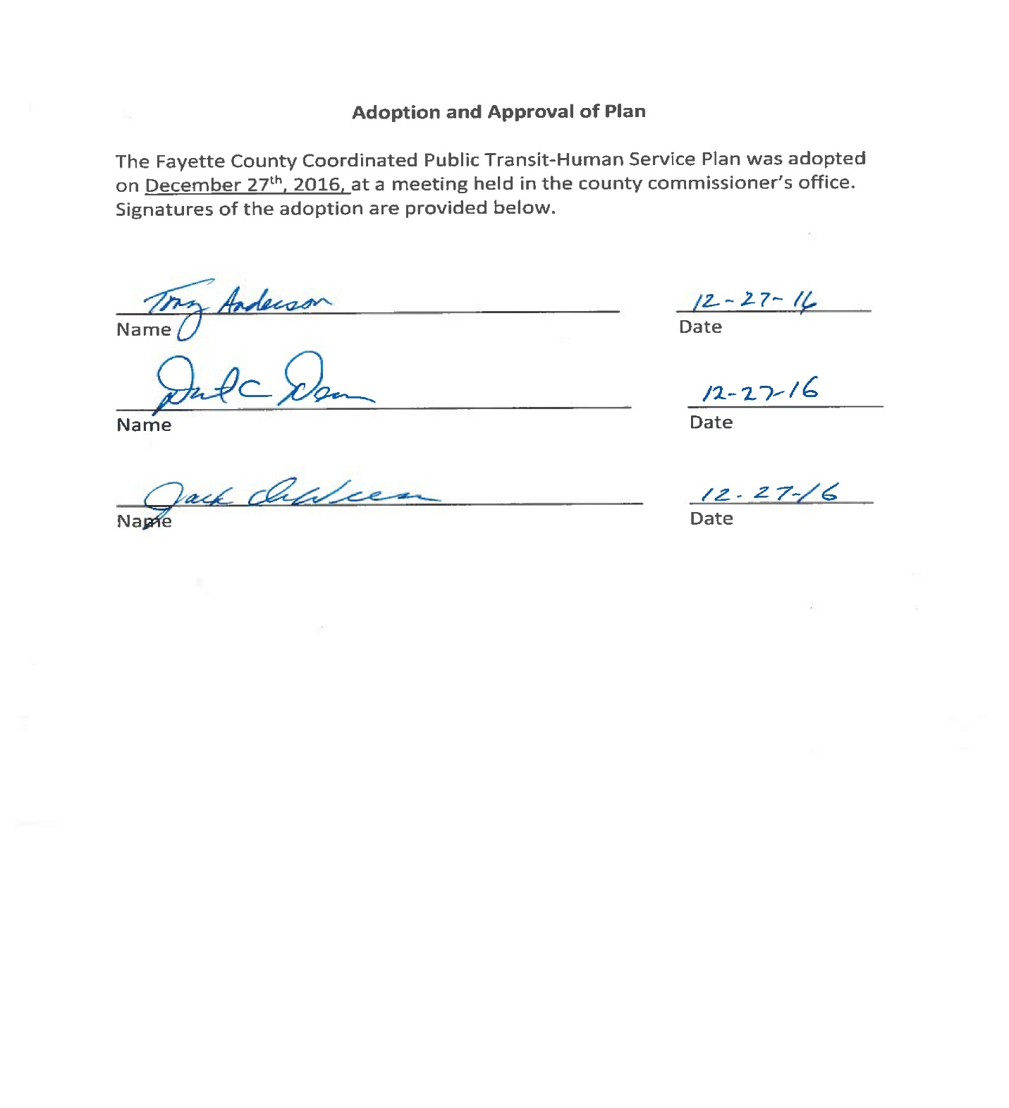

APPENDIX #3 – MEETING SIGN-IN SHEETS
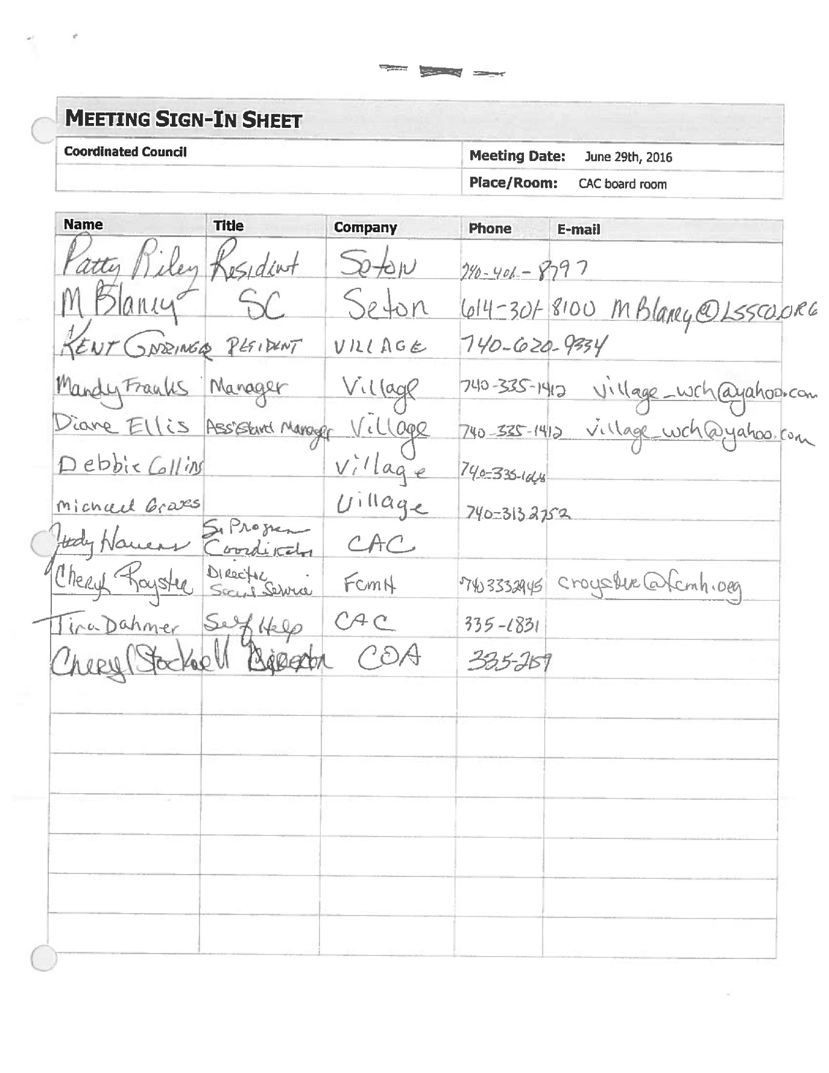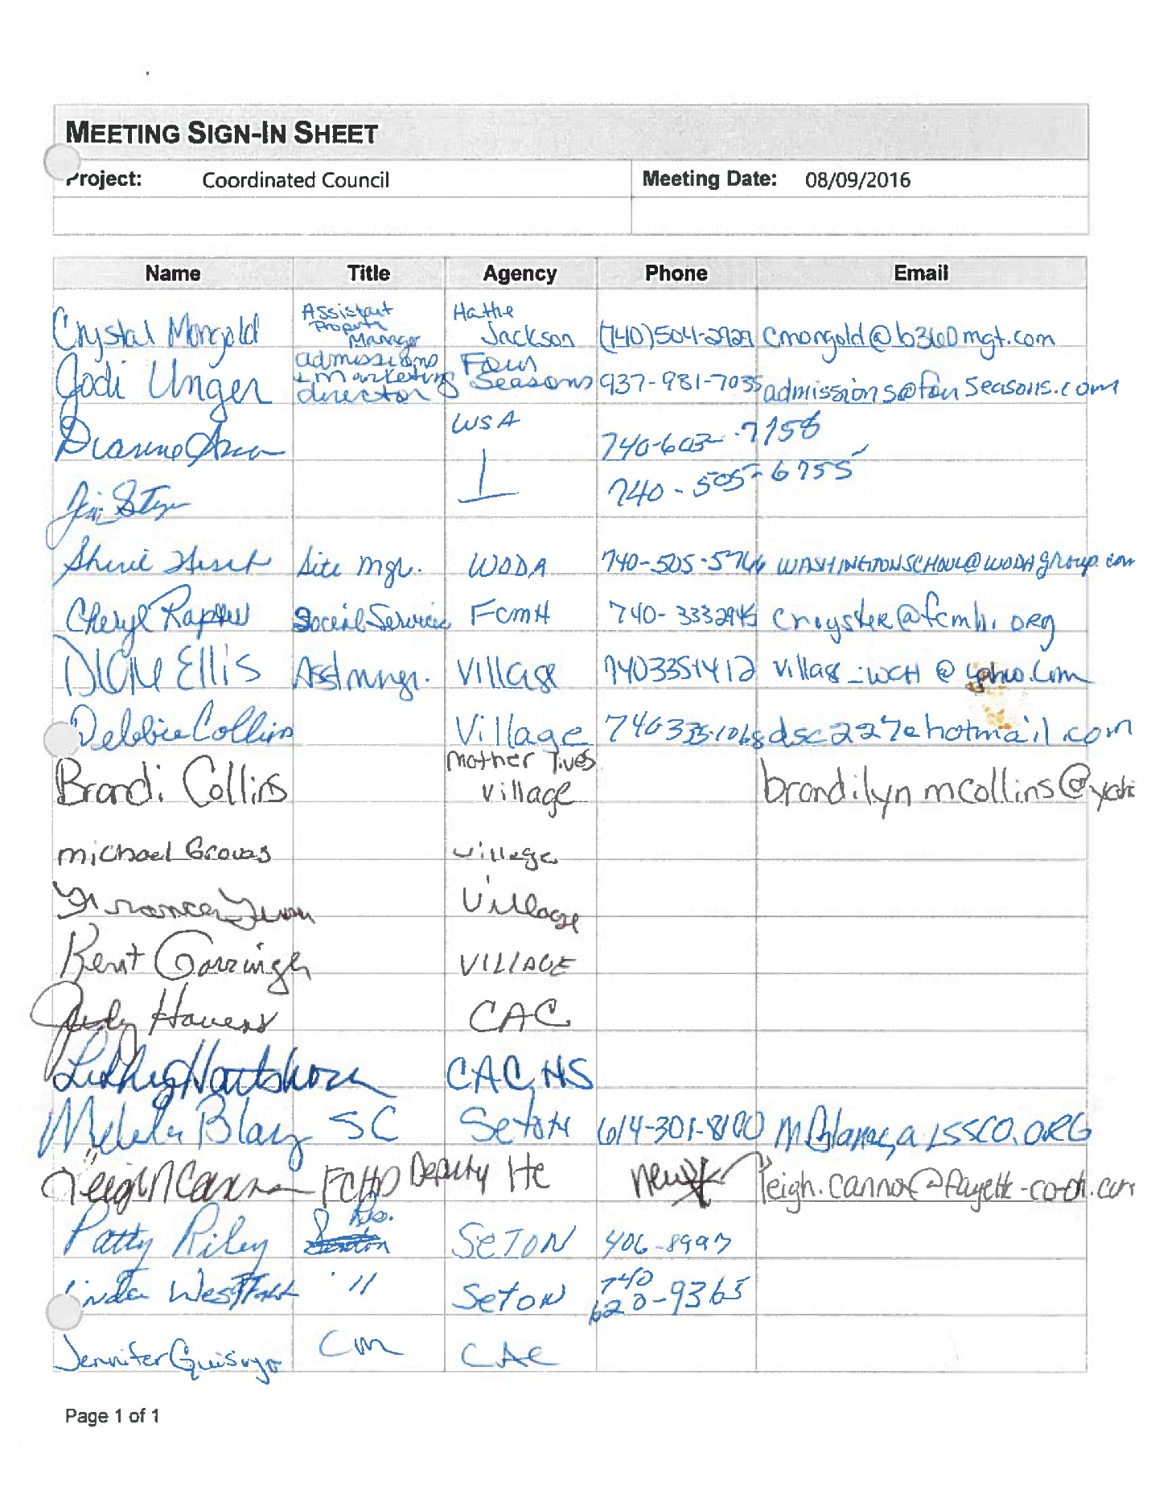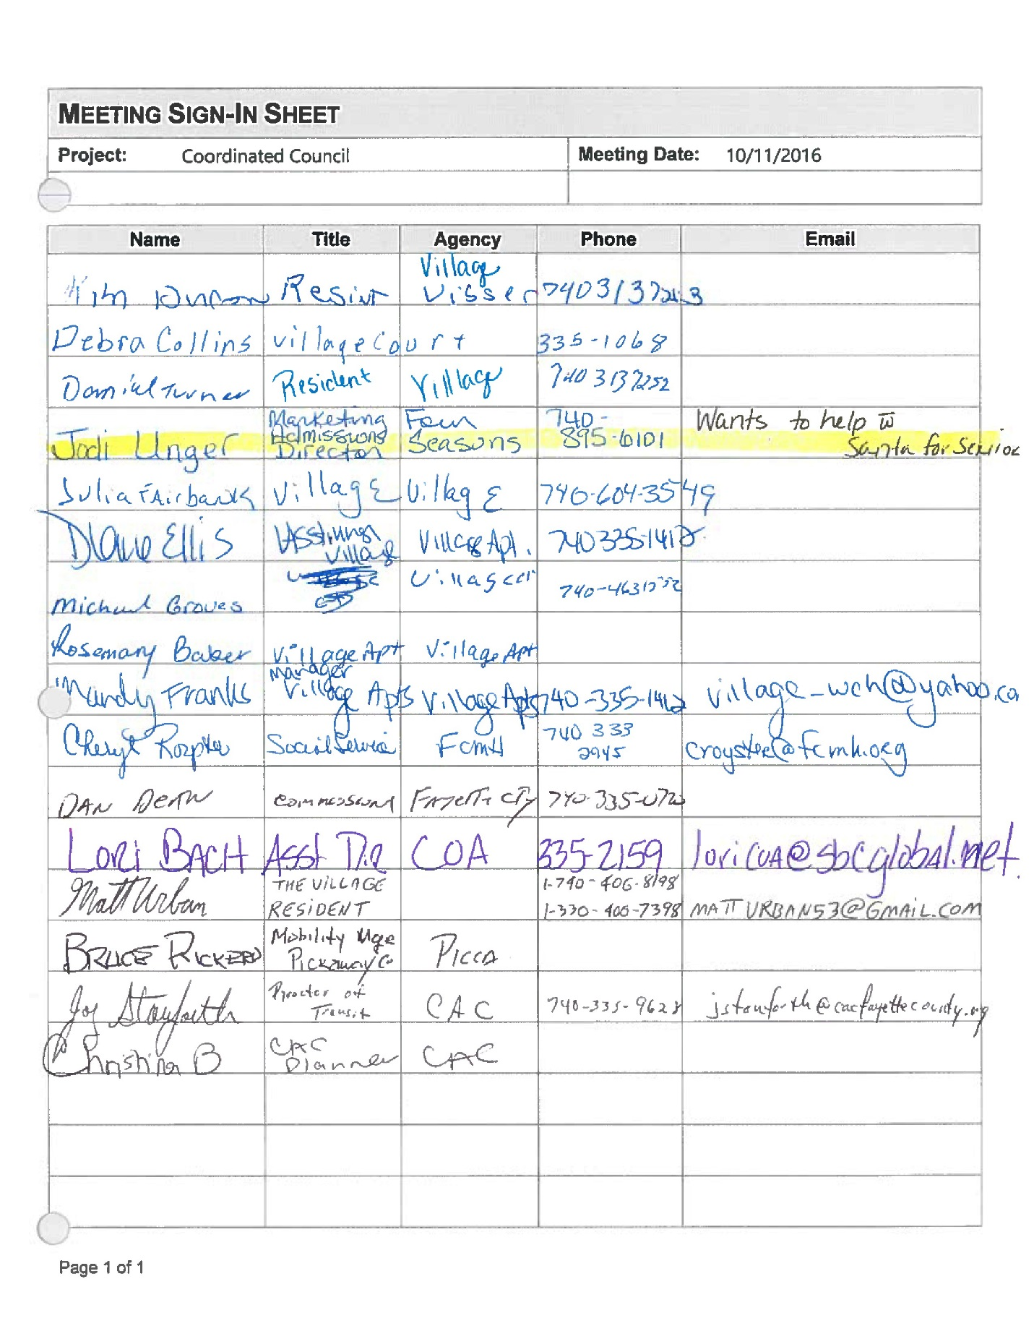

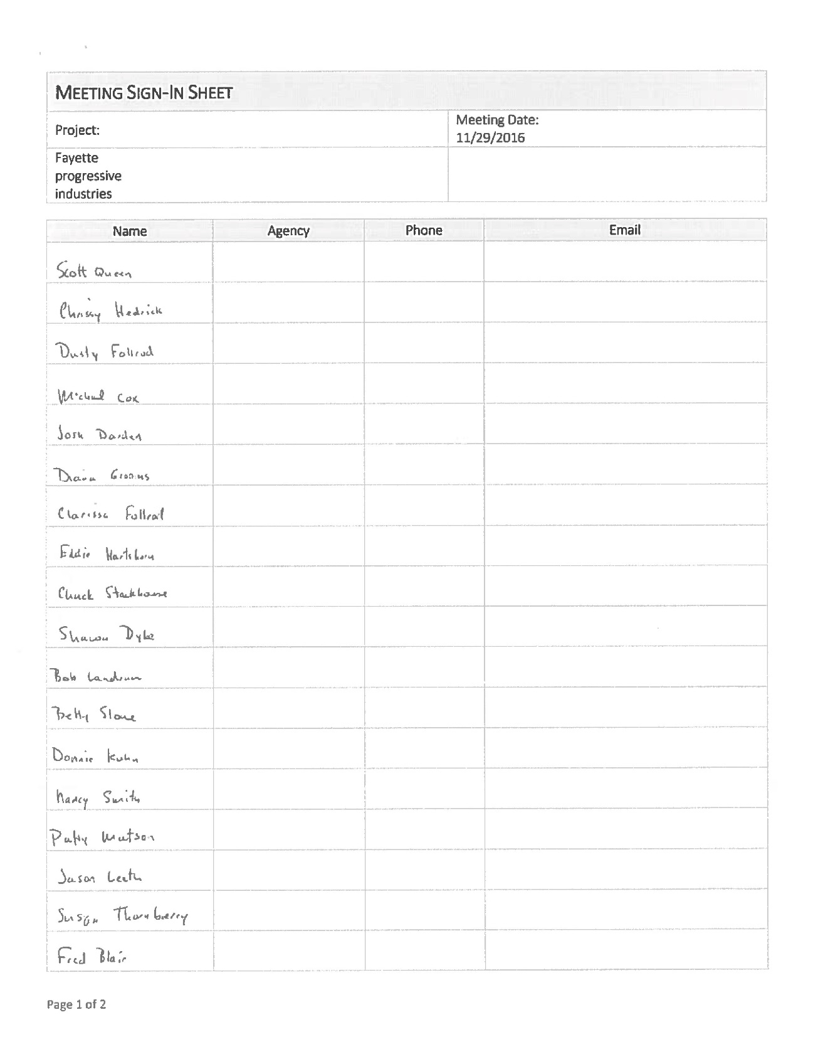

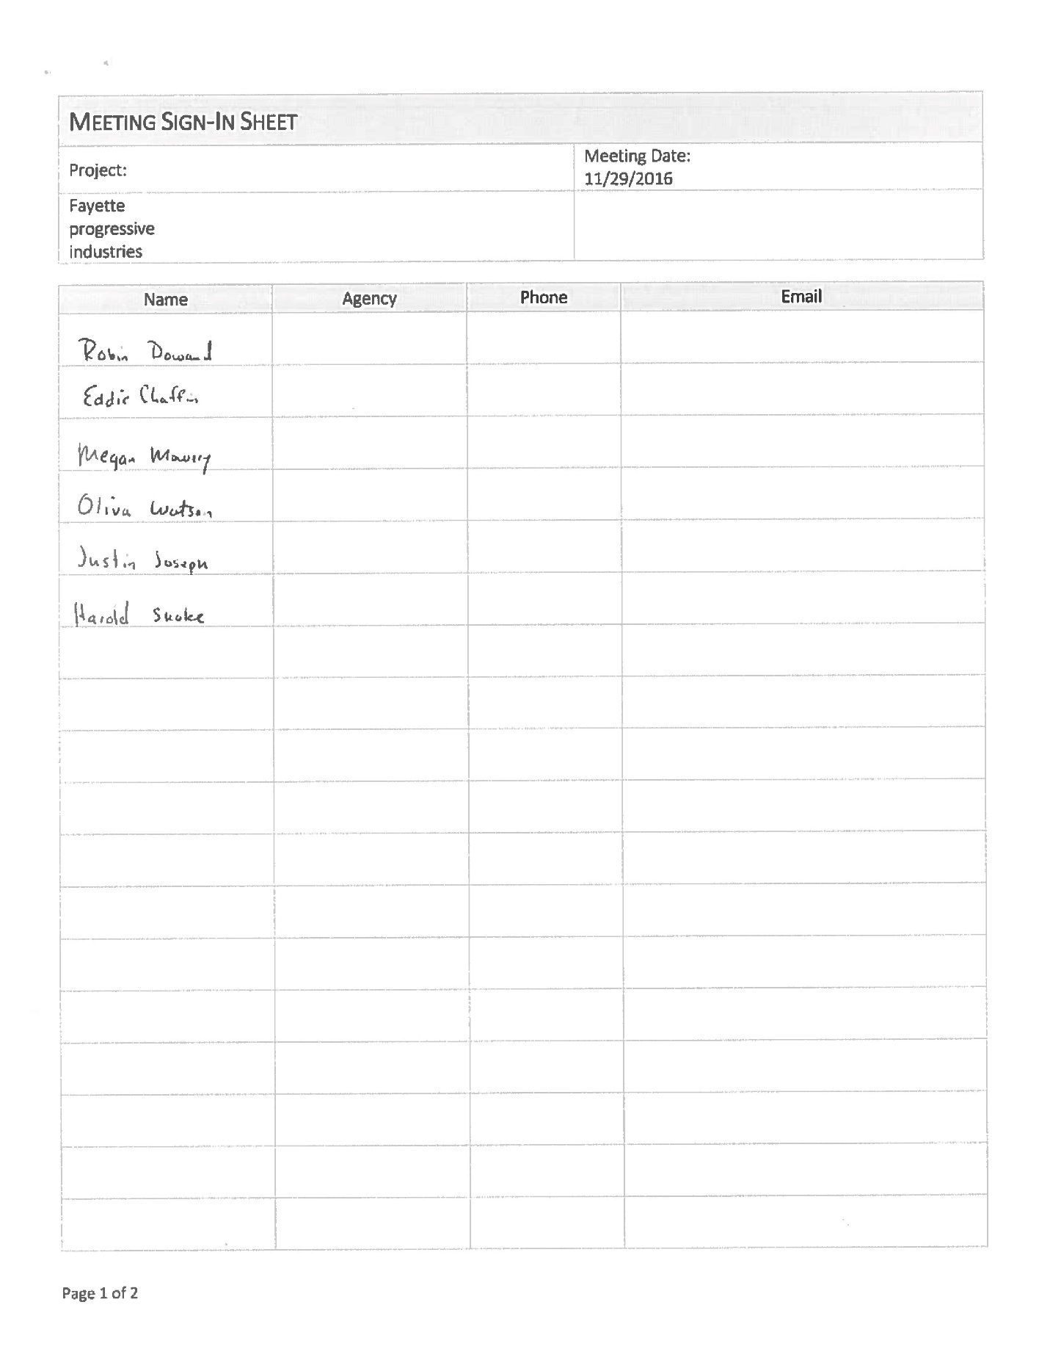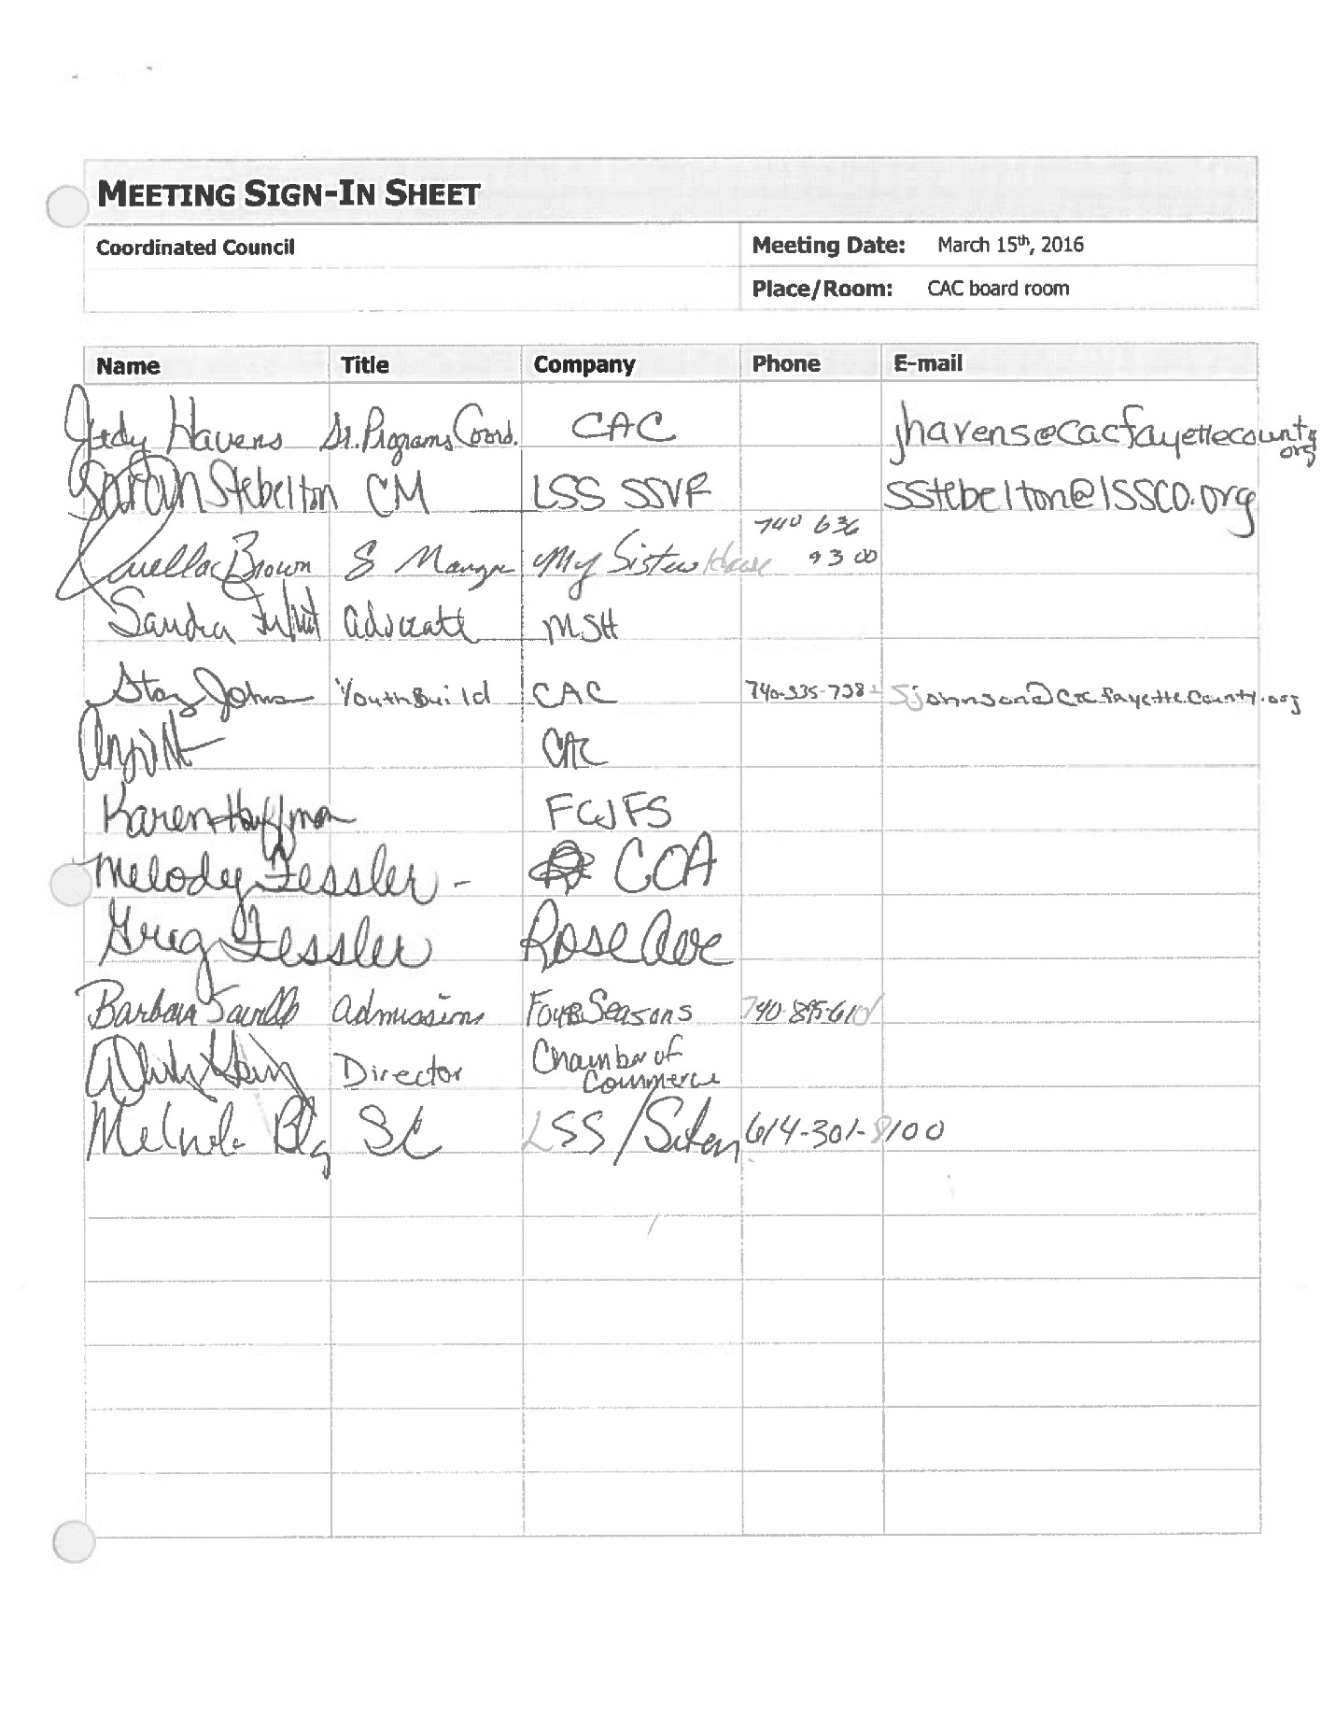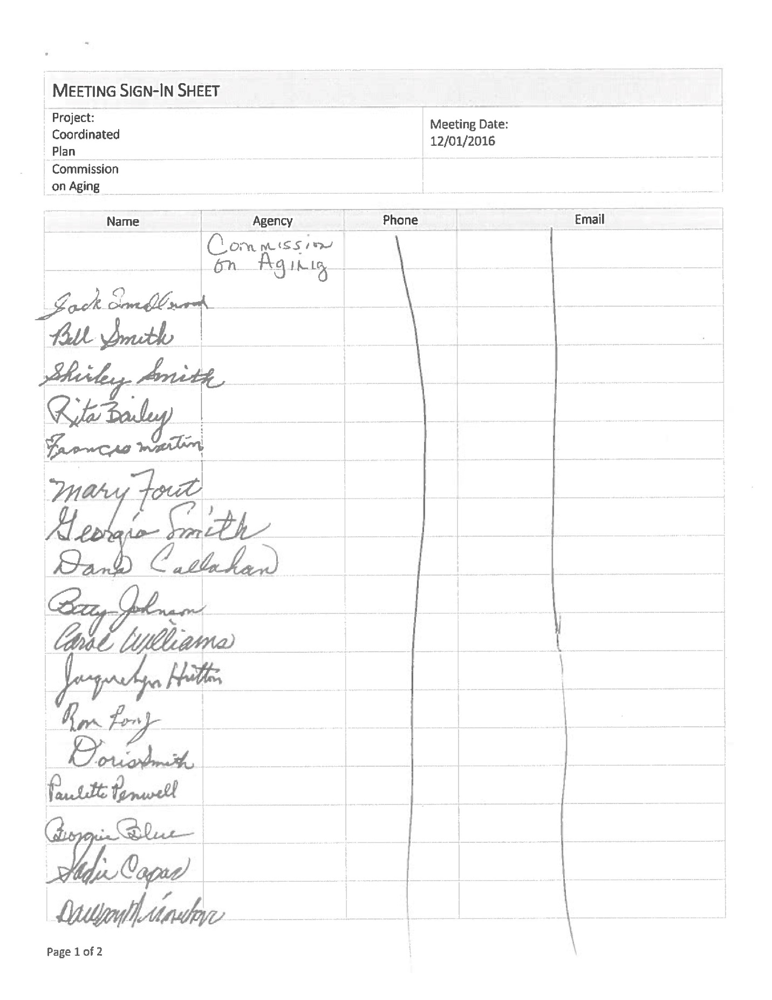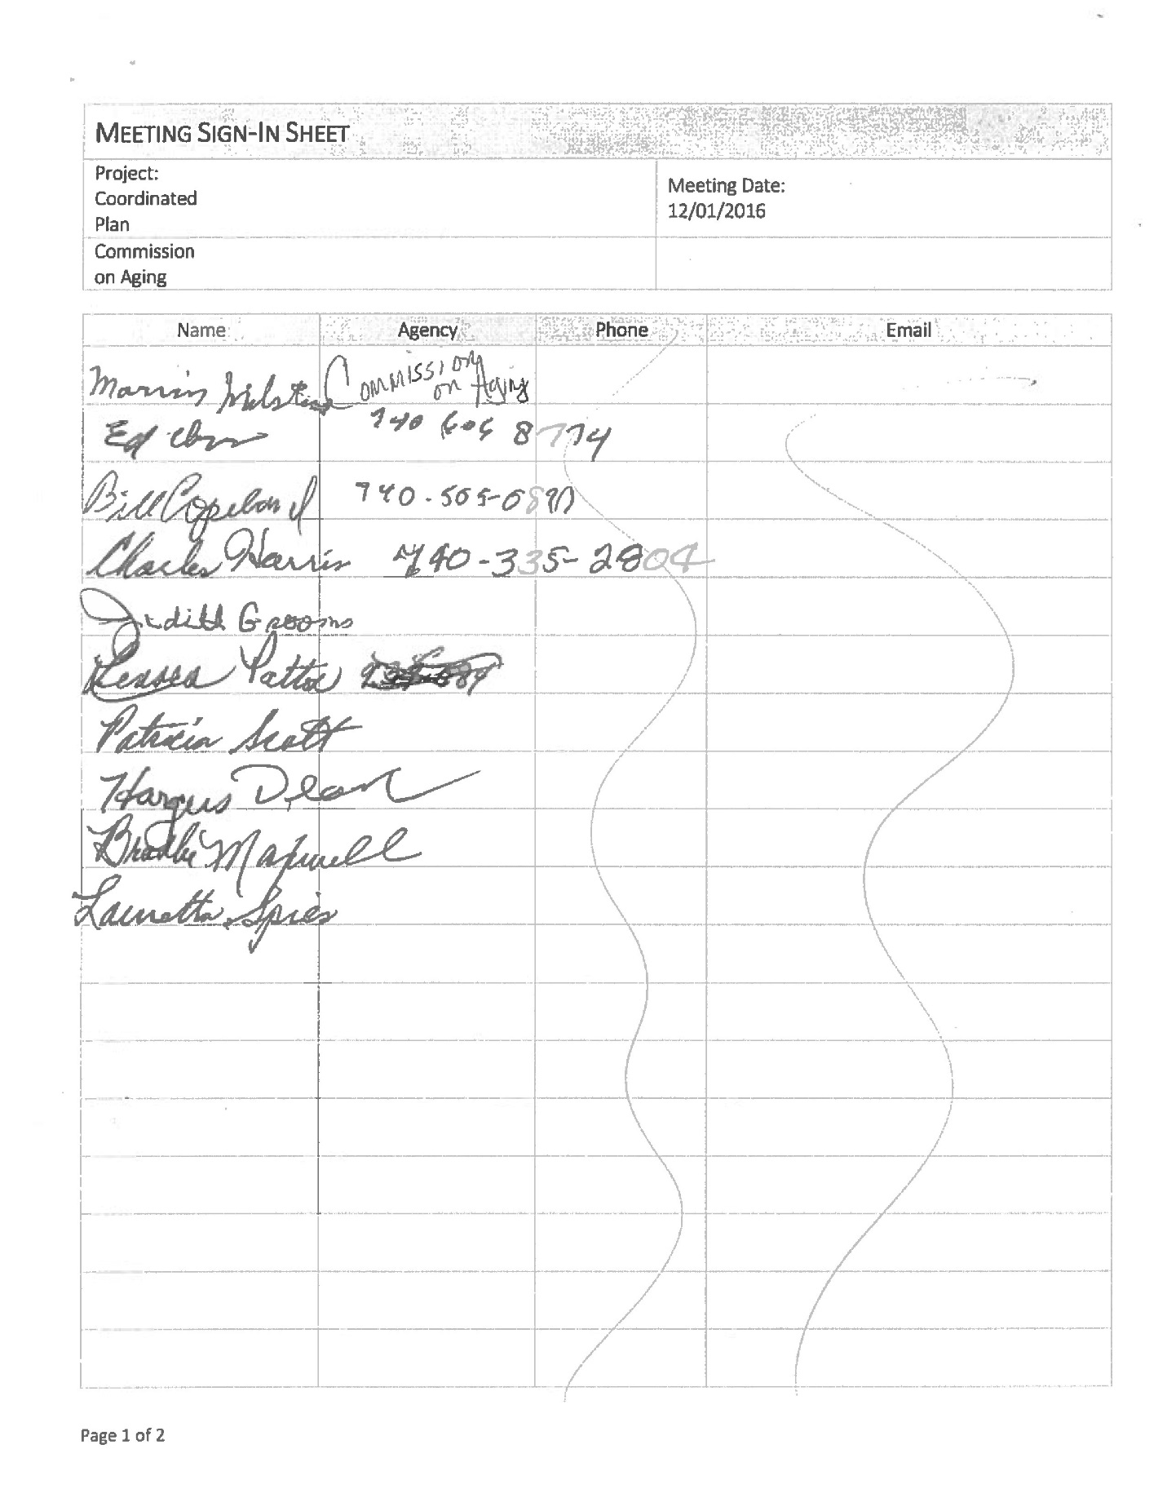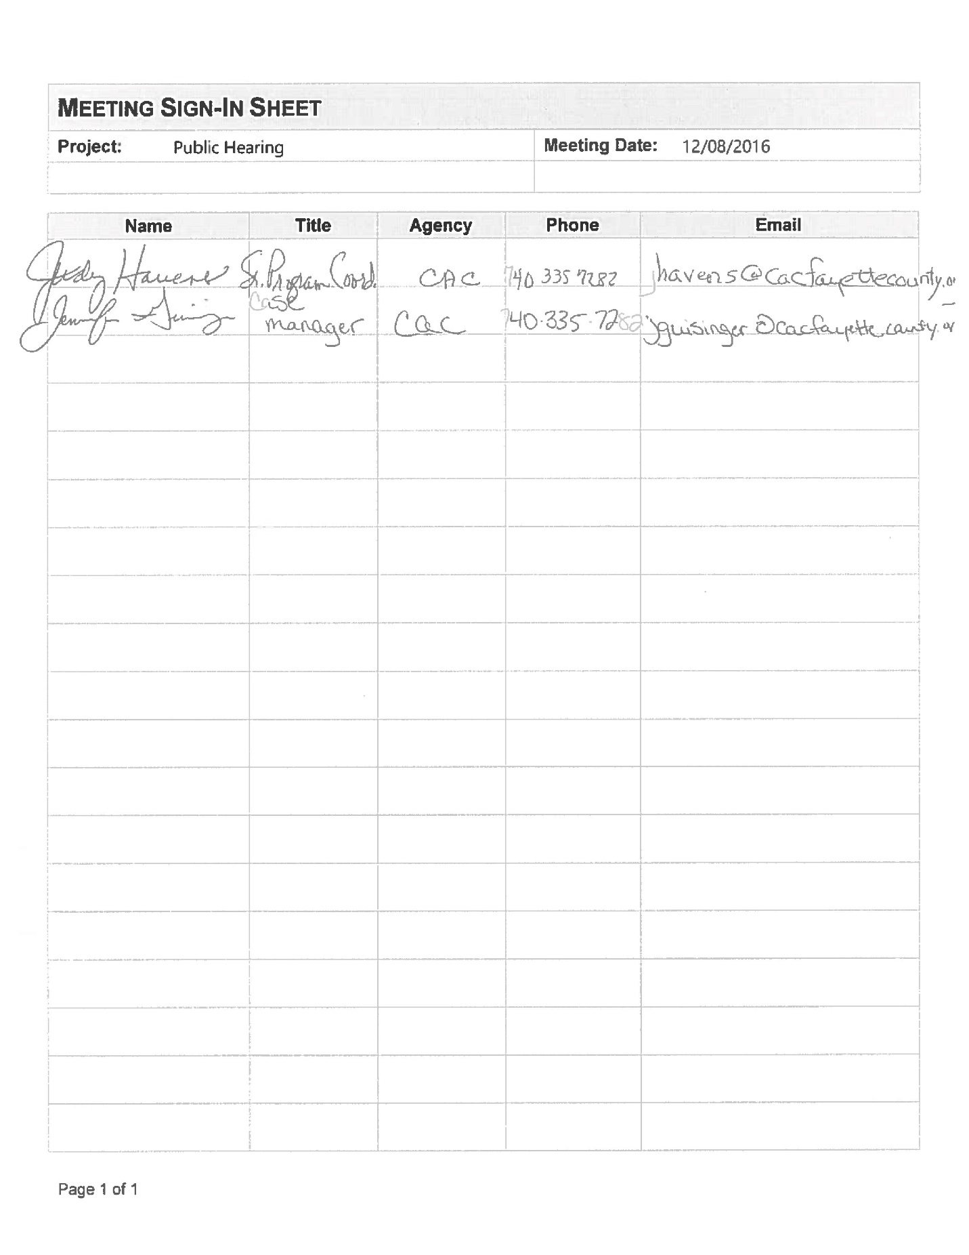
APPENDIX #4 – SURVEYS
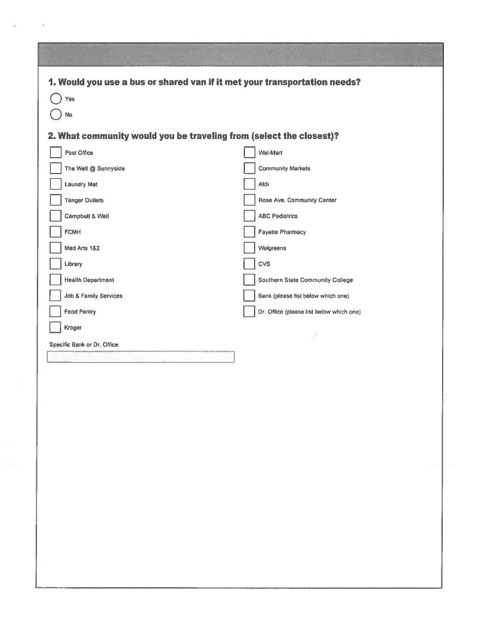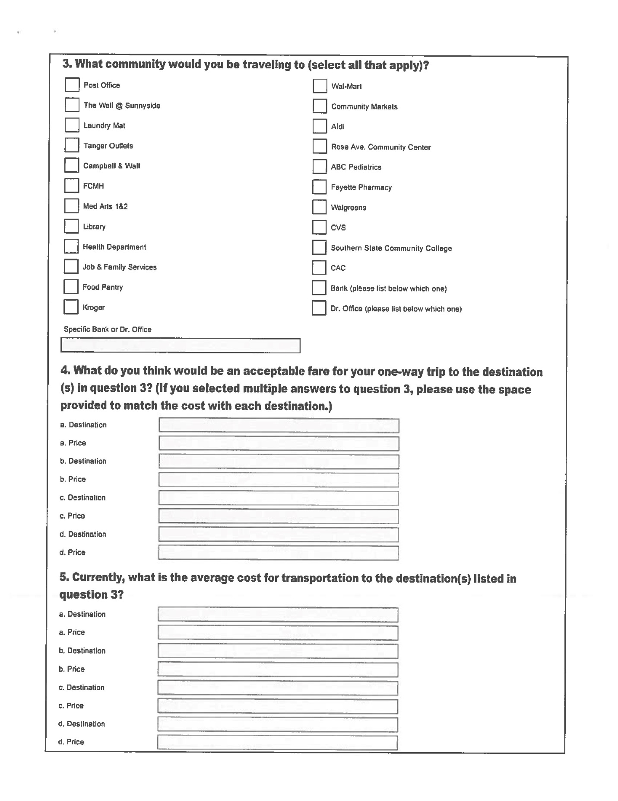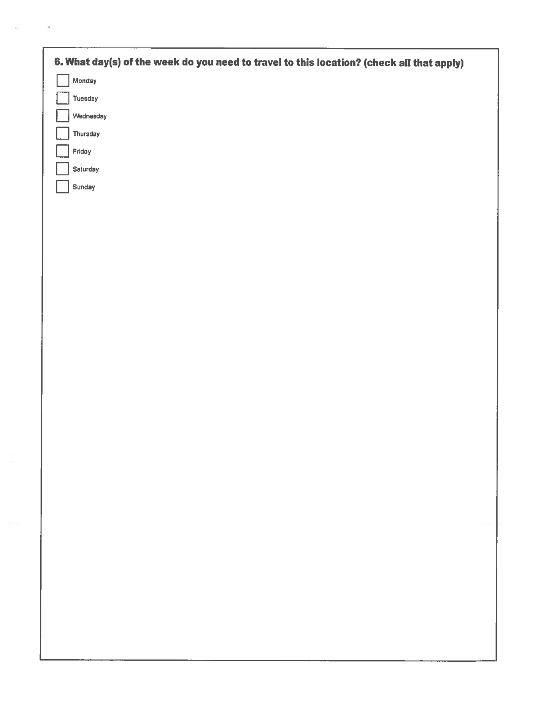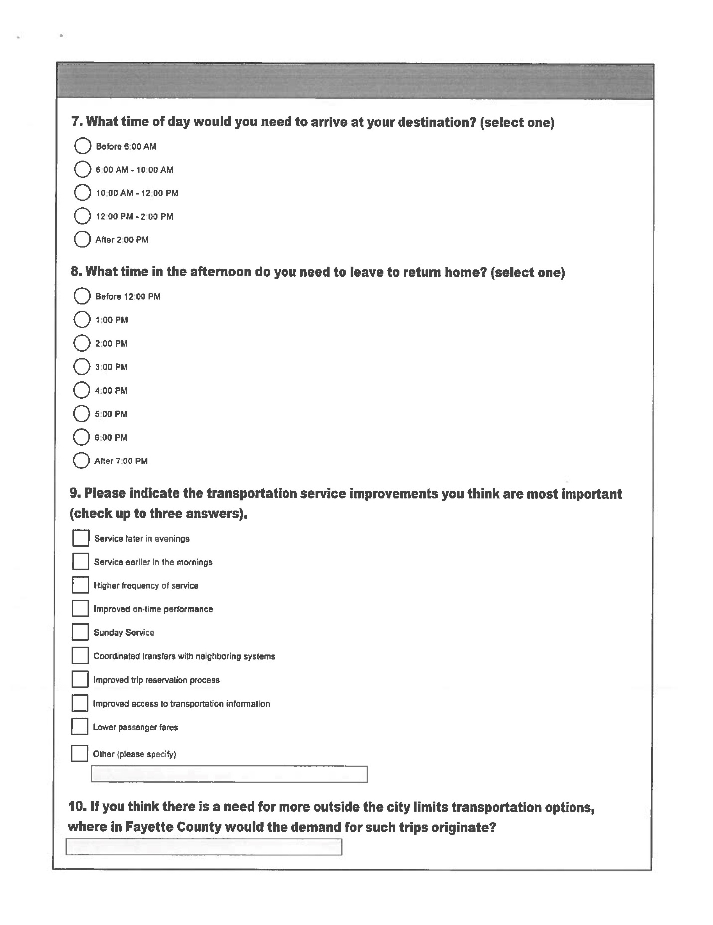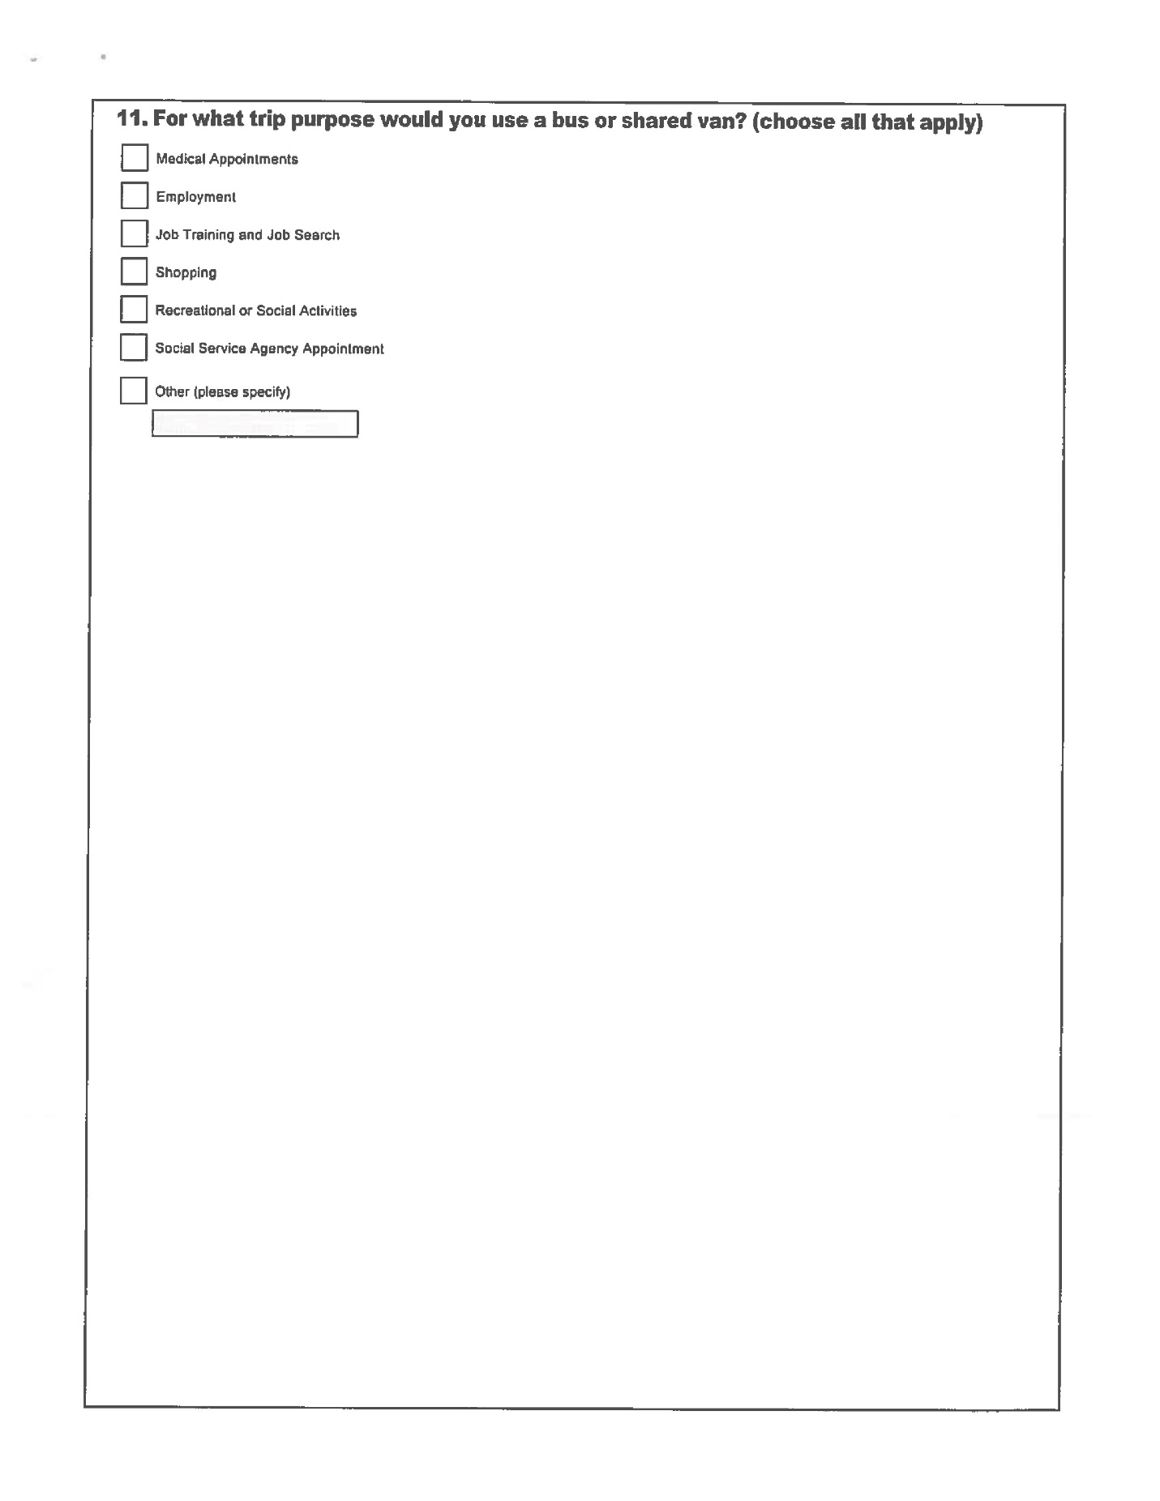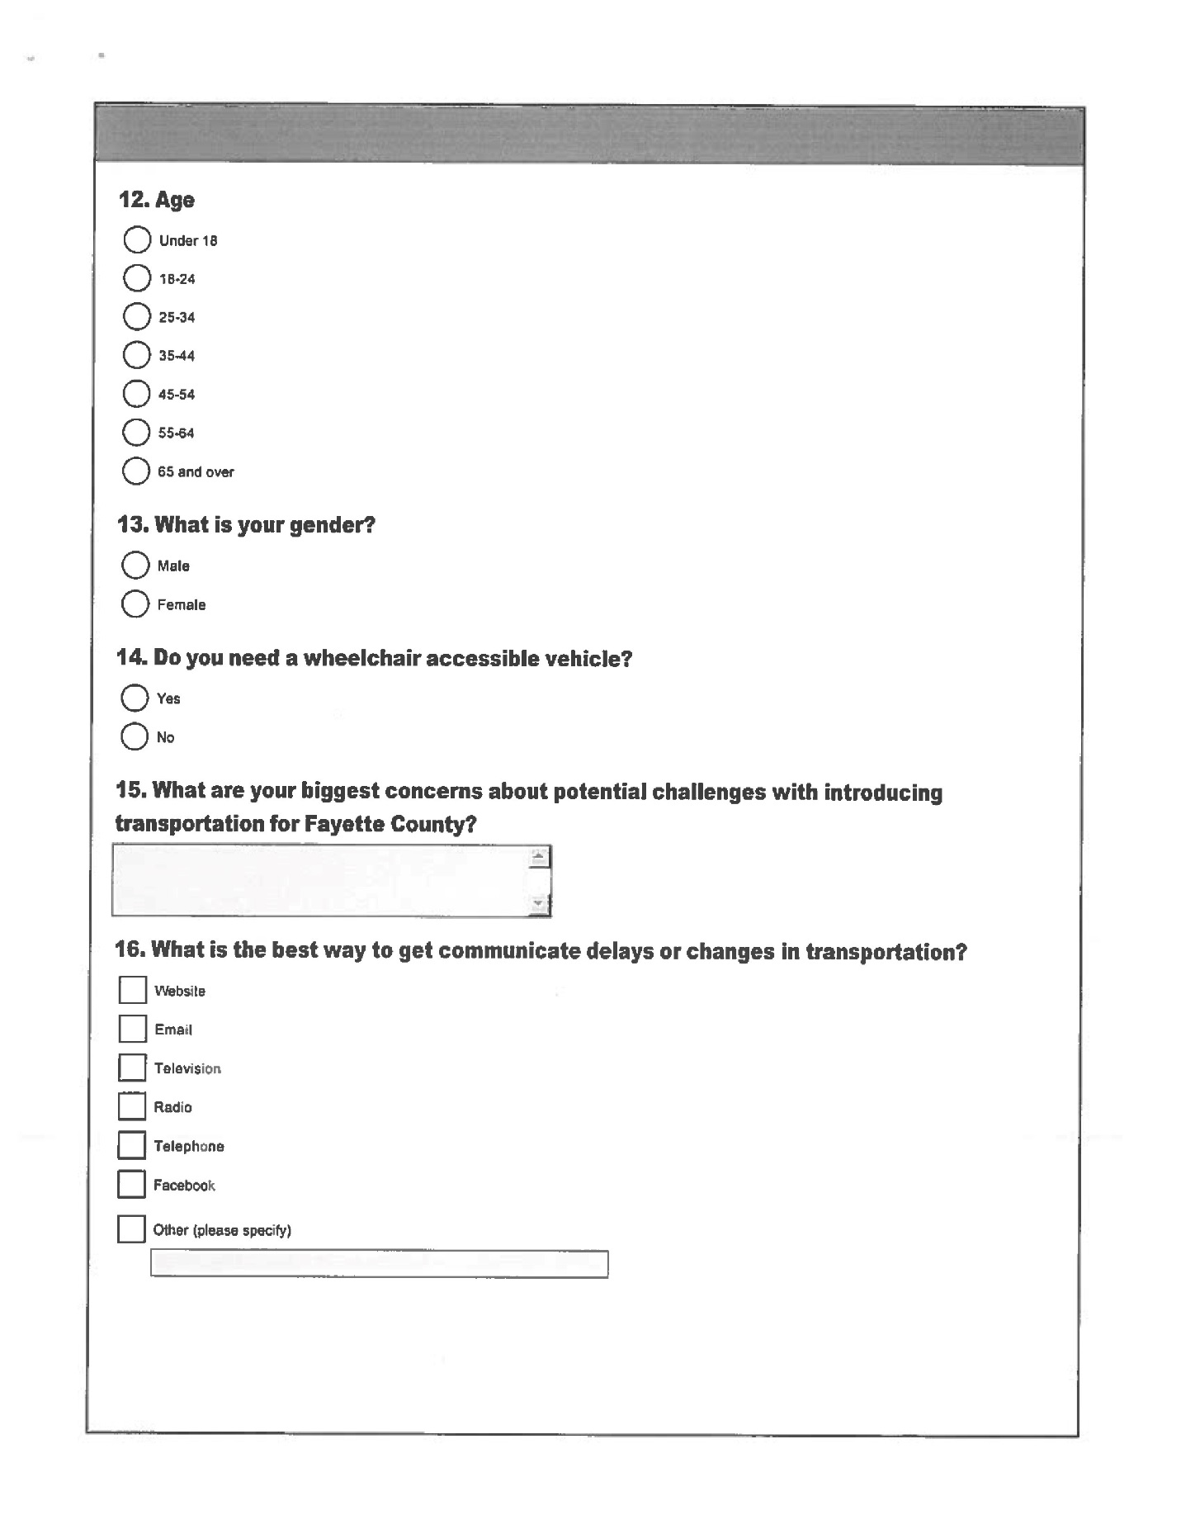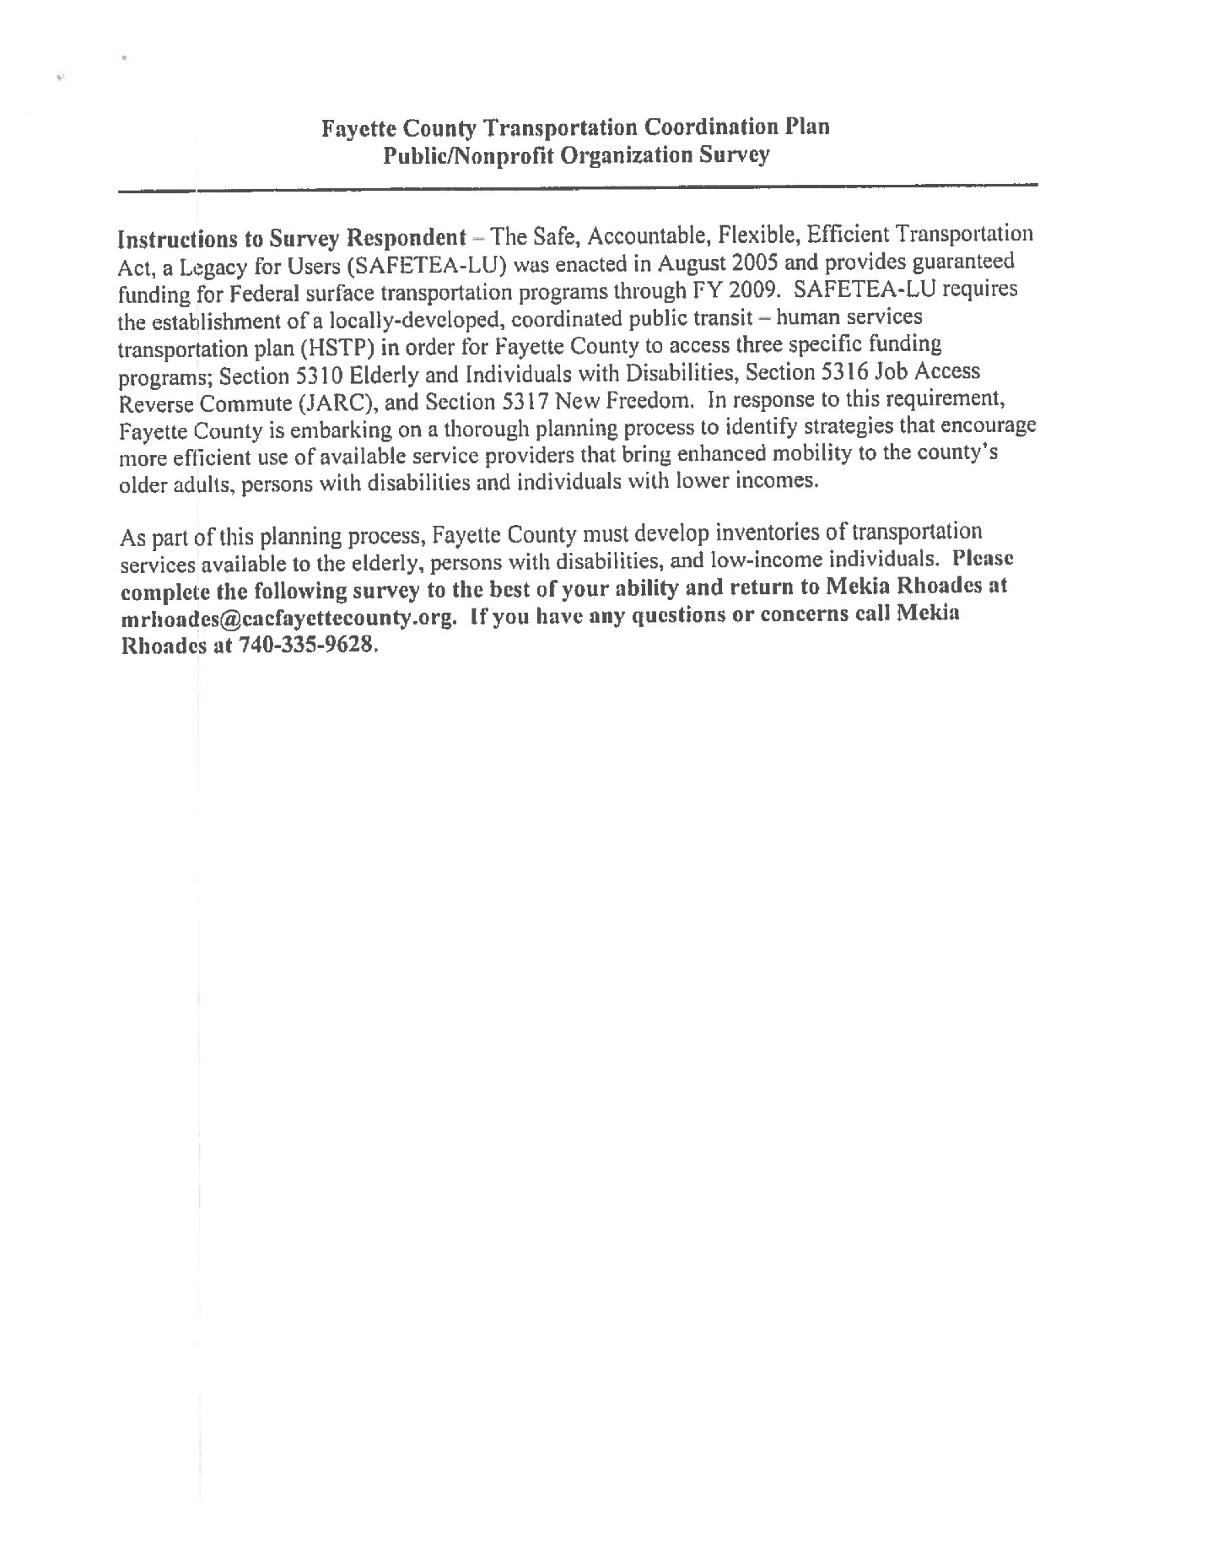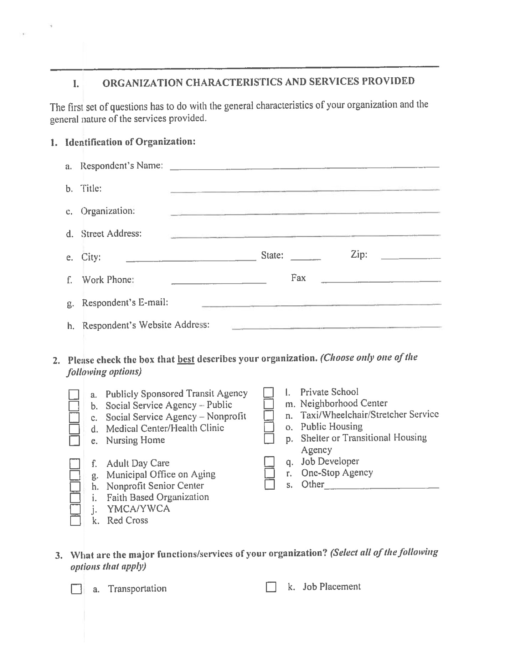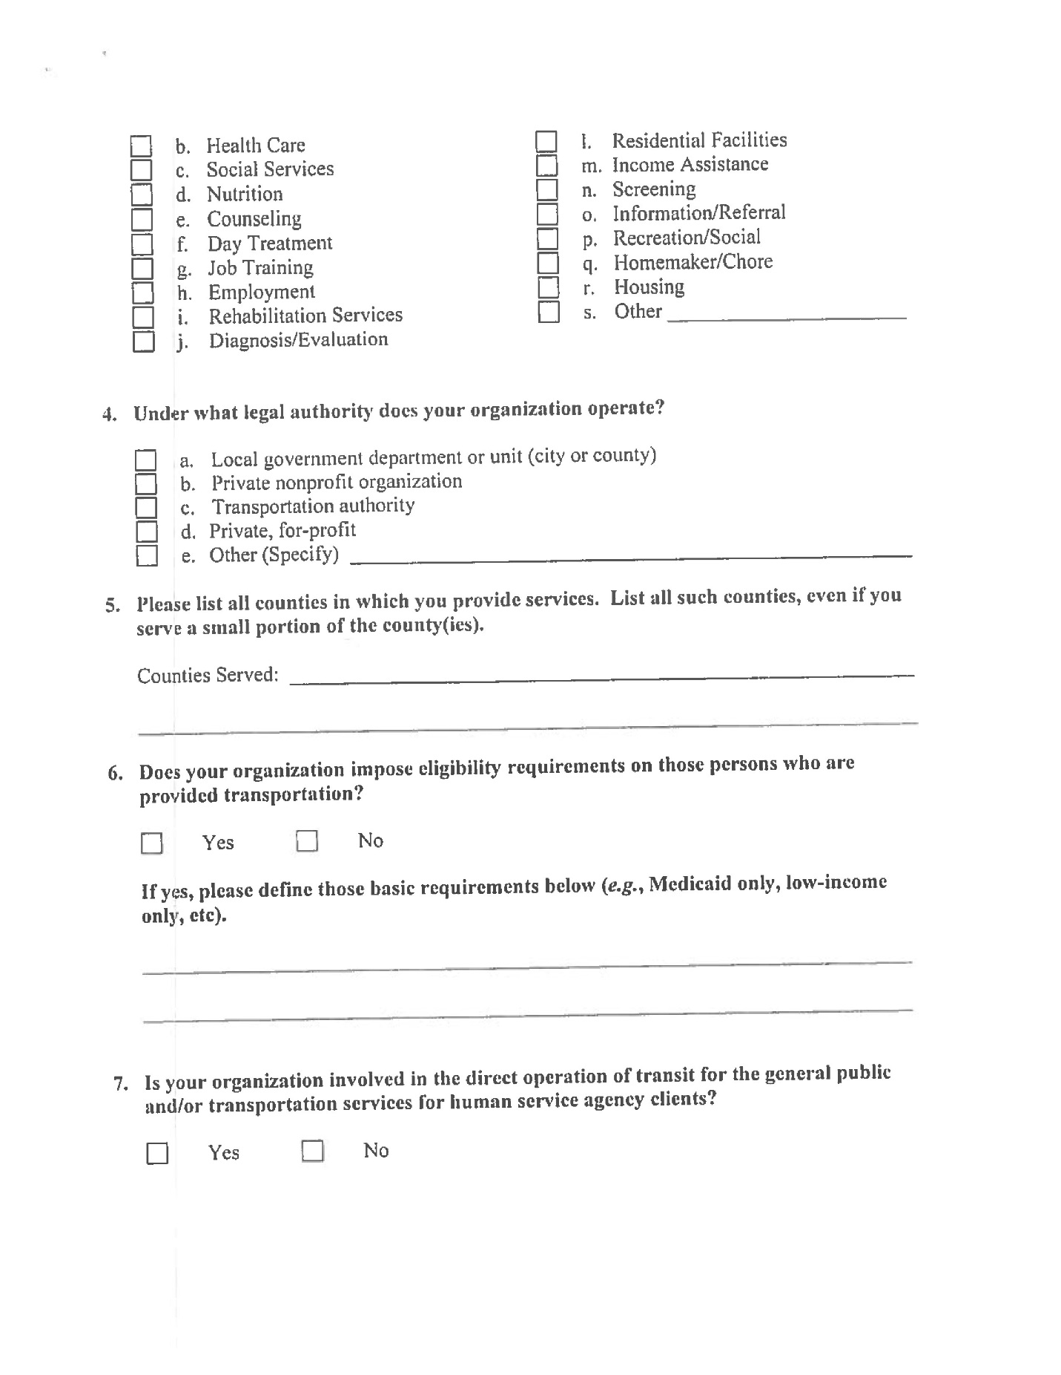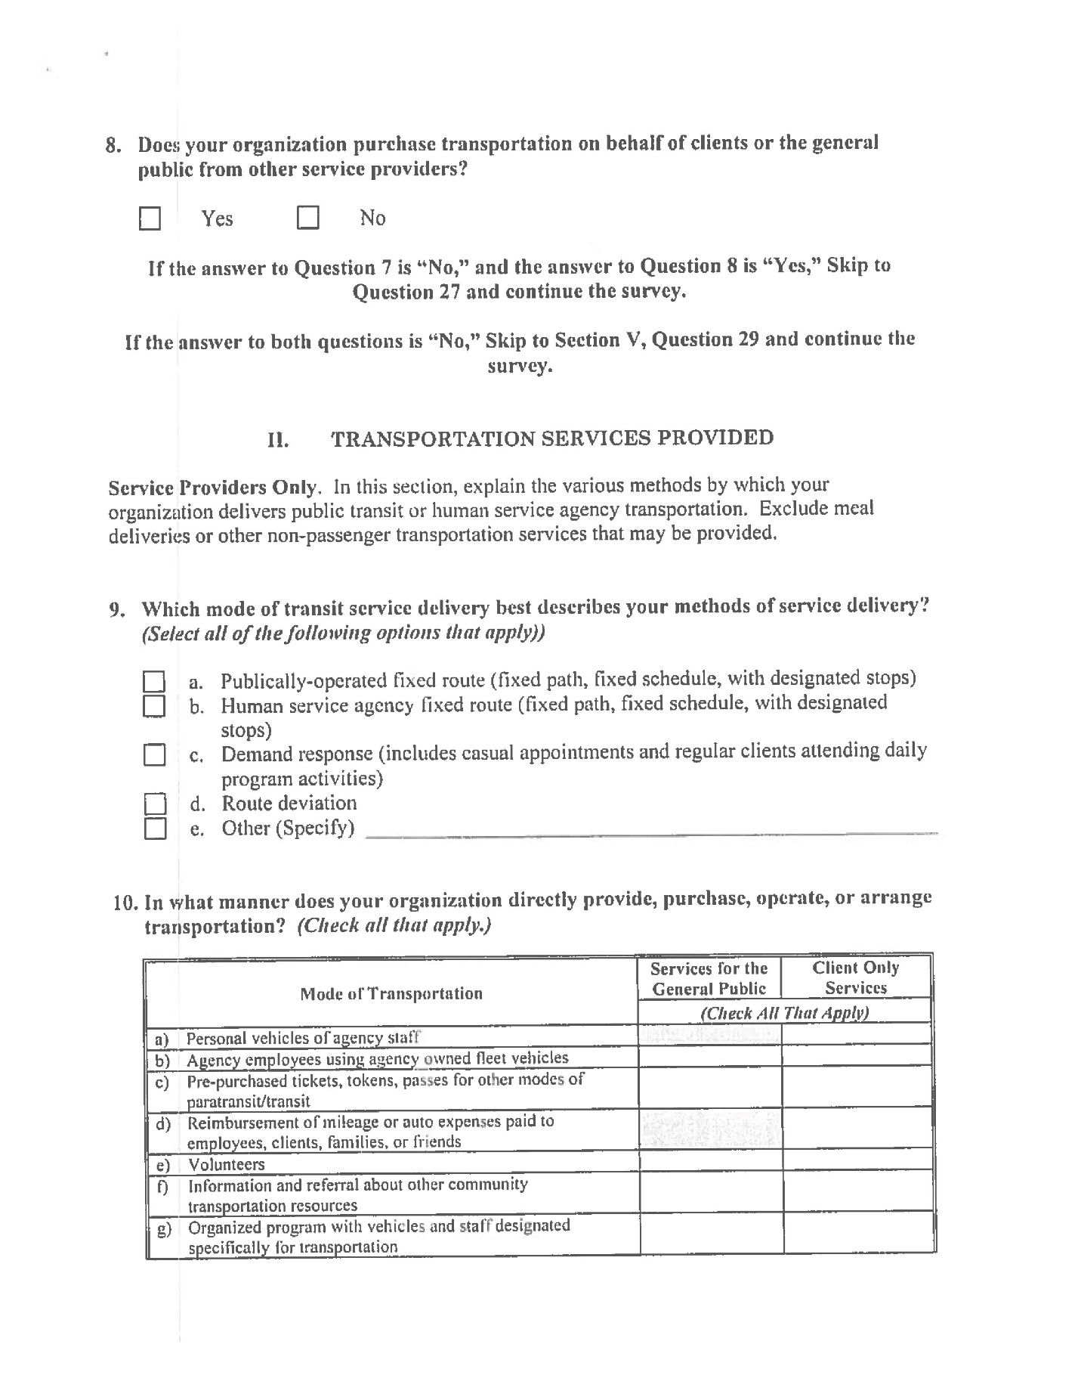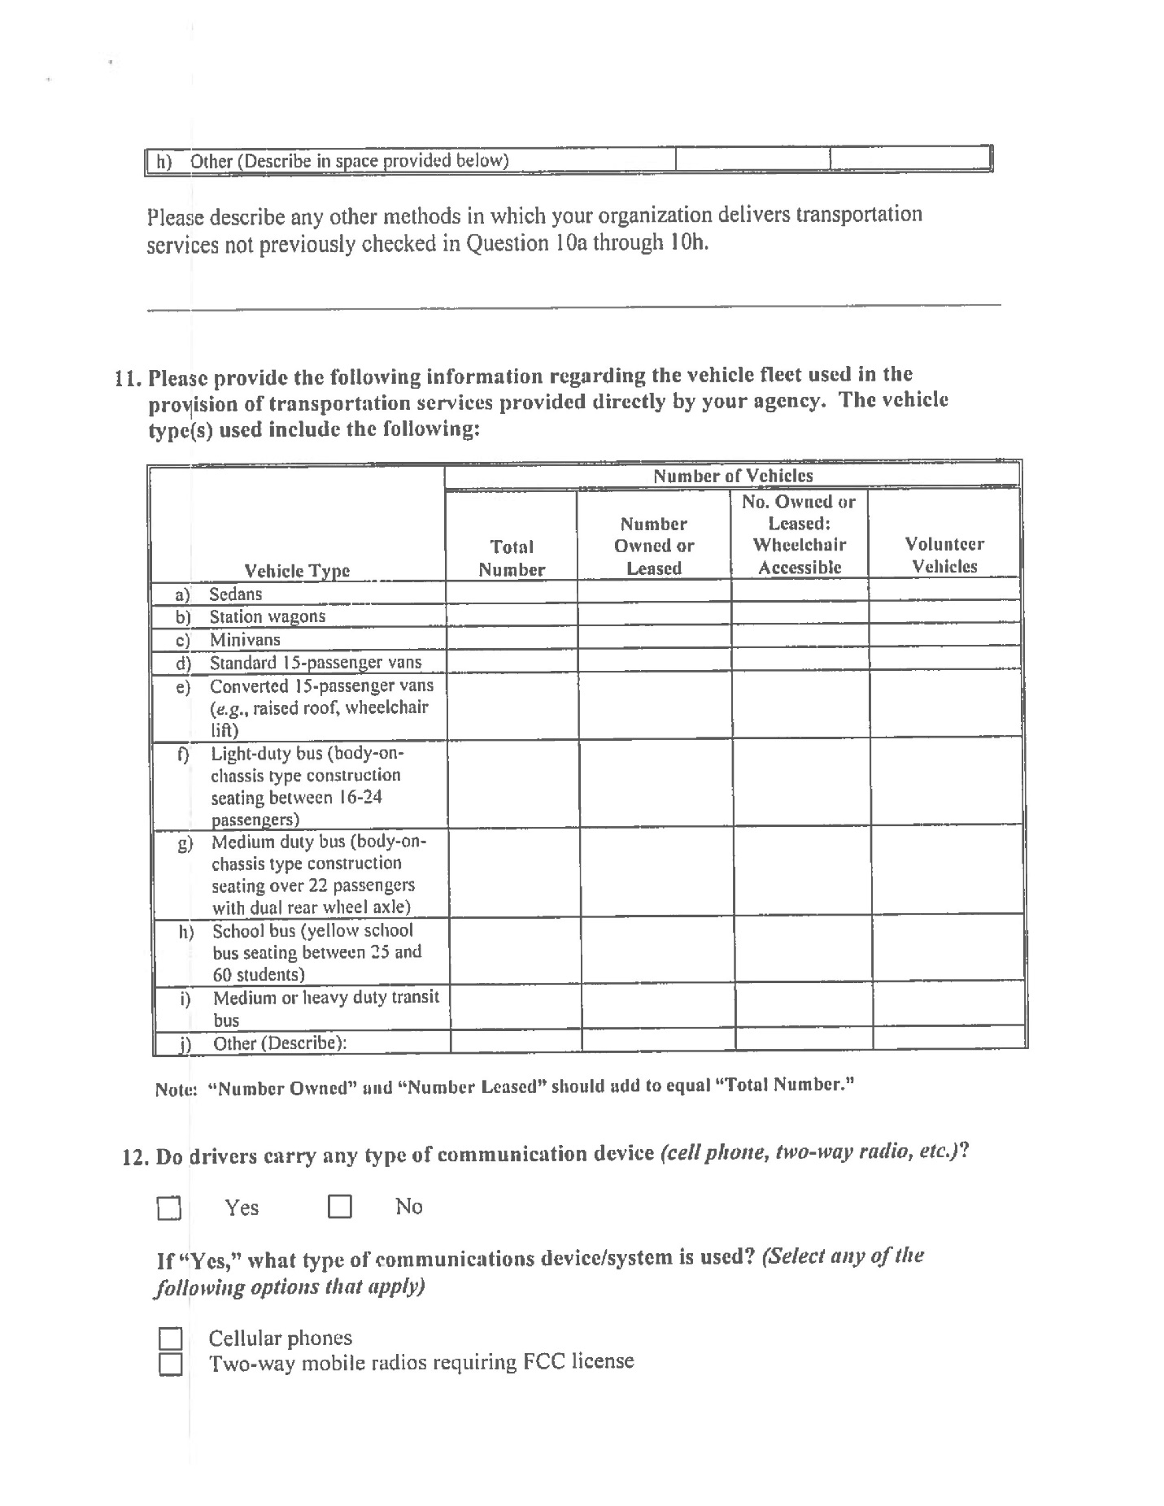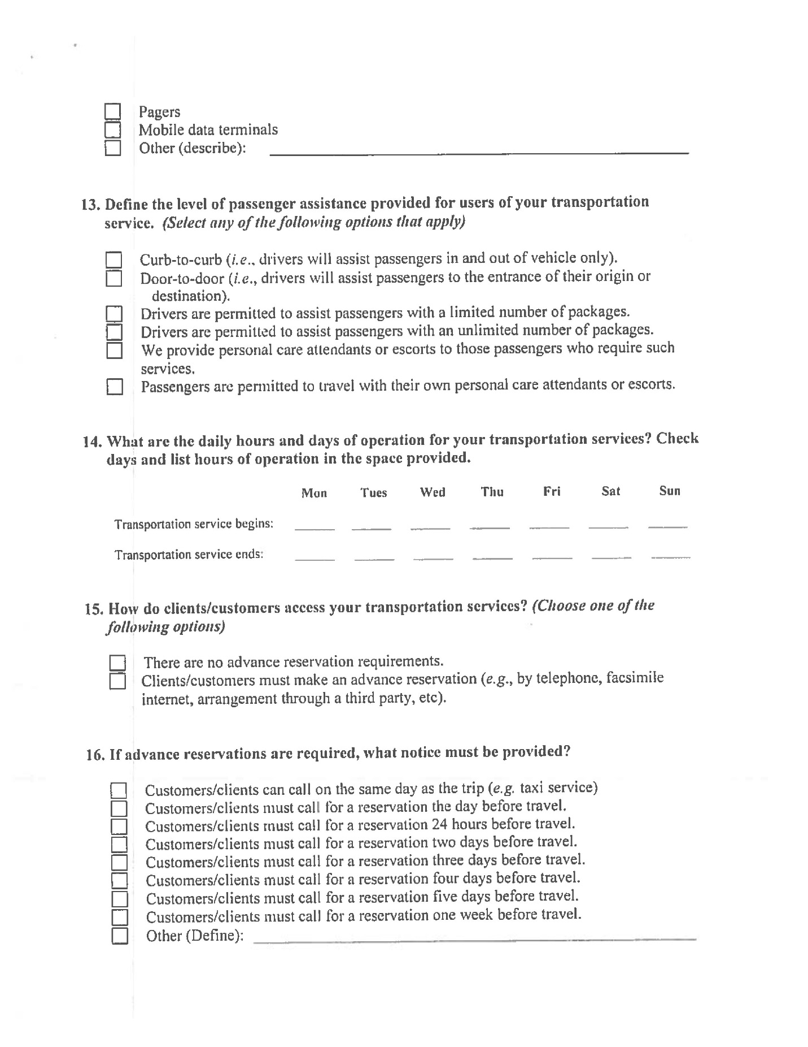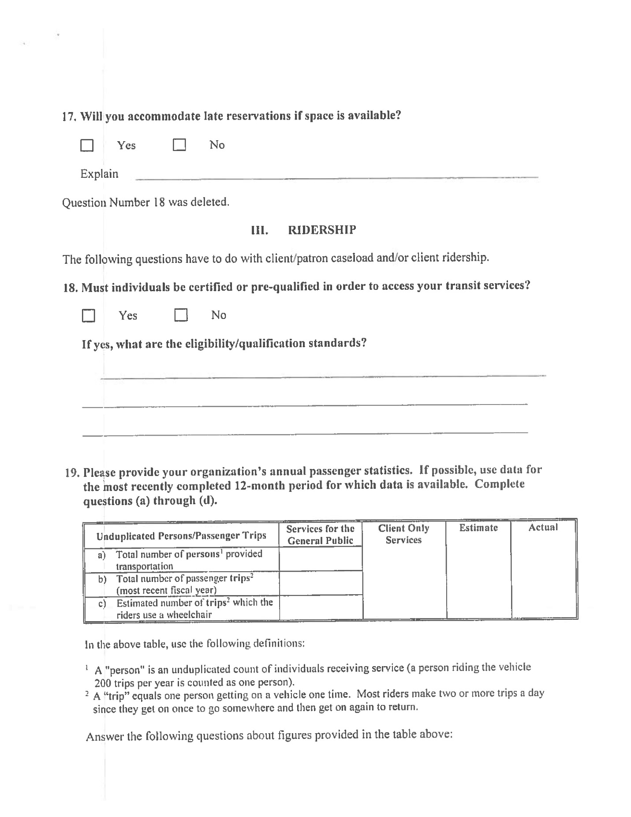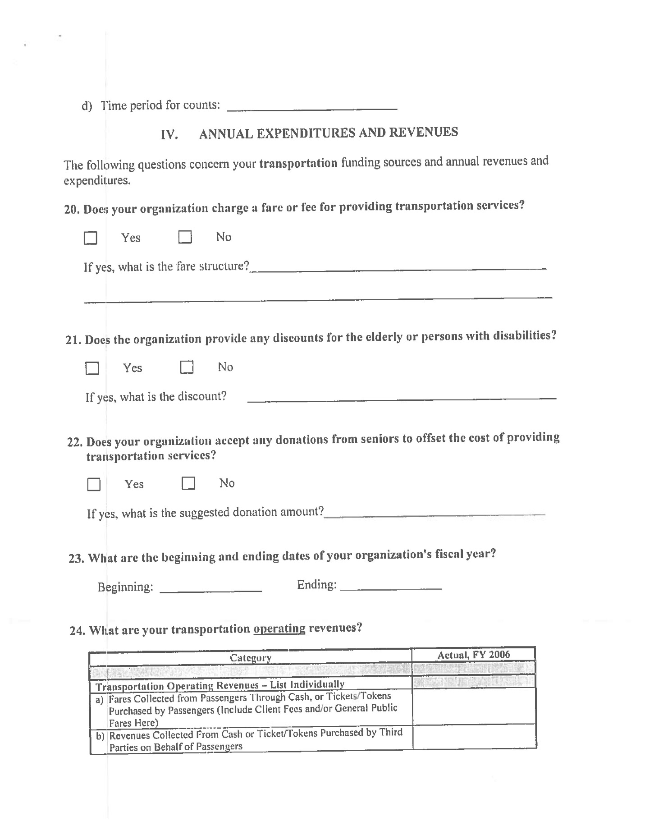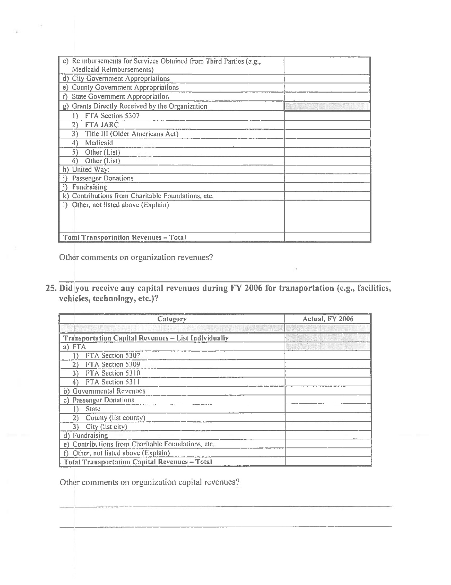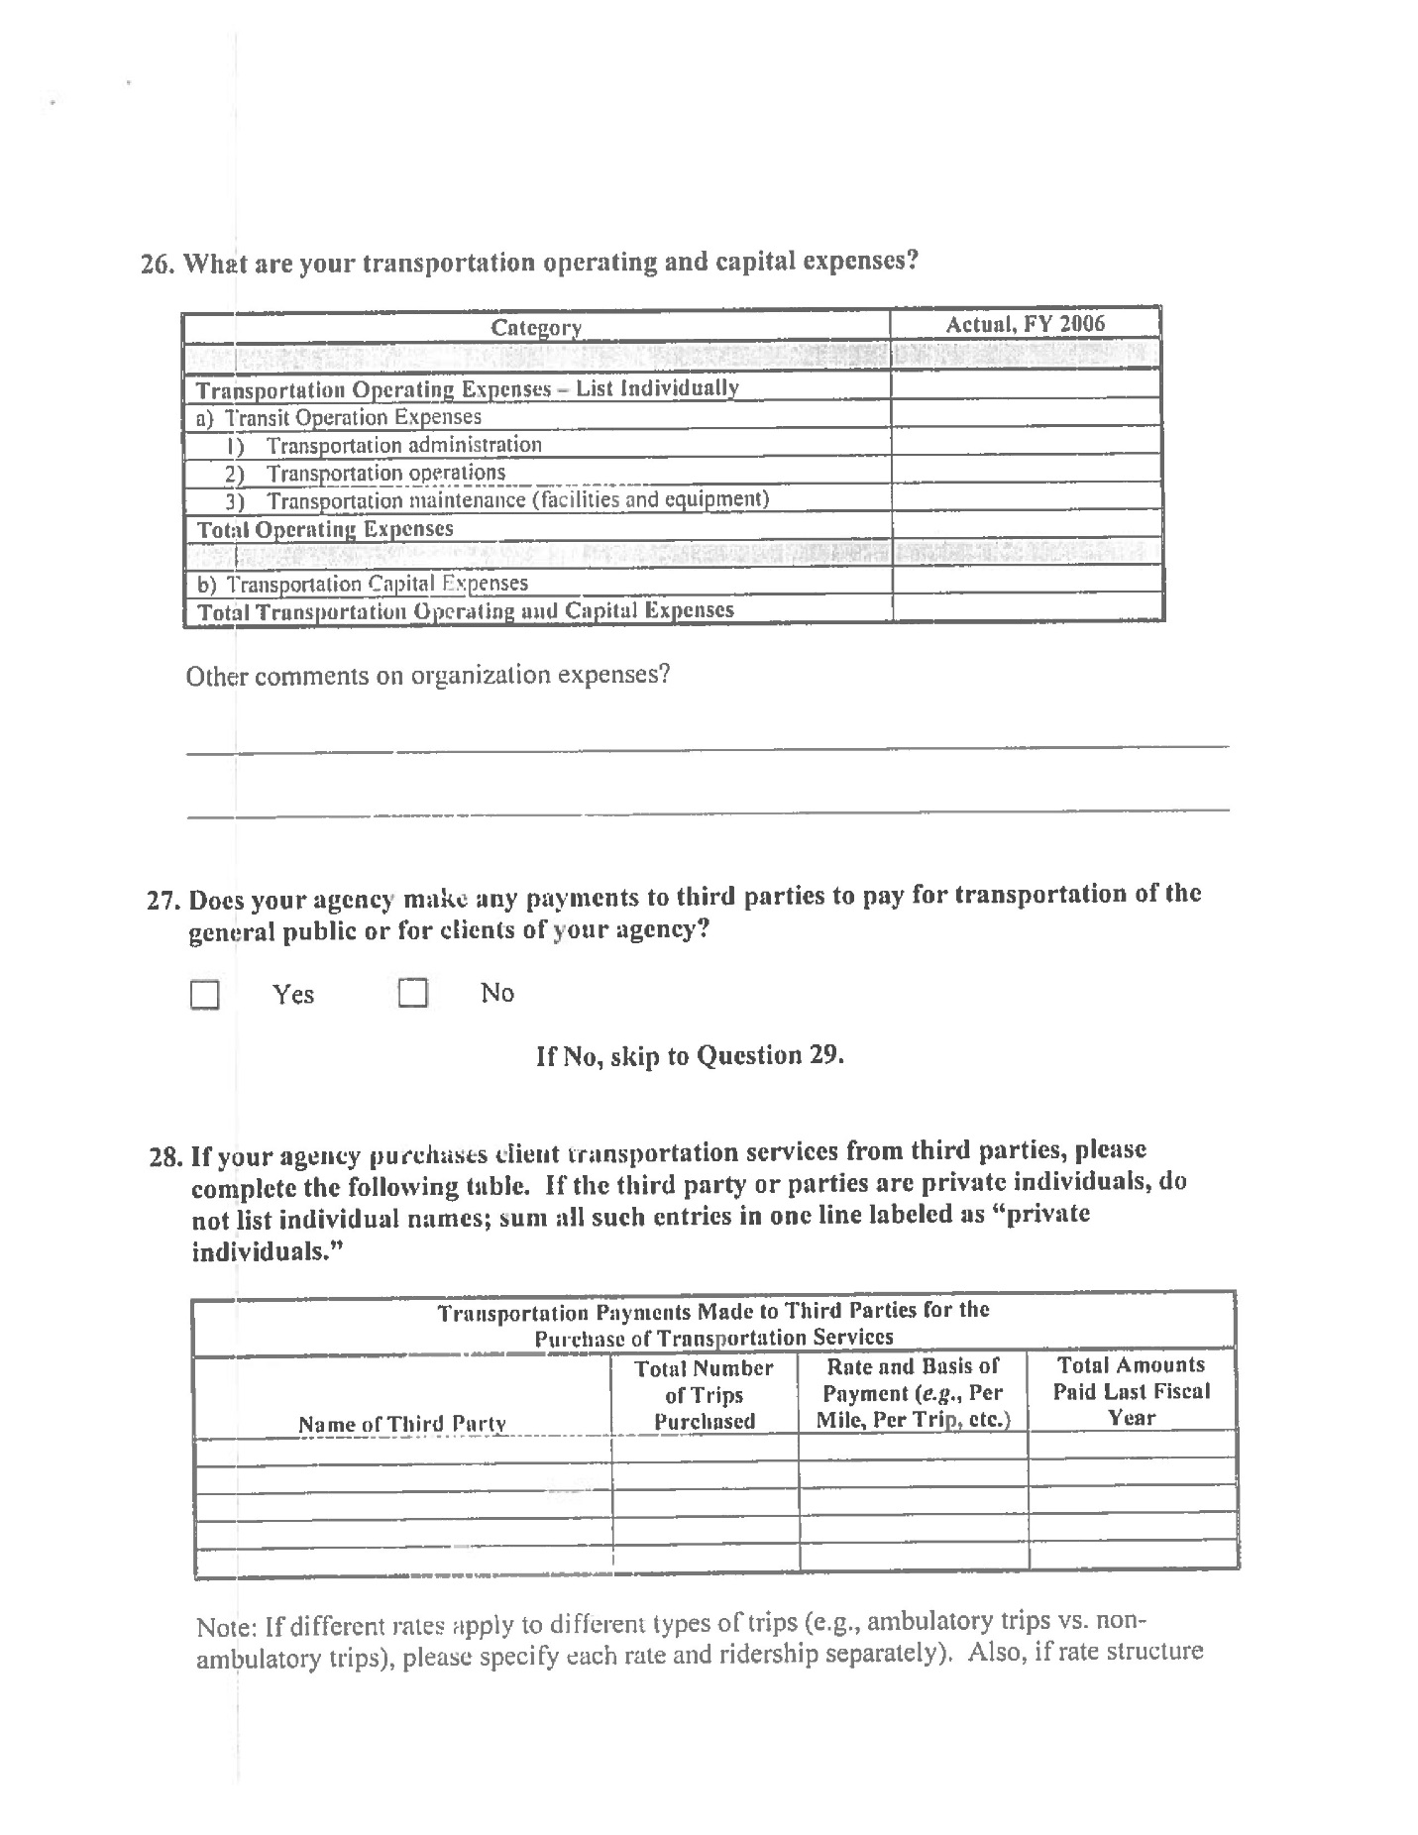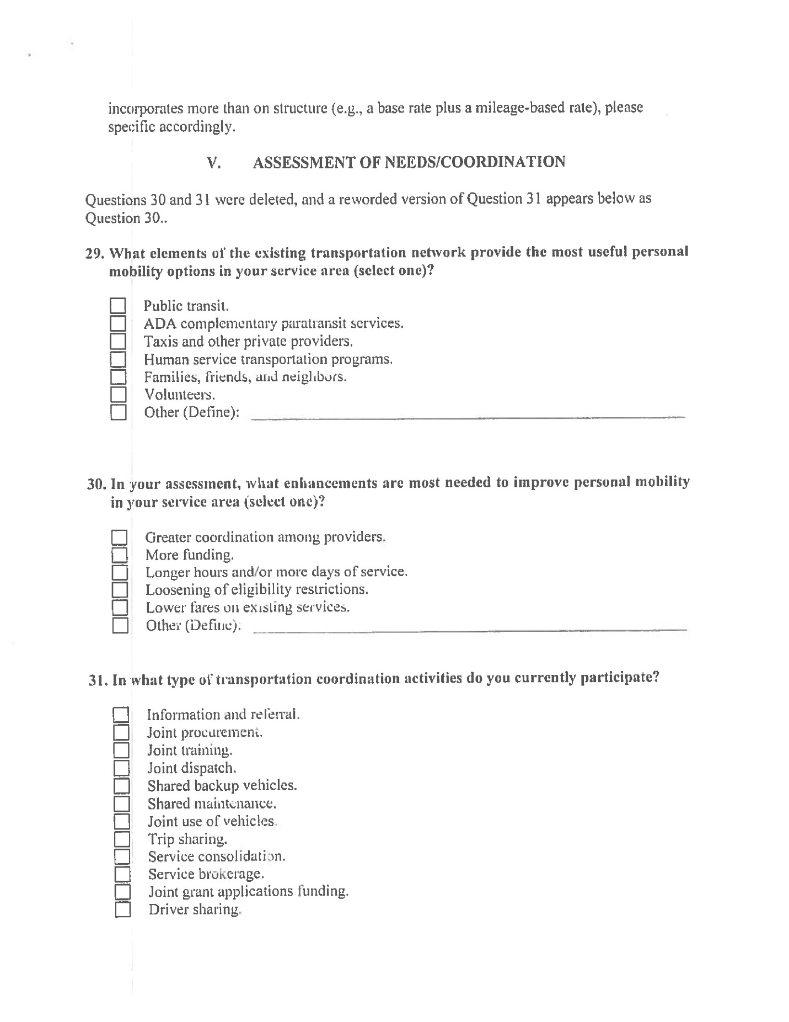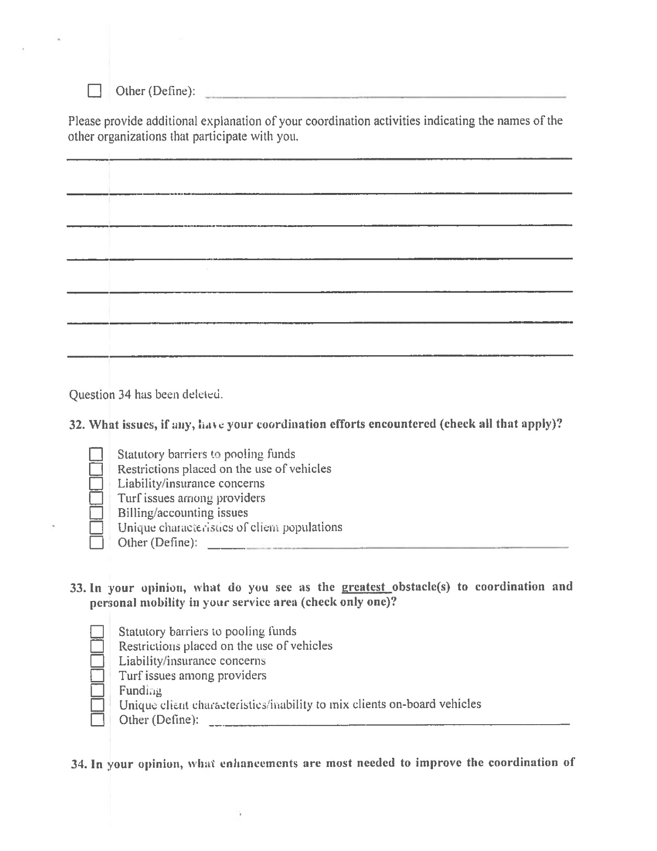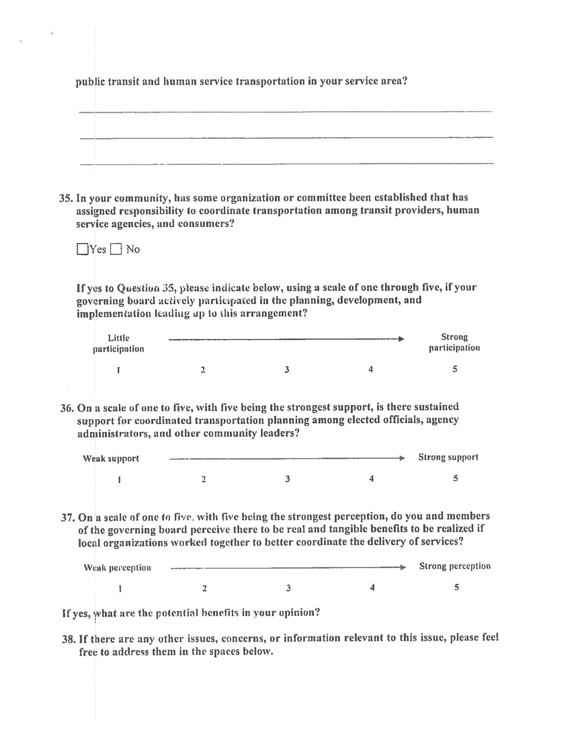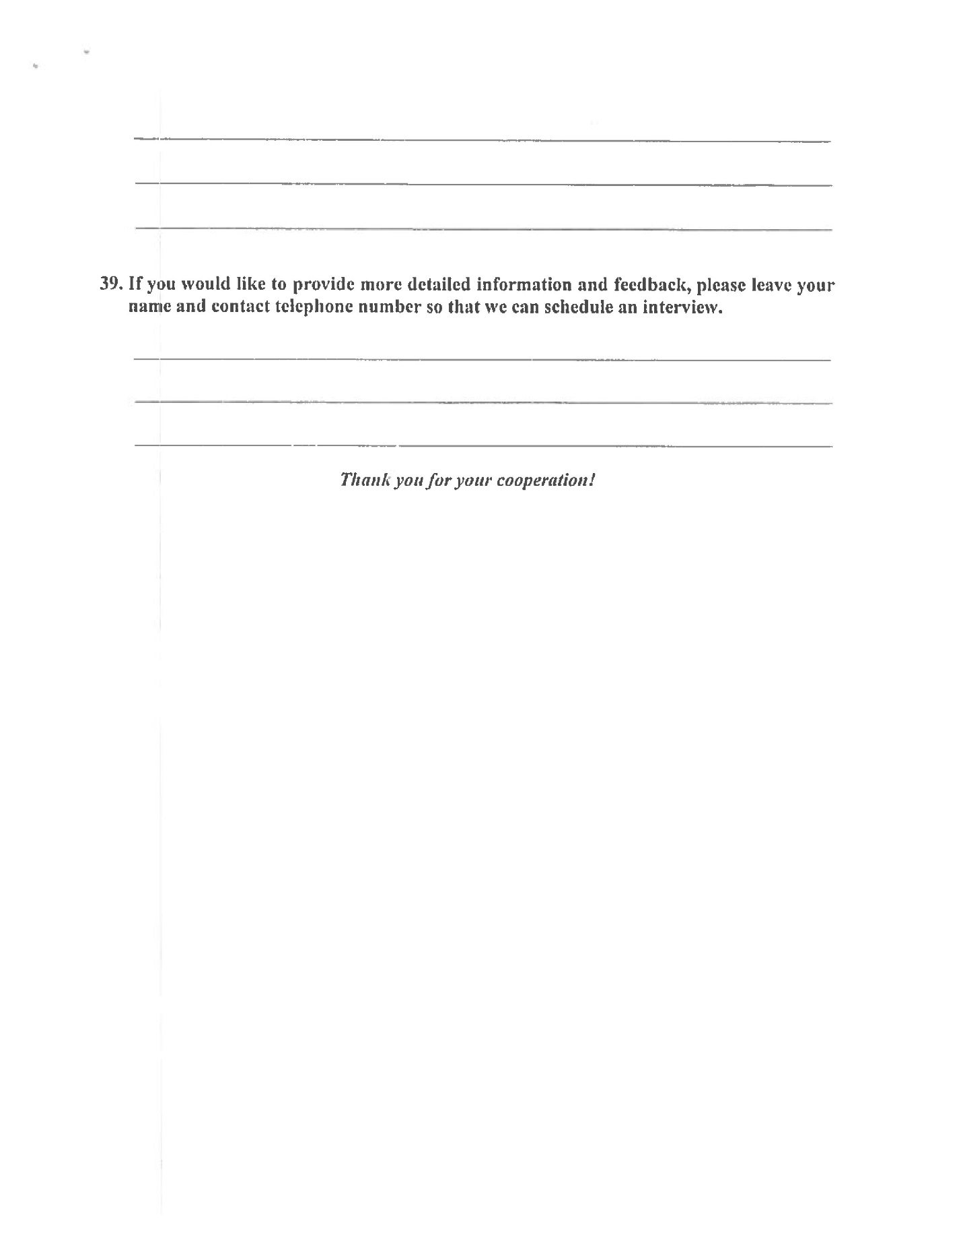

APPENIX #5 – LEGAL NOTICE AFFIDAVIT
