Why are Compliant Surveys Important?

Compliance surveys are important to the community for the following reasons:

- They help the community understand the attitude and practices of retailers, parties tracking enforcement, and residents.

- They help identify educational opportunities.

- Reinforce community standards, reducing “risky” behaviors associated with tobacco products.

- Key component to supporting local and state enforcement efforts.

- Reduces the amount of times tobacco is sold illegally, which limits youth access to it.

Do these things sound appealing and healthy for your community?

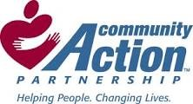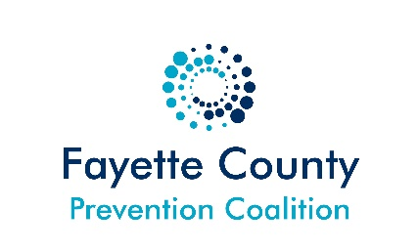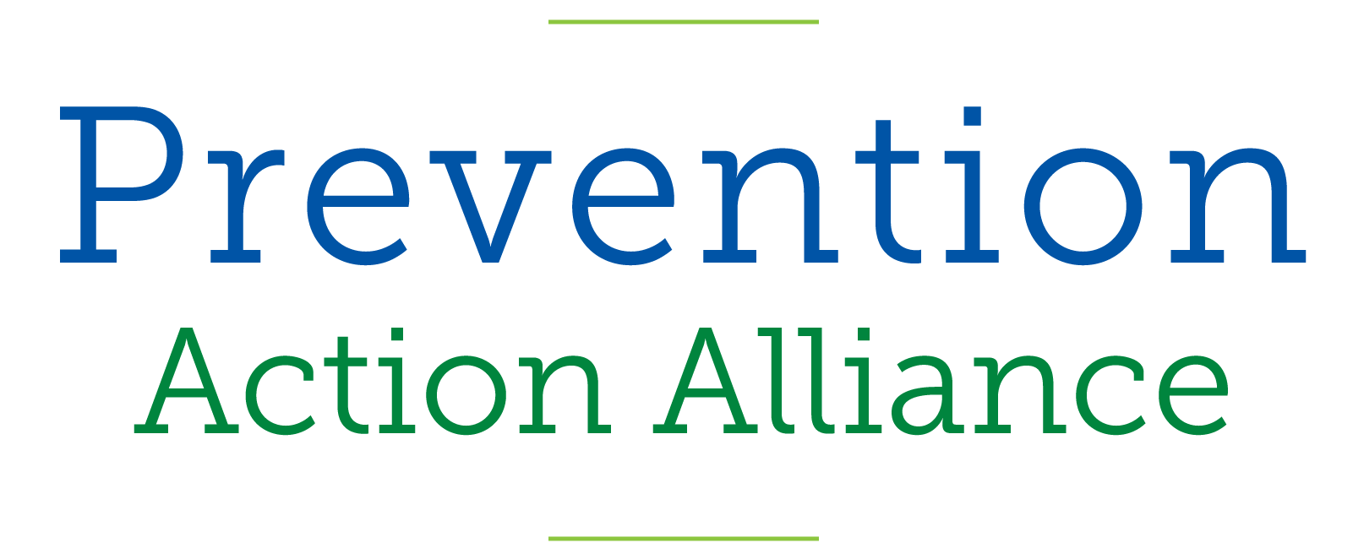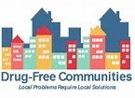
Funded by: Prevention Action Alliance with support from the Ohio Department of Mental Health and Addiction Services

