OCTOBER is
MEDICINE ABUSE AWARENESS MONTH

Prescription medicine is a critical part of our cultural fabric and it sometimes seems as if there is “a pill for every ill.” The fact is we live in a society where the potential for prescription drug abuse and addiction is ever present. Among teens and young adults, next to marijuana, Rx drugs are the most commonly abused substances. Young people are abusing pain relievers, depressants and stimulants to go to sleep, wake up, study, stay alert and/or get high.

DID YOU KNOW?

- In 2016, more than 46 people died every day from overdoses involving prescription opioids. (CDC)
- Drug overdoses have now surpassed car crashes as the leading cause of accidental death in the U.S. (CDC).

Misuse or abuse of prescription drugs means taken in ways or amounts not intended by a doctor or taken by someone other than the person for whom they are prescribed, even if for a legitimate medical complaint such as pain. Prescription drug misuse or abuse can have serious adverse health effects, including overdose – especially when taken along with other drugs or alcohol. (NIDA)

Many teens and young adults still believe that prescription medications are safer to use than illegal drugs, and sadly these medications prove all too easy to get and are as addictive and dangerous as illicit drugs.

Talking regularly youth about the dangers of alcohol, tobacco and other drugs reduces their risk of using in the first place.

SHATTER THE MYTHS – WITH THE FACTS!
For information about how to talk to your kids about drugs and alcohol visit our website at

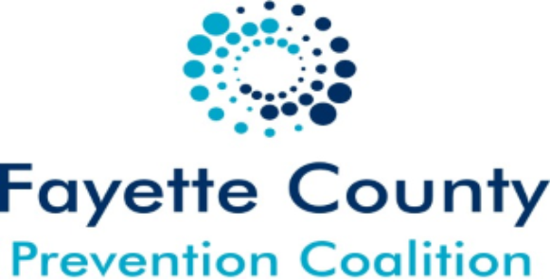
www.cacfayettecounty.org/fcpc/

