Disability Statistics 2017

.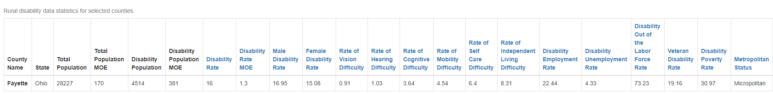

http://rtc.ruralinstitute.umt.edu/geography/index.asp#step1
Accessed August 4, 2020

