Community Action Commission of Fayette County
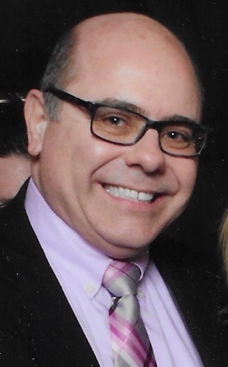
Survey Themes:
- More drug treatment services including MAT
- More mental health services
- More space for operations
Considerations:
- Internet countywide? (Only one person said this, but may be greater need since COVID-19)
- Community awareness of youth programs?
Agenda for Virtual Retreats
- Establish ground rules.
Christina – rules for Go To Meetings
Jeff -- No wrong answers, only your opinion, all input is important; due to tight time frame, I will work to keep us on track and within one hour; however, I will ask for clarification and specificity to ensure your comments are understood.
- Key Questions:
- What is the best thing about CAC?
  - I like that they have local people serving our community
  - I enjoy collaboration between programs. Everyone works very well together as a team and that is essential.
  - Collaboration, programs work well together, teamwork
  - Enhances relationships, networking between programs and other organizations in the community. CAC is diverse and helps broaden networks. CAC tries to be focused on certain aspects of the community that others don’t think about. Think about seniors in ways that most don’t consider.
- If you could change one thing about CAC, what would it be?
  - Could CAC build a partnership with Developmental Disabilities? That would be helpful. CAC should look more into the future. Head Start program is growing and they should expand to meet the needs to avoid problems as we move forward.
  - Parking is unanimous. For staff and clients
  - Office space
  - Those who work at other extensions are out of the loop about what the agency offers. The cook at Jeffersonville Head Start isn’t aware of the full scope of what CAC does. Halona agrees. Broader outreach of what services we offer and inform employees so they are able to give references to people we serve. Concerns that the CAC website needs updated.
- Do you believe that needs have changed since COVID-19 has hit? If so, what are they now compared to pre-COVID-19?
  - Single parent cannot run to the store without taking all of their children. More stress on those who don’t have family close by that can help. Parents laid off and that is stressful.
  - Increased need for mental health
  - Places offering clothing and resources, like Rose Ave, are closed due to COVID-19. People can only leave a name and number and must wait to get their needs met when they are open again.
  - Mental Health is a huge need at this time. We have also had a lot of families in our Head Start program ask for help with clothing as well as sanitizing supplies/cleaning supplies
  - Unemployment isn’t coming through
- Community survey results state that more drug abuse treatment and mental health services are needed for Fayette County. In what ways, should CAC’s Pathways to Recovery program be expanded to help meet the needs?
  - Male drug abuse treatment centers are a need that has not been met. The new jail is being built and we can hopefully use this to help bridge the gap for men.
  - More housing, shelters for people who have lost a job or a home due to COVID-19. Substance abuse is increasing as a result of COVID-19 and the stressors. Our current shelter can only handle so many people/families with children. Single men are not able to be served. This service needs to be provided for all.
  - Shelter for men is in Circleville, not WCH. Definitely a need.
  - On a personal level, I could not find a place (treatment facility) that I could afford for my family member because it was not court ordered and that person had insurance. That's a problem.
  - Treatment is available but inpatient treatment is not available.
  - Suicide rates have increased due to COVID-19. Kids are stuck in the house.
  - After graduating treatment, there is no transitional housing or sober living for people who return to the community. Need recovery housing, not just HUD housing. Some kind of housing that does not require you to show homelessness.
- Where/how could CAC acquire, build and/or rehab new office space for agency operations?
  - Head Start needs a place. Have heard rumors of building behind our building but the parking would still be an issue. Also heard about using Kmart but that wasn’t feasible.
  - Parents struggle with pick up and drop off for children. Some have to park and walk and it isn’t convenient. A bigger building would be nice. Something like Kmart would be more accessible.
  - Pathways has 7 people in an office and client confidentiality is an issue. A separate building for the program would be nice. Bambi does not want anyone offsite but we could get a grant for rental space. We are getting space at the new jail, we work at children services and second chance, but it would be nice to have more space where we can all work in the same building.
- If CAC would to undertake a business venture, what do you believe is the agency’s core programmatic strengths to build upon?
  - Transportation helps get people to work and we have a demand to increase the workforce. Expand transportation as a business venture to serve more of the communities transportation needs.
  - Onsite childcare offered to businesses as a service. Childcare centers are needed in Jeffersonville.

