Christina Blair, Planner

This assessment of Fayette County, Ohio will guide the actions of the CACFC through the time period of 2021-2023.

2021 - 2023
Community Needs Assessment

Contents
Introduction 2
Mission Statement 2
Vision Statement 2
Approach 2
Person-Centered Philosophy 2
The Community Action Promise 2
Background 3
Assessment & Planning Process 4
Discussion of Low-Income Involvement 4
Customer Satisfaction 5
Community Profile 5
Agency Resources 7
Programs 7
Agency Coalitions – Lead Agency 10
Community Resources 10
Community Coalitions - Participant 10
Poverty Specific Profile 11
Location 11
Population Profile 11
Causes & Conditions of Poverty 0
Needs of the Community 2
Conclusion 4

Introduction
Community Action agencies were created as a direct result of the Economic Opportunity Act of 1964, to address the root causes and end poverty in our communities. Community Action agencies, all working towards national goals, tailor services to meet the unique needs of the communities they serve.
3 National Goals of Community Action agencies:
Goal 1: Individuals and families with low incomes are stable and achieve economic security.
Goal 2: Communities where people with low incomes live are healthy and offer economic opportunity.
Goal 3: People with low-incomes are engaged and active in building opportunities in communities.
The CAC of Fayette County is the designated lead anti-poverty agency in Fayette County, Ohio.

Mission Statement
The mission of the Community Action Commission of Fayette County is to combat causes of poverty, expand community services, and implement projects necessary to provide services and further community improvements.
Its mission is also to consider the problems concerning youth, adults and senior citizens and deal with the prevention and solving of those problems.
The provision of affordable housing is a specific purpose of the agency, as is the development of income-generating projects consistent with the purposes of the corporation which will increase funds available for services and reduce the agency’s dependence on public funds.

Vision Statement
Our vision is to facilitate the development of effective community programs that provide every individual and neighborhood in our community the opportunity to thrive.

Approach
Offering support services and providing basic needs to which all people have a right.
Developing opportunities for people with low incomes. Increasing public awareness about the challenges that many people with low incomes face.
Ensuring that people with low incomes provide the leadership in the decisions that affect their lives.
Engaging many voices in promoting human rights and economic justice.
Advocating for policies that help and taking a stand against policies that hurt those living with low incomes.

Person-Centered Philosophy
Community Action believes in the person-centered approach to human services. Key values are: not judging others, understanding other’s experiences from their point of view, and fully honoring the uniqueness of the individuals we serve in a genuine and heartfelt way while respecting autonomy. We believe that without a significant relationship there cannot be significant learning. To that end, we value the dignity and respect of each member of our community.

The Community Action Promise
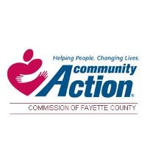
The Promise of Community Action is to change people’s lives, embody the spirit of hope, improve communities, and make America a better place to live. We care about the entire community, and we are dedicated to helping people help themselves and each other. Community Action uses a results-oriented and outcome-focused approach to promote self-sufficiency, family stability and community revitalization to eradicate poverty, through empowerment and helping people help themselves
Every three-years, CAC of Fayette County conducts a community needs assessment to evaluate and understand conditions, identify needs and assets in the community at large. The assessment allows the agency to:
1. Assess the needs of the overall community
2. Understand the scope of CAC’s role in addressing the ongoing needs of economically-insecure residents in the community.
3. Evaluate whether current programs, services, and activities are filling identified needs of the community, identify economic resources, social resources, and partnerships opportunities in the community that can help meet the needs, and assist Board Members in strategically planning, developing and delivering relevant and needed services, programs and activities.
4. Identify significant public policy issues.
5. Educate community residents and leaders about identified needs and provide input on policies and strategies.
6. Explain to the community the rationale behind decisions to prioritize needs and allocate resources.

Background
Federal poverty thresholds were originally developed in the 1960s by the Social Security Administration. At that time, a study showed that families of three or more persons facing some short-term hardships used roughly one third of their total money (after taxes) on food. Using the “three times the cost of food” methodology, poverty thresholds were developed for families of all sizes. Since that time, updates have only been made in relation to the Consumer Price Index, and no other factors. The Federal Poverty Guidelines are updated and issued annually by the Department of Health and Human Services.
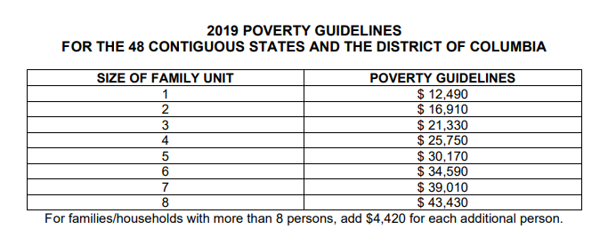
Community Action Agencies receive federal Community Services Block Grant (CSBG) dollars, designed to reduce poverty, revitalize low-income communities, and to empower low-income families to become self-sufficient. This funding supports agency operations and administration, and direct service programming impacting those individuals and families at or below 125 percent of the federal poverty limit. For Cares Act funding that guideline was increased to 200%. As of 2016, census estimates that the Fayette County population was 28,645. Of this population, the number and percentage of the residents living in poverty were 4,764 and approximately 16.99 percent. The CAC of Fayette County serves roughly 4,000 individuals in 1,600 households each year.
In response to deficiencies in federal poverty guidelines there is also the Self Sufficiency Calculator. This estimates the income needed to meet very basic needs. The information regarding this standard for Fayette County is available at https://www.cacfayettecounty.org/wp-content/uploads/2020/10/Self-Sufficiency-Standard-Fayette-County-Ohio.xls.

Assessment & Planning Process
This Community Needs Assessment (CNA) was developed utilizing the tools discussed in this section below and posted on the agency’s website at https://www.cacfayettecounty.org/community-needs-assessment/.
Compilation of data specific to poverty and its prevalence related to gender, age, and race/ethnicity for the service area obtained from the https://cap.engagementnetwork.org/ accessed on August 3, 2020
Compilation of housing specific data https://cap.engagementnetwork.org/ accessed on August 3, 2020
Customer Satisfaction Surveys created on 6/28/18 and available at https://www.surveymonkey.com/r/2020CSSCAC and https://www.surveymonkey.com/r/CACFCCS.
These surveys were created by the agency’s Planner and distributed by the agency’s frontline staff.
Head Start needs assessment and customer feedback survey available at https://www.surveymonkey.com/r/FPSKNYS.
Community Needs Assessment Survey created on 12/16/2019 and available at https://www.surveymonkey.com/r/CACHD2021. This survey was developed through research of the agency’s planner and a partnership with the health department’s community needs assessment. This survey was posted on the agency’s website, on Facebook and featured in the local paper. You may see our article at https://www.recordherald.com/news/50950/community-assessment-goes-live
Business Survey created on 8/19/20 and available at https://www.surveymonkey.com/r/CACHDBusiness. This was created by the agency Planner and distributed in person to local businesses.
2 web-based focus groups targeted to Community Action employees, customers and community stakeholders conducted on May 18 and 19, 2020. The article is accessible here https://www.recordherald.com/features/health/52827/cac-assessment-survey-focus-groups-go-virtual
Focus Group with low income individuals on Pathways to Recovery program that took place on July 23, 2020.
Data pulled from the Homeless Management Information System and the OCEAN Database regarding agency activities.
Survey on individuals in jail created on 8/28/16 and accessible at https://www.surveymonkey.com/r/JAIL2020.
Additional data gathered from multiple sources like the American Housing Survey, Ohio Department of Health, the Cares Engagement Network, County Health Rankings, State of Poverty Report, Ohio Department of Public Safety, Ohio Attorney General’s Office, etc. All sources of data are available at https://www.cacfayettecounty.org/community-needs-assessment/.

Discussion of Low-Income Involvement
The CACFC engaged low income individuals in the following ways to participate in the needs assessment:
Conducted community based online focus groups through promotion through programs and on local media.
Conducted outreach to program participants to fill out Customer Satisfaction Surveys and the Needs Assessment Survey face to face at time of service, online (both Facebook and the CACFC website), and in the local paper.
Head Start conducted a feedback survey distributing it directly to program participants and online.
57 Customer Satisfaction Surveys were submitted and 25 Needs Assessment Surveys were completed by low income individuals.
Head Start had 120 low income parents respond.

Customer Satisfaction
The agency’s customer satisfaction data is collected through surveys completed at the time of service. Completed surveys are returned to the agency Planner who has staff input them into Survey Monkey for analysis. In addition, the Head Start program as a part of their needs assessment update collects information from community stakeholders that essentially ranks all CAC programming in terms of its ability to meet their needs.
Analysis of general customer satisfaction in 2019 indicated there were no issues within any of CAC programs with the exception of homeless programs. There was feedback that the program’s processing time was not sufficient. So far this year, it seems that this has been remedied by hiring a Homeless Program Director and additional staff.
In terms of feedback on the Head Start survey disapproval was minorly noted in some programs with numbers of less than 6%.
Self-Help – 5.36%
Caregiver Support – 3.57%
Transportation – 3.57%
Permanent Supportive Housing – 2.63%
During the next update, we have added qualitative questions to identify the issues. In the past, focus groups uncovered generally that it is difficult for individuals with no income to access transportation. There was also feedback regarding the eligibility criteria of permanent supportive housing, as it requires chronic homelessness per the funding source.
Customer Satisfaction Surveys collected during 2019 and 2020 were overwhelmingly positive. Customers indicated that their case managers connected them to resources, went above and beyond, and followed up with them even after their program stay to ensure their continued stability. Some negative feedback was received; however, it was one client and Program Directors addressed the issue with the staff members in question.

Community Profile
The Community Action Commission of Fayette County (CACFC) is the designated Community Action Agency for Fayette County, Ohio. The service area includes the cities of Bloomingburg, Jeffersonville, Milledgeville, Octa, New Holland, and the county seat, Washington Court House. With an area of 406.36 square miles and a population density of 70.8 per square mile, Fayette County is less dense than the state and national average. Population in Fayette County has actually been on the decline for some time as many individuals leave the community for increased economic opportunity. The largest segments of its population are between 5-17 and over 65.
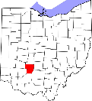
Geographically, Fayette County is located in southcentral Ohio with access to several of Ohio’s major highways including: Interstate 71; U.S. routes 22, 35, and 62; and Ohio Routes 41, 38, 207, 729, 734, and 753. Bordering Appalachia and sharing many characteristics with Appalachian counties, Fayette County isn’t actually designated as such and therefore has less access to funding.
Compared to the rest of the state and nation, CACFC’s service area has relatively low levels of racial and ethnic diversity. The vast majority (94%) of the population identifies as white. Fayette County’s disabled population is 16.7%, which is greater than both the nation and state. Individuals that report as multi-racial or black were also identified as disabled at greater rates than whites, with 22 and 22.7. Most notably, all Native American/Alaska Natives were disabled. Only 1.34% of the population has limited English proficiency. 77% of that population speaks Spanish, 4% German, with the remainder speaking Asian languages like Japanese or Korean (https://www.lep.gov/maps/lma2015/Final).
Fayette County is home to two public school districts and has one private Christian school. There are 4,790 students in the assessment area. Within the report area 2,496 public school students or 52% are eligible for Free/Reduced Price lunch. 14% of the total population is identified as experiencing food insecurity at some point during the year. 21% of children were identified as food insecure. 27% of these food insecure children are not eligible for any assistance. There are free meals available in the community every day of the week and six faith-based organizations running food pantries.
Miami Trace School District has a graduation rate of 95.1%. The district report card is as follows: A for gap closing and graduation rates, B for progress, C for achievement and improving at-risk K-3 readers, but an F in prepared for success. Washington Court House has a graduation rate of 86.9%. It received A in progress and B in graduation and gap closing. Achievement, Improving At-Risk K-3 readers and preparing for success were D, D, and F, respectively. https://reportcard.education.ohio.gov/ This is relevant because research suggests that education is one of the strongest indicators of health.
Transportation is a challenge for many low-income families in Fayette County. While only 4.3% of all household’s report having no motor vehicle (ACS 2018), the local transit system is often overwhelmed. Fayette County Transportation provided over 45,982 trips in 2019 alone. The vast majority of these trips were for employment (over 34,000) with medical following (around 5,600).
The housing market in Fayette County is very challenging. 26% of all homeowners pay more than 30% of their income towards their housing and 37% of all renters are also burdened with excessive housing costs. The housing stock, as projected by the census, is around 12,817 units. Approximately 63% of those units are owner occupied. Discussion amongst homeless program staff indicated that rental housing that will pass inspection is difficult to find and that many individuals have had to move outside of their school district or the county at times when unable to locate affordable, quality housing. This is supported by the fact that the county has 26% of its housing units being occupied with one or more substandard conditions. This data point, however, has improved most likely from the initiation of the Fayette County Landbank.
Ohio Development Service Agency’s county profile indicates that 7.7% of the county’s housing units are vacant. 63.4% of the housing stock was built before the 1980’s. The greatest percentage of homes are valued between $60-79,999.
Fayette County does fair better than the state and nation in terms of access to HUD-Assisted units with 697 units in the county. 390 are HCV, 249 are Project-Based, and 58 are HUD 202 (https://www.huduser.gov/portal/datasets/assthsg.html). The county is also home to 587 Low Income Housing Tax Credit units.
The median household income in the community is $47,733, well below the state and national median incomes of $56,155 and $61,937 respectively.
According to Ohio JFS statistics and the PCSAO Factbook there are 345 children receive OWF/General Assistance at about $289/month. 107 families with 226 children receive childcare assistance.
The county is both a mental health professional shortage area and a medically underserved community. Currently, Fayette County has three substance abuse treatment providers, Fayette Recovery, Phoenix Integrated Health, and Scioto Paint Valley Mental Health. There is a total of 14 mental and 11 primary healthcare providers in the entire county. A total of 6.18% of the entire population is uninsured. However, this issue impacts minorities in the community disproportionally. Uninsured rates are 41.95, 31.48, and 57.98 for other races, Hispanics and Asians respectively.
Indicator | Fayette County | Ohio | United States
Mental Health Care Provider Rate | 111.6 | 244.3 | 202.8
Primary Care Physicians Rate | 31.41 | 76.2 | 76.6
Percentage of Adults w/o Primary Care | 39.11% | 18.65% | 22.07%
Percentage living in HPSA | 42% | 12.2% | 23.1%
Years of Potential Life Lost | 10,999 | 8,619 | 6,588
Age Adjusted Drug Poisoning Death Rate | 35.5 | 26.66
Deaths of Despair (suicide, alcohol disease, overdoses) | 66.97 | 52.4 | 40.67

The area also has more families on SNAP than the state and national averages, with 17.6% of the population receiving SNAP (or 4,648 individuals in May 2019). The county has 33 Authorized SNAP retailers, allowing higher access than the state and national average.
In terms of education, the community also lags the state and nation in terms of individuals with a high school diploma, associate’s degree, or bachelor’s degree. This is likely due to a large portion of the community leaving for college and frequently not returning or moving for economic opportunity. 15% of the population has no high school diploma, 22% has an associate’s or higher, and 14% reports having a bachelor’s degree or higher. 42% of the Hispanic population does not have a high school diploma.
The current unemployment rate for the county is 9.7%. Over the course of June 2019 – June 2020 rates ranged from as low at 3.4% to 16.1%. The county’s rate is slightly less than the United States and Ohio.
Due to many health-related factors and access to care, the county ranks 66 out 81 in terms of health outcomes. This was a vast improvement over our last assessment, where the county was ranked 77. Most notable are its obesity (36%) and teen births (41) compared to other Ohio Counties, according to the County Health Rankings produced by the Robert Wood Johnson Foundation. The county also has more children in poverty, single-parent households, and injury deaths by comparison.
The community has been overrun by the opiate epidemic. In 2017 the community was ranked #2 in Ohio for overdose deaths. In 2018 (the last full year of data) we were ranked #45. The age adjusted death rate is 22.2 versus the state average of 19.6 and national average of 13.4. Past 30-day use data obtained of surveys of the two local school districts showed 23% of 10th graders reporting alcohol use, 13% reporting marijuana use, and 5% reporting the illegal use of prescription drugs.

Agency Resources

Programs
Youth Programs
Early Head Start – program for infants, toddlers and pregnant women to help parents use their home environment to provide rich learning opportunities and enhance their child’s development. Serves youth ages 0 – 3. Services include: home visits, parenting skills, promoting sound, physical social and emotional growth, information on development and nutrition, pre-school preparation, identifying developmental delays and access to dental appointment and transitions to pre-school. This project also works with childcare centers to offer these services to youth within the target population.
Head Start – free preschool program for youth ages 3-5. Head Start provides breakfast, lunch and a snack. Children receive developmental, speech, vision, and hearing screenings onsite. We serve all eligible children, including children with disabilities. We provide transportation to both site locations.
Drug Free Communities Program – youth substance abuse prevention program working to do decrease youth substance use utilizing a comprehensive set of strategies to address both individual and environmental change in the community. DFC staff conduct SBIRT (Screening, Brief Intervention and Referrals to Treatment) for youth that are suspected of having a substance use issue. Parent education is available on how to talk to your kids about substance use. Staff also run youth drug-free coalitions at both local school districts. Youth led programming employs education, alternative activities and community service projects targeted to use positive peer pressure to delay 1st use of substances. The program also offers community education and other early intervention programs in conjunction with local partners.
Senior Programs
National Family Caregiver Program - The Caregiver Program offers assistance with Respite Care and supplemental services such as purchasing medication, house and rent payments, utility bills, food and medical equipment, and much more depending on the applicant’s needs. This Title III funded program provides support services to persons who are acting in a caregiver capacity to a person age 60 or over. Support services include respite care for the caregiver, emergency payments for the client or the caregiver and linkage to other needed services. Care recipients must be Seniors ages 60 and over and must reside in Fayette County.
Homemaker Aide Program - An aide goes to the homes of persons age 60 or over who are unable to do their own housework and provides homemaker services. Services include vacuuming, dusting, cleaning bathrooms, washing dishes, mopping floors, laundry and shopping.
Healthy U Chronic Disease Self-Management Program - There are 3 workshops available: chronic pain, chronic illness, and diabetes. Healthy U is a FREE six-session workshop that can help people with diabetes, asthma, arthritis, heart disease, chronic pain and other lifelong conditions set goals and make a step-by-step plan to improve their life. This workshop can also be taken by those who do not have a chronic condition but are wanting to find ways to help a friend or family member to better self-manage their chronic condition. Workshops are available to anyone 18 or older and are offered through teleconferencing and Zoom.
Matter of Balance – This is a free workshop designed to reduce falling and increase activity of older adults that are concerned about falling.
Homeless Programs – All of Community Action’s Homeless Programs provide case management, housing placement, action planning and referrals based upon the housing first philosophies.
Emergency Shelter – The Brick House Homeless Shelter is a 16-bed facility targeted to victims of domestic violence, families with children, and single women.
Peace House Domestic Violence Shelter – Peace House is a 12-bed emergency transitional housing facility targeted to victims of domestic violence, dating violence, sexual assault and stalking. Services include case management, crisis intervention, safety planning, support groups, basic needs, and non-residential supportive services meaning victims do not have to access housing resources to engage in services.
Homeless Prevention – HP is a homeless prevention program targeted to individuals that would be homeless but for the assistance. Staff must be able to document applicants would be homeless but for the assistance, score a specific number on the homeless prevention scale and have incomes under 30% AMI.
Rapid Re-Housing (RRH) – RRH is a homeless program that provides financial assistance and case management to individuals and families that are homeless on the streets or have been in shelter for 5 or more days. Income must be no greater than 50% AMI at entry and below 30% AMI for continuation at 90-day intervals of re-evaluation. There is also specialized funding targeted to transition aged youth (18-24).
Permanent Supportive Housing (PSH) – Community Action has 5 different PSH programs. To qualify for PSH a household must have one person that has a disability and the entire household must have an income no greater than 35% AMI. Specific programs have different guidelines. Four of the five programs require that individuals are chronically homeless. This means they have a disabling condition and have been homeless for 12 continuous months for four times in three years where the cumulative time homeless is 12 months. Regardless of program, individuals must go through the coordinated entry and prioritization process. Individuals with the most severe needs and longest homeless history will be served first.
Pathways to Recovery
The purpose of the Pathways to Recovery Program is to reduce the morbidity and mortality related to opioid overdoses in Fayette County, Ohio by strengthening the development of the Faith in Recovery community coalition to prepare individuals with opioid-use disorder (OUD) to start treatment, implement care coordination practices to organize patient care activities, and support individuals in recovery by establishing new peer support activities. The project will also include an educational component to train members of the community and healthcare professionals on OUD, methods for preparing/referring individuals for treatment, and supporting individuals while in recovery. Services: overdose response, harm reduction and naloxone training and distribution, case management and referrals, care coordination, and transportation coordination.
Salvation Army
The Salvation Army provides emergency payments for medical, housing, utilities, clothing, food, baby supplies and other needs on a case-by-case basis. Individuals must have experienced an emergency and be able to manage the expense once assistance has been provided.
Self Help Housing
Self Help is a credit repair and home ownership program that enables low to moderate income households achieve the dream of home ownership. Financial literacy, budgeting and homebuyer education classes are provided to program participants. Participants may choose to build a new home or do a rehabilitation project. Household income can be no greater than 80% AMI.
Transportation
Community Action has several different transportation programs. Community Action provides Medicaid transportation to medical appointments. This service does travel outside of the county. They also have a general, in-county demand-response transportation programs. Passengers must call ahead to arrange these services. Trips are $1 within Washington Court House and $1.50 within Fayette County. Out of county trips cost $2.50/mile. Last, the agency has fixed route that runs from Community Action, to Aldi, downtown and across town to Ohio Thrift and Seton. Trips cost 50 cents. The route runs from 10 a.m. to 5 p.m. Monday through Friday. For special mobility issues, the agency operates a Mobility Management program.
Utility Programs
Community Action has HEAP (Home Energy Assistance Program), PIPP (Percentage of Income Payment Plan, and the Winter and Summer Crisis programs. Applicants must a gross annual income of 175% FPG. HEAP pays a one-time payment towards heating your home. Summer crisis provides an air conditioner to the elderly and individuals with disabilities that would be improved by having an air conditioner. Winter crisis is for individuals with a disconnect notice or have less than 25% fuel in their tank. PIPP is a program that allows eligible customers to make affordable monthly energy payments on a year-round basis. When a PIPP Plus household pays its monthly PIPP Plus payment on-time and in-full, some of their old debt and the rest of that month’s bill goes away in the form of a credit on their utility account. Individuals will pay no more than 12% of their income towards utilities.
Weatherization
Weatherization reduces costs for low-income families by improving the energy efficiency of their homes while ensuring their health and safety. Services include furnace safety inspection, water heater insulation, air leakage reduction, attic insulation, sidewall insulation, floor insulation and elderly home repair.

Agency Coalitions – Lead Agency
In addition to the aforementioned programs, the agency is the lead for the following coalitions.
Faith in Recovery - Our mission is to combat substance abuse in Fayette County through collaborative community development projects to promote a safer, healthier community.
Faith in Recovery Fayette County Prevention Coalition - The Faith in Recovery Prevention Coalition will create a unified community response to prevent youth substance abuse and support the development of effective community programs to promote a safer, healthier, and drug free Fayette County.
Region 16 CoC - The mission of the SCOR Continuum of Care is to develop, promote, and support a regional collaborative of social services and housing opportunities that reduce and prevent homelessness in our communities.
Fayette County CoC - To promote secure and affordable housing for residents of Fayette County who are homeless or who have been identified as being at risk of becoming homeless
Family & Children First - The Mission of County FCFCs is to increase the access, capacity and effectiveness of services for the most vulnerable of our county's youth and their families whose needs extend beyond any one youth-serving program.
Coordinated Council on Access & Mobility/Transit Advisory Committee - The mission is to provide access to transportation information and resources so that all residents, including older adults, people with disabilities, and individuals with limited income, will be able to access a wide range of transportation solutions to ensure mobility in and around our county.

Community Resources
Fayette County has a wide range of programs and services that work on various social issues that impact or are impacted by poverty.
Food – At the time of this assessment there are 7 food pantries and multiple site offering meals.
Treatment – Health Department, Fayette Recovery, Scioto Paint Valley, and Phoenix
Utility/Rent – St. Vincent de Paul, Fayette County Veteran’s Services, Housing Authority, St. Coleman
Job & Family Services – SNAP, Medicaid, transportation, etc.
Pregnancy Support – LIFE Pregnancy Center
Mental Health – Fayette Recovery, Scioto Paint Valley, Phoenix, NAMI
Domestic Violence – See all mental health agencies, Municipal Court, Victim/Witness
Jobs – Ohio Means Jobs
Multi-purpose – Rose Avenue Community Center, Second Chance
Post-Secondary – Southern State Community College
Youth – Big Brothers Big Sisters, OSU Extension, Ranch of Opportunity

Community Coalitions - Participant
I-Team – Collaboration board for domestic violence and sexual assault.
Suicide Prevention Coalition – ran by Paint Valley ADAMH Board
Community Health Task Force – ran by Fayette Health District

Poverty Specific Profile
Fayette County has a poverty rate higher than both the nation and state. In comparison to other Ohio Counties, Fayette County ranks 21st, meaning there are only 20 counties that have higher rates of poverty. Poverty has been on an upward trend in the community despite the agency’s efforts and comprehensive programming. We have increased to 15.1% of individuals and 15.6% of households living in poverty during this reporting period which is a 5.1% increase since 2000. When looking at the 5-year average, 16.99% of all persons in Fayette have lived in poverty.
In terms of gender, age, race and ethnicity, the data shows that women experience poverty at greater rate than men in the community with rates of 18.25% and 15.68% respectively. Poverty by family type estimates show that It is estimated that 12.8% of all households were living in poverty within the report area, compared to the national average of 10.1%%. Of the households in poverty, female headed households represented 54.7% of all households in poverty, compared to 33.5% and 11.8% of households headed by males and married couples, respectively.
Poverty by family type estimates show that It is estimated that 12.8% of all households were living in poverty within the report area, compared to the national average of 10.1%%. Of the households in poverty, female headed households represented 54.7% of all households in poverty, compared to 33.5% and 11.8% of households headed by males and married couples, respectively.
Minorities also experience poverty at greater rates. Individuals of Hispanic ethnicity experience poverty at 52.14%, versus the state and national of 25.85% and 21.02%. In terms of race, there is a greater mix in regards to whether our county is above or below state and national averages. Those reporting “other” or “multiple race”, poverty is higher in Fayette County at 66.67% and 51.47%. However, Native Americans and Native Hawaiian or Pacific Islanders report no poverty. Asians report less poverty than their white counterparts, with 10.34% reporting poverty vs. 15%. However, African Americans experience poverty at greater rates in the county with 25.05% living in poverty. However, this is under the state average of 31.18%.
Poverty by age shows that children are the largest group living in poverty with 25.3% of all youth living 0-17 living in poverty. When it comes to youth 0-4 the rates are even higher with 37% in poverty. This statistic is above state and national averages. The Senior poverty rate is lower than state and national averages with 6.3% of this population living in poverty.
For more detailed information and graphics on Fayette County poverty data, please see the information below.

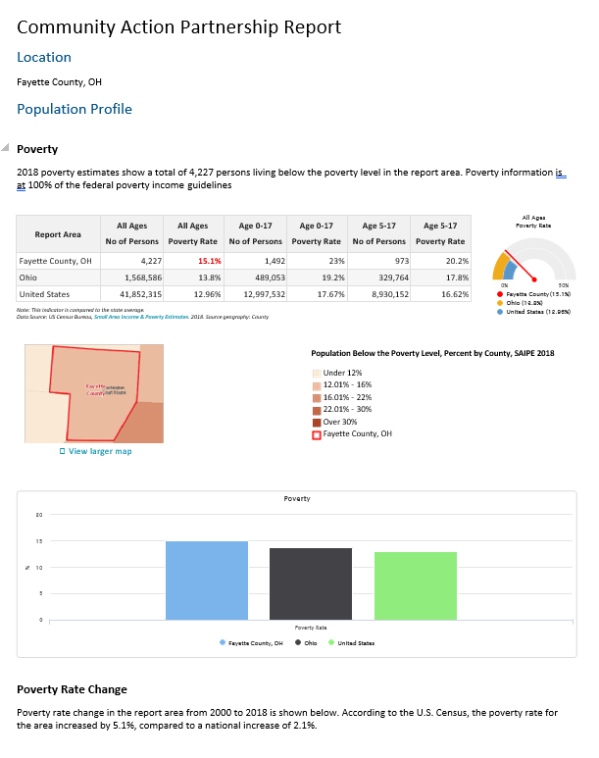
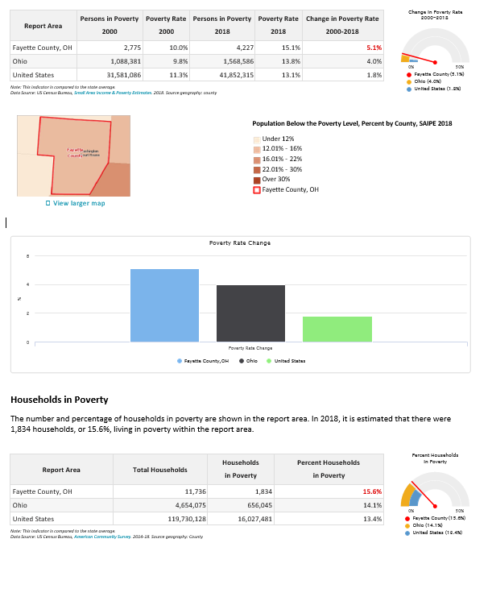
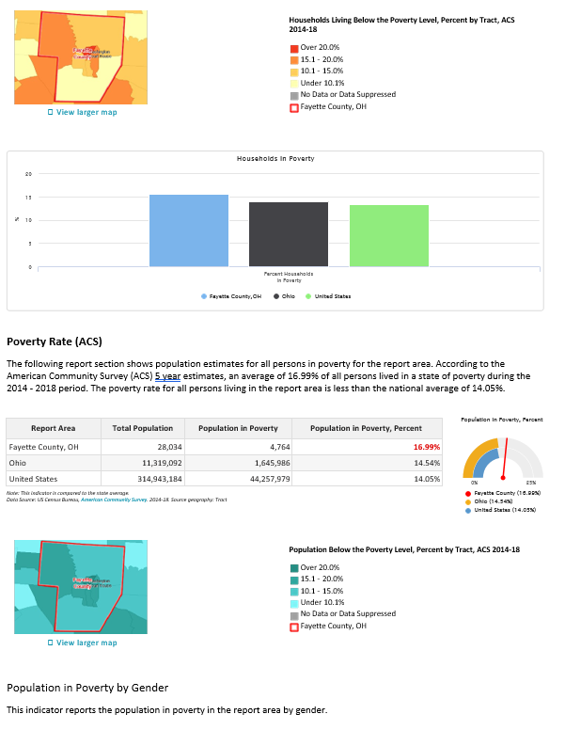
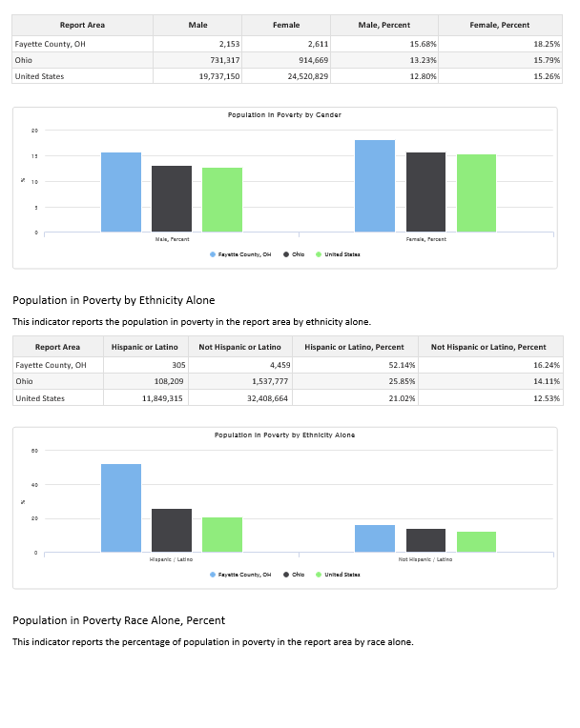
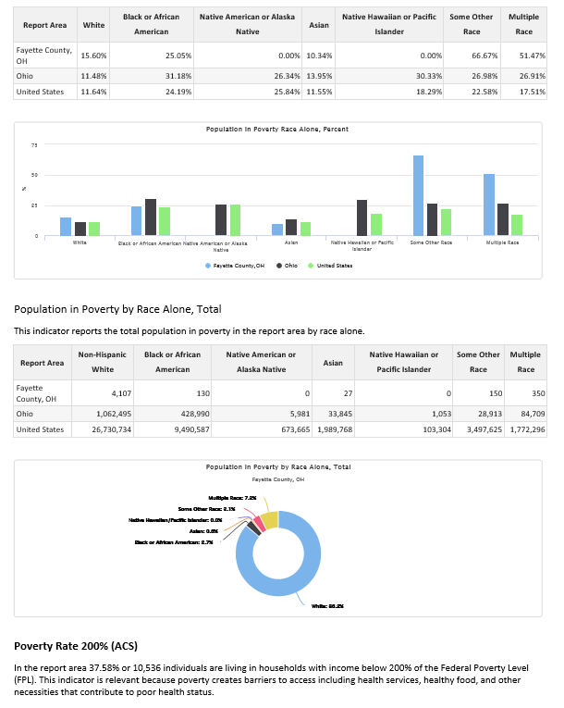
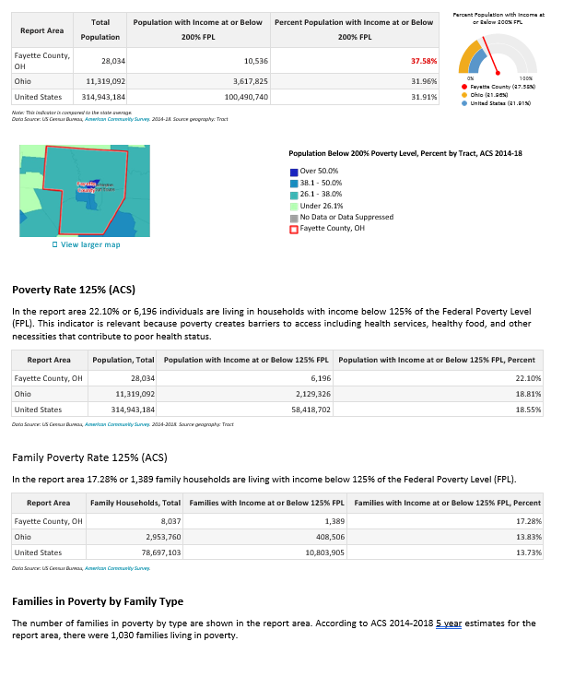
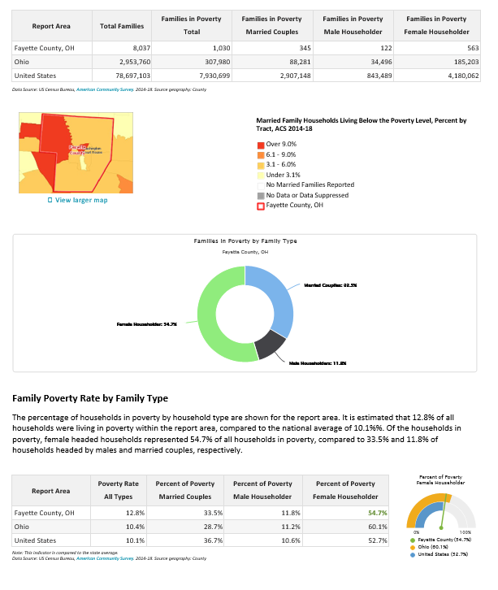

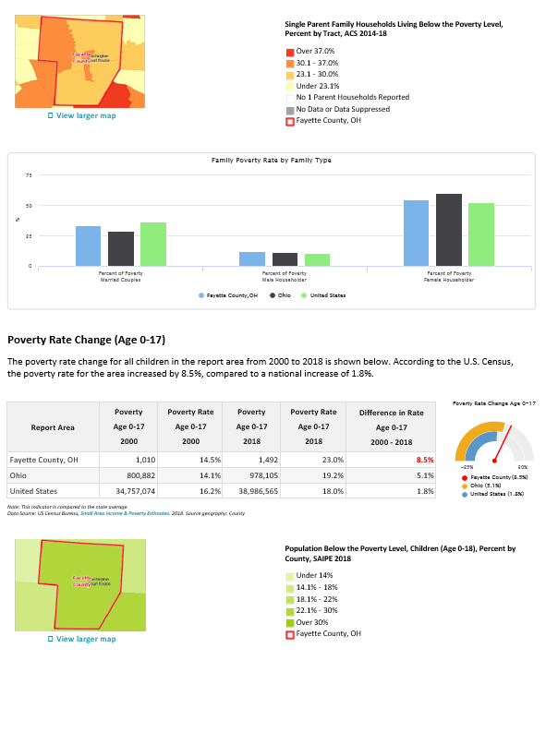
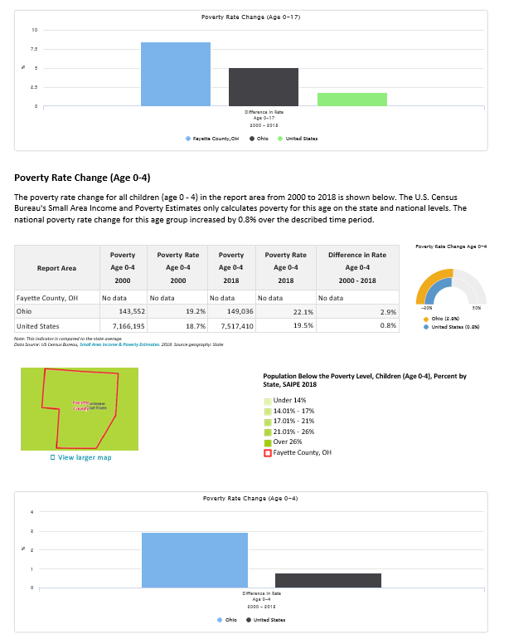
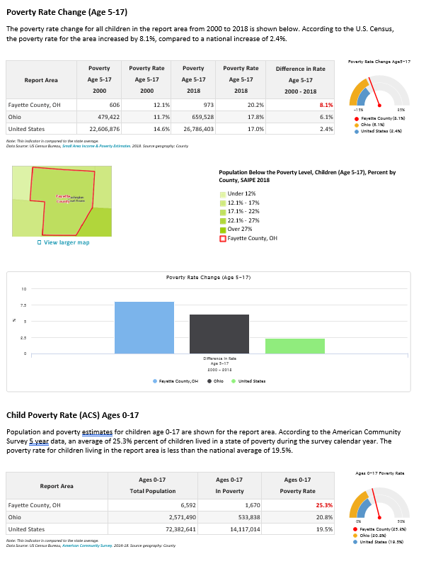
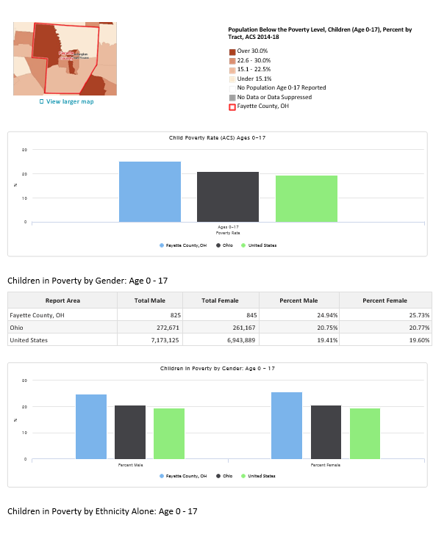
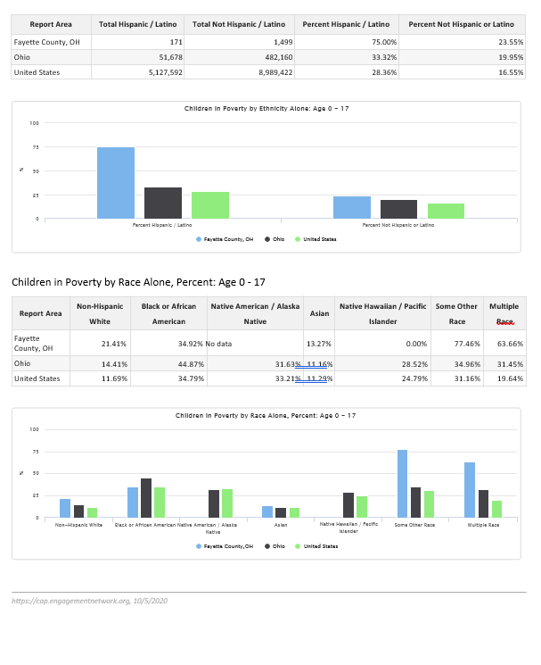

Causes & Conditions of Poverty
To determine the causes and conditions of poverty in the community the Planner examined the feedback from the low-income/client population, agency staff, volunteers and board members, the business community, and other various stakeholders and examined themes that showed up regardless of whom we were asking. Feedback overwhelmingly prioritized under-employment, affordable housing, homelessness and substance abuse as the key community conditions causing poverty. Most individuals considered these key issues solvable through higher wage jobs, education, transportation, increasing parenting skills, as well as medication assisted treatment and counseling resources. Additionally, the Planner explored poverty data and other secondary quantitative data to draw additional conclusions discussed in this section.
Under-employment – Across groups under-employment (meaning jobs are inadequate to meet economic needs) was the number one issue. Employment itself fell within the top 10 for most groups. However, across groups everyone agreed that under-employment was the issue. When we look at our employer surveys most of them indicate there is a lack of workforce. When speaking with low-income households they often indicate that the use of temp agencies or the lack of high paying jobs is the issue. CAC does not have any employment related programming at this time since we lost YouthBuild funding starting in 2021. However, this goal would fall under community-level goals with the focus being to increase employment opportunities.
Affordable Housing – Across groups affordable housing was the issue. Much of the community’s housing stock is lower quality but higher in rent. When speaking with landlords there is a sentiment that it is difficult to find renters that pay on time and often times their units are left in disrepair. The agency currently has a small grant to cover homeless families that have caused damage to units. CAC is also a community housing development organization and is a partner on 400 units of affordable housing. The agency also participates in the Landbank, which is a project that demolishes substandard homes and resells the property. Compared to other communities Fayette County has more HUD-assisted housing units available to eligible renters. There are 674 units total for a rate of 531 per 10,000 housing units. This is higher than both state and national numbers. During the last community needs assessment period the agency Planner applied for more vouchers through the Housing Authority and obtained an addition 50 units for the community. Overall, the community continues to work on housing, but growth in the number of units in the community is .95% compared to the state’s 2%.
Homelessness – Across groups homelessness was often identified as a critical need. This, most often is cited because despite the large amount of resources the agency has for homelessness there is no emergency shelter specifically for men or runaway youth. During the last assessment, we were successful in opening a domestic violence shelter and during this period we must continue to gain resources for this project to ensure 24-hour coverage. Given the current funding environment, it is unlikely that the agency will be able to obtain resources for a men’s shelter or for runaway youth. There are no new funds for shelters but the agency coordinates with resources in nearby counties to obtain shelter. Regardless, many homeless men are unwilling to leave the community. We do have several programs that serve single men, but they do require an extensive assessment process, requiring those individuals to prove their current homelessness, history of homelessness and be willing to meet with case management monthly. There have been several community groups that have popped up over the years to take on this challenge. Another option is to locate alternative housing for the emergency shelter. The current setup is not conducive to serving both males and females. Substantial resources would be needed to obtain such a unit in the community and modify the structure to meet the project’s needs.
Current CAC homeless programs include a domestic violence shelter, emergency homeless shelter targeted to single women and families with children, rapid re-housing, and permanent supportive housing.
Substance Abuse – Substance abuse was our top public health concern in the last community health assessment. At that time the agency was ranked 2nd in Ohio for unintentional drug overdose deaths. Our community currently sits at 45. The agency obtained two large federal grants and since that time we’ve seen a 69% reduction in overdose death and reductions ranging from 2-50% reductions in youth use of specific substances. Changes to youth substance use will take decades to realize. Reduction is opioid use are apparent, but we are seeing increases in other use, particularly around methamphetamine.
Despite these gains, substance use was identified by businesses as the second biggest barrier to employment. It remained the number one public health issue in the community with 97.8% of respondents indicating it to be a top health issue in the community. The agency continues to advocate that funding not be drug-specific and while there has been movement on this in that SOR funding now allows the use of stimulants, alcohol remains the number one abused substance in the community. Any funding that does not consider substance use as a whole will be limited in its community impact.
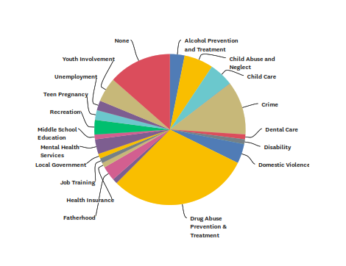
Access to substance abuse treatment remains a concern in the community. The community’s care needs are as follows: mental health counseling (66%), substance abuse counseling (62%), medication assisted treatment (45%), and trauma-specific counseling (44%).
Additionally, in Head Start’s survey of community needs 38% indicated the community needs more alcohol prevention and 59% indicated we needed additional drug abuse prevention.
A recent survey of individuals in the Fayette County jail shows that the majority of individuals using substances are poly-drug users with marijuana, alcohol, meth, cocaine and heroin the most used drugs in the community. Inmates indicated that meth, heroin, and alcohol influenced their decisions directly resulting in their current incarceration.
Due to expiration of DFC and RHOP funding during this assessment period agency resources to fight the epidemic are all threatened. It is essential to find continuation funding, including Medicaid billing to sustain these programs that target both community and individual goals. To achieve that goal the agency must obtain Ohio MHAS certification.

Needs of the Community
The Community Needs Assessment Survey and Focus Groups held by CACFC were analyzed to determine agency, family and community goals that will drive our next performance period.
Top 10 Critical Needs
Priority | Low Income | All Stakeholders | Overlapping Priorities | Agency Program
1 | Under-employment | Under-employment | Under-employment | None
2 | Affordable Housing | Affordable Housing | Affordable Housing | Income-based housing
3 | Homelessness | Homelessness | Homelessness | Multiple programs
4 | Employment | Substance Abuse (All populations) | Substance Abuse/Prevention | DFC/RHOP
5 | Rental Assistance | Parenting Skills | Healthcare Costs | Salvation Army/Caregiver
6 | Substance Abuse Prevention Youth | Before & After School Childcare | Before & After School Childcare | EHS CCP
7 | Healthcare Costs | Healthcare Costs
8 | Credit and/or Savings | Youth Counseling
9 | Before & After School Childcare | Medical Care
10 | Medical Care | SA Prevention for youth

Within employment/under-employment common themes that came out include: lack of decent paying jobs, a workforce able to pay a drug screen, workforce without reliable transportation, and child care. The agency has a Pathways to Recovery program to assist individuals with their recovery, childcare through Head Start and Rockabye, and a transportation program.
Under affordable housing and homelessness common themes that came out include: low paying jobs, mental health/substance abuse, employment, lack of quality housing and housing in general, waiting lists and credit. Additionally, there is a lack of programming targeted towards men. The agency is a community housing development organization and is a partner in 400 units of affordable housing. All homeless program has increasing income and connections to benefits as a goal. There is an opportunity in the community for additional mental health and substance abuse recovery resources coming in and the need for our agency to continue our Pathways to Recovery program to provide transit and connections to resources outside of the community.
Substance abuse was a recurring theme regardless of what type of open-ended question we asked in the community needs assessment survey. Related to that included the lack of treatment, including medication assisted treatment. All of these were also impacted by youth growing up around substance use. In particular, there is a lack of treatment facilities for men.
While the homeless programs are very robust, there is room to improve temporary housing for men, but currently no funding sources for that endeavor.
Before and after school childcare remains an issue. CAC currently operates a program but is limited in the number of individuals it can serve. Additional space is needed to expand this program.
Also, throughout the survey the need to expand office space for new and current program was a common theme.
Connecting Community Needs to Agency Programs and Opportunities for New Programs
Family Goals:
- Homeless individuals are connected to safe permanent housing.
- Individuals in active addiction are connected to treatment and supported in recovery.
- Low-income individuals are connected to affordable housing.
- Families with children are provided parenting skills and support.
- Low income families have access to before and after school childcare.

Agency Goals:
- Obtain additional space for programs, including childcare.
- Identify resources for homeless programs that could include temp shelter for men and/or coordinate with other community stakeholders to provide this service.
- Obtain alternative funding sources for substance abuse treatment and prevention programs.
- Obtain additional funding to fully staff Peace House.
- Obtain additional funding for medical care expenses.
Community Goals:
- Reduce youth substance use past 30-day use rates by at least 15%.
- Reduce unintentional drug overdose by 15%.
- Advocate to expand living wage employment opportunities in the community.
- Identify QRT funding to respond to overdose victims.

Conclusion
Fighting poverty is a complicated process. Since the early 60’s Community Action has been given the responsibility to identify the root causes of poverty, identify interventions that address those root causes, evaluate our effectiveness, and begin the process all over again. In spite of these efforts, poverty in our community continues to increase. We know what is causing it and we have a plan, but we cannot fight this battle ourselves. We need individuals from each socio-economic class to buy into the process. We need representation of all ethnicities and races at the table contributing to explaining their experience and identifying what they need. Last, we need to redefine how we tell our stories and fight the idea of the deserving and undeserving poor. We have to eat the elephant one bite at a time.
I leave the community with this, despite the challenges before us as a community these are the assets we have based upon your feedback:
- Strength
- Closeness
- Community involvement
- Collaboration among providers
- Awesome churches
- Family
- Liberty
- Opportunity for growth
With those assets working in our favor it is certain we can achieve our vision that every individual and neighborhood can thrive.

For a full listing of data used to complete this assessment please visit https://www.cacfayettecounty.org/community-needs-assessment/.

