Community Action Commission of Fayette County (CACFC)

Customer Satisfaction Survey

1.What type of service(s) did you seek at CACFC? check all that apply:

COVID Assistance

Food pantry referral

Utility Assistance

Homeless Assistance

Emergency Shelter

Rapid Re-Housing

Permanent Supportive Housing

Domestic Violence Program

Weatherization

Transportation

Home ownership programs

Credit Repair/Financial Education

Youth programs

Senior programs

Home Buyer Education

Head Start

Early Head Start

Prevention Programs

Treatment and Recovery Support Programs

Other? Describe Service below:

Date Survey was completed:

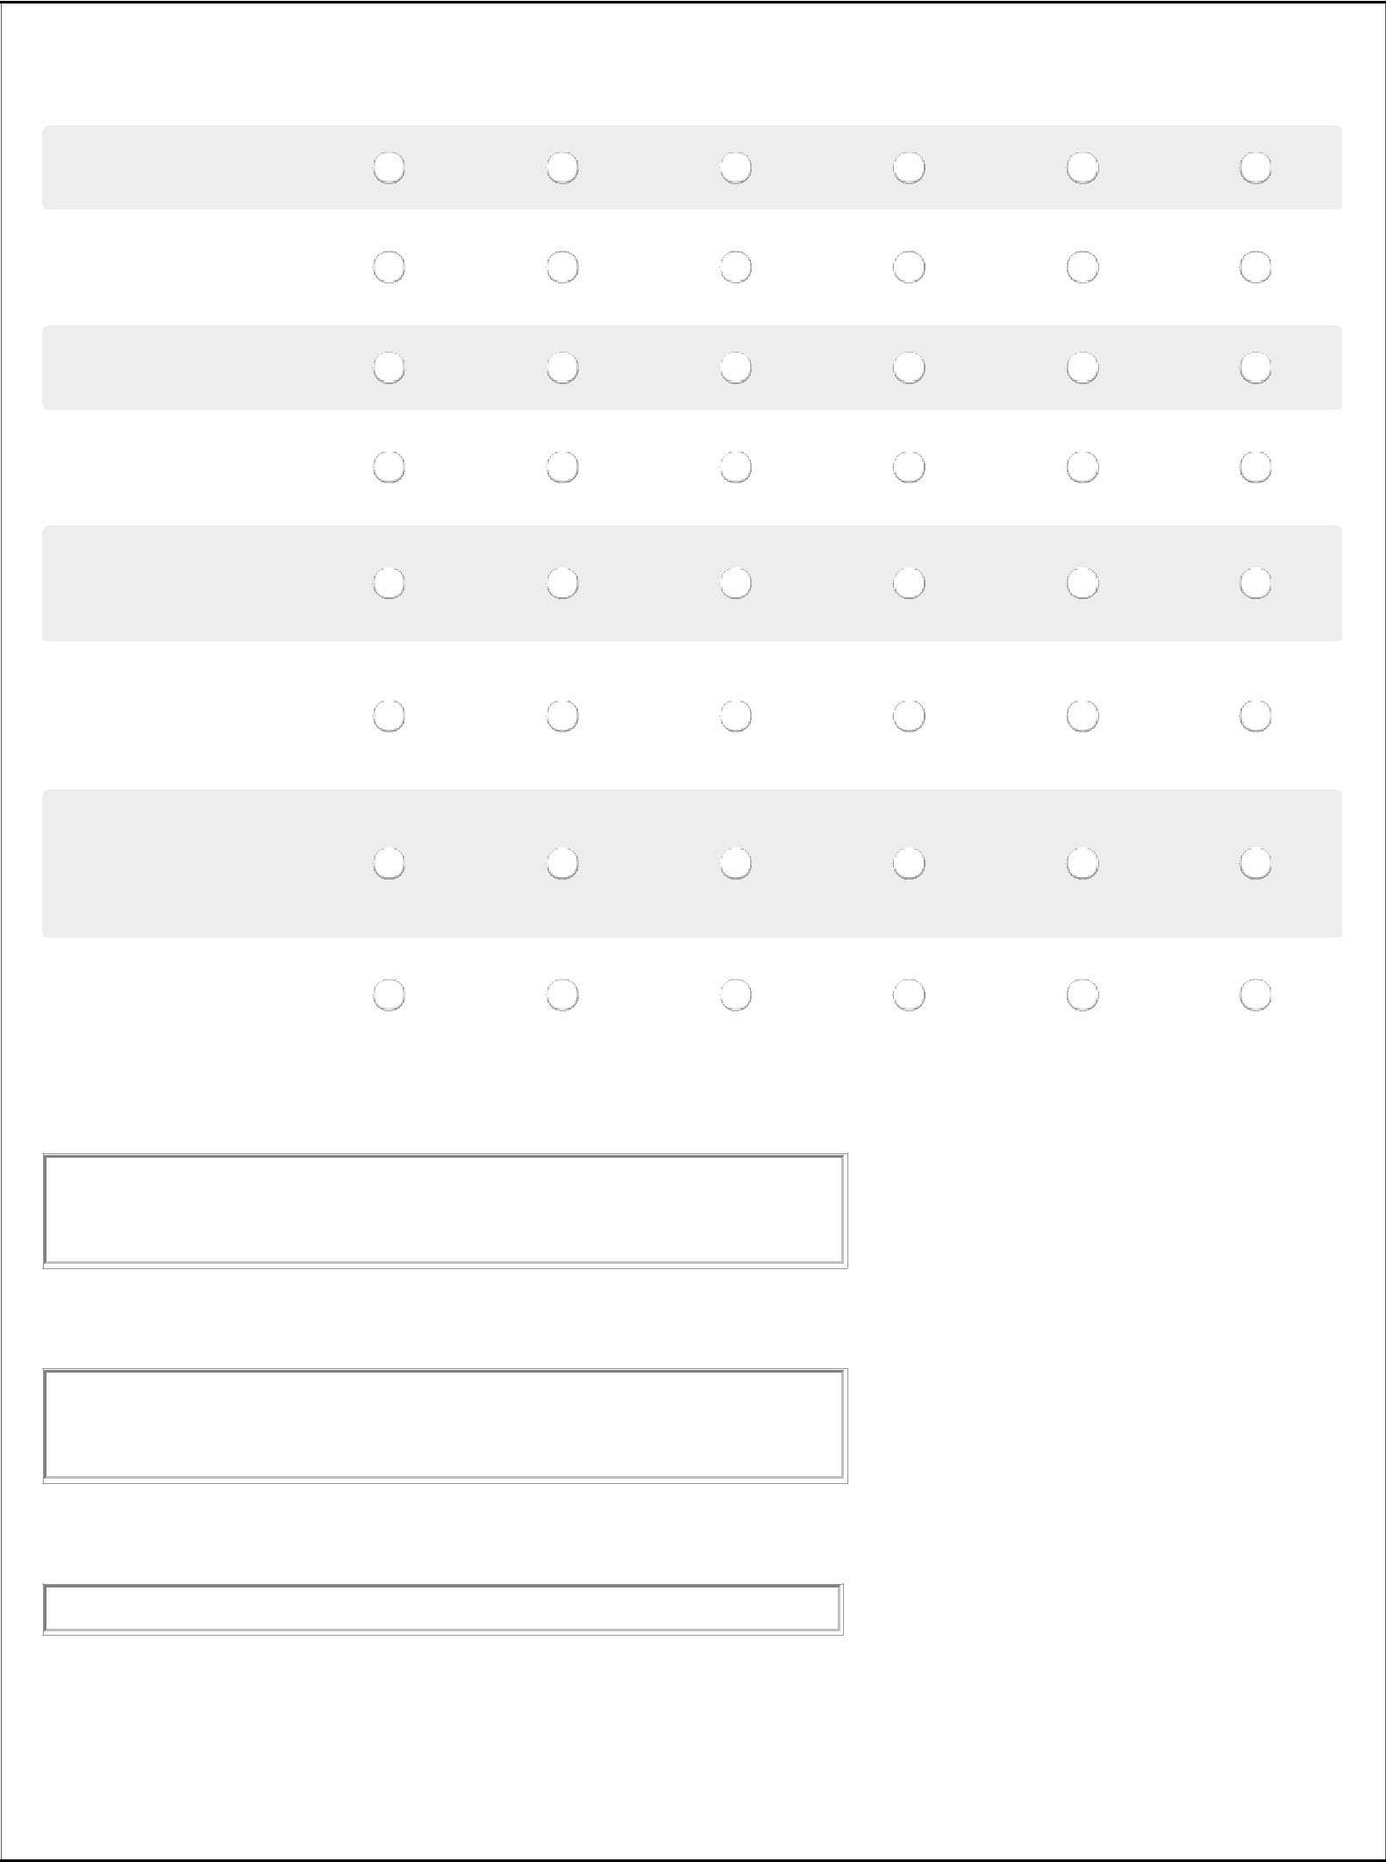
2. Please rate your experience at CACFC today:

Strongly Agree Neutral Strongly Disagree Doesn’t
Agree Disagree Apply

a. Our receptionist was
polite and respectful
b. My request for assistance was attended to as quickly as possible

c. I was treated with
dignity and respect

d. Staff listened and responded to my concerns

e. Staff told me about other programs that might be helpful to me

f. Staff explained the paperwork and answered all my questions

g. If I was not eligible for assistance, staff clearly explained the reasons for the denial

h. I would recommend Community Action to others

- What was the most helpful thing about the program you worked with today?

4. What is not helpful about the program or a service that you really don't need?

5. Do you have any comments or recommendations? Please share them below:

