
PROGRAM OVERVIEW

HCRP RRH program helps individuals and families to break free from homelessness. This program serves households that would likely remain homeless without RRH assistance.

Homeless households are rapidly moved out of emergency shelter or off the streets and into permanent housing.

Assistance is provided to help households obtain affordable housing and to increase self-sufficiency.



How can I apply?

Please call your County assigned Access Point listed on the back of this brochure.

Remember households must be screened to determine eligibility based on program requirement and level of need.

County Access Points with Locations:

Fayette County
Emergency Shelter

740-333-7580
320 North Hinde Street

Washington Court House, Ohio 43160

Fayette County CAC
740-335-7282
1400 US Route 22 NW

Washington Court House, Ohio 43160

Fayette Landing

740-895-6742
719 Rawling Street

Washington Court House, Ohio 43160
Peace House DV

740-505-0090

Pickaway County

Pickaway County Community Action
740-477-1655
469 East Ohio Street Circleville, Ohio 43113

Ross County
Ross County CAC
740-702-7222
250 N. Woodbridge Ave. ,

Chillicothe, OH 45601

Clinton County
Emergency Shelter
937-382-7058
36 Gallup Street

Wilmington, Ohio 45177

Highland County

Highland County Homeless Shelter 937-393-0634
145 Homestead Ave Hillsboro, Ohio 45133

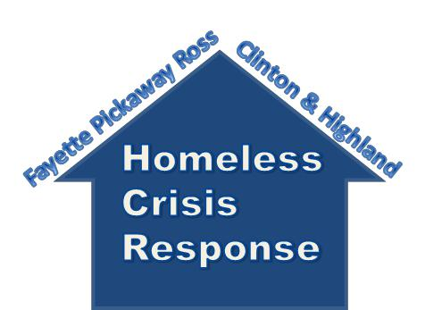
ME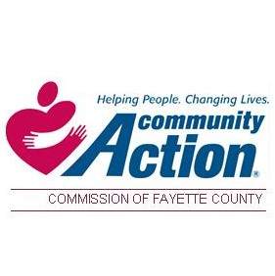LESS CRISIS RESPONSE PROGRAM



A Regionally Coordinated

project with the goal to prevent and functionally end homelessness in our communities.

RAPID RE-HOUSING

The goal of the HCRP RRH program is to promote housing stability for households experiencing homelessness. Every household assisted by the program is provided case management to help them identify needs, establish a safe living situation, and to create a plan that connects them to the resources needed to help them obtain and maintain housing.

Each household’s case plan may include:

- Case Management

- Referrals to housing opportunities.

- Referrals to community services.

- Referrals to employment and or
educational opportunities

- Budgeting assistance.



WHO IS SERVED?

Individuals and families who have:

- No housing support, such as permanent housing options with family or friends.

- A lack of financial resources and support networks needed to obtain immediate housing.

- A head of household who is at least 18 years of age.

- Met the literally homeless definition.

????

Have questions?
Reach out to your local Access Point for additional guidance!
Literally homeless definition:
- Sleeping in a place not meant for human
habitation ( car, tent, outside, etc.)

- Residing in an emergency shelter

- Timing out or graduating from
transitional housing

- In hospital or institution for up to 90 days (but
homeless prior to entry)

- Living in a motel/hotel paid by federal, state
or local government programs, or by local
organizations

Region 16 Service Area

