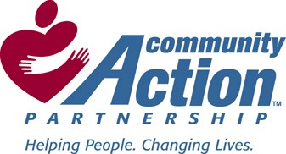
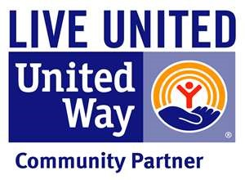

What is Permanent Supportive Housing?

Permanent Supportive Housing (PSH) represents the Community Action Commission of Fayette County’s efforts to ensure that homeless
persons transitioning to housing will be successful in maintaining their housing stability and not fall back into the cycle of homelessness.

PSH provides housing opportunities for households comprised of families or single individuals with chronic homelessness and a disabling condition.

Through funding provided by the Department of Housing and Urban Development and the State of Ohio, Community Action Commission of Fayette County can supplement rent payments on behalf of eligible households to ensure they meet their lease commitments, while supporting on-going case management services to maintain their housing.

PERMANENT
SUPPORTIVE
HOUSING
PROGRAMS

CACFC
1400 US RT 22 NW W.C.H., OH 43160

Phone: 740.335.7282 Fax: 740-335-6802

Permanent
Supportive
Housing:

Stable Futures

STABLE FUTURES

What is Stable Futures? Stable Futures is federally funded by the Department of Housing and Urban Development & through the state of Ohio. It is designed to assist households with a minor child, or children, who are chronically homeless and have a disabling condition find and maintain permanent housing.

How is someone referred to Permanent Supportive Housing(PSH) programs?
A person can self-report or be referred to an Access Point. Once documentation of chronic homelessness and a disabling condition have been obtained the individual will go through an assessment and receive assistance with housing placement and maintenance.

Target Population

Stable Futures is designed to provide housing and supportive services on a long-term basis for disabled individuals and
families who have been homeless for one year or four times in the past three years.

To meet HUD’s definition of homelessness an individual must currently be living in an emergency shelter, or a place not meant for human habitation. Examples include: street, cars, abandoned buildings, parks, woods, etc.

To meet HUD’s definition of disabled an individual must suffer from a physical disability, serious mental illness, and/or chronic problems with drugs and/or alcohol that is documented by a medical provider.

Fayette Access
Point contact info:
CAC- 740.335.7282
Shelter- 740.333.7580
Fayette Landing- 740.895.6742
Fayette Inn-
740.620.9016

Program Details

Role of the Case Manager
The Case Manager develops a service plan with each household and works to provide long-term supportive services to ensure that the household maintains their housing. The Case Manager will meet with the household monthly to keep sure the unit is in proper order, the lease requirements are fulfilled, and that the household is connected to all necessary community supports.

How is rent calculated?
Rent is based upon 30% of all income less approved medical expenses. A HUD issued rental calculation is used to complete the calculation.

Why is Stable Futures a good program for homeless households? Unlike other housing programs, PSH provide permanent housing services focused on enabling people to live independently within their community with necessary wrap around services.

What are the goals of Stable Futures?

*Obtaining housing

*Increasing skills/income
*Obtaining greater self-reliance
*Sustaining housing stability

